NCI Adult Family Survey Outcomes
Maryland Report
2014-2015 Data

Table of Contents
What is NCI? 1
What is the NCI Adult Family Survey? 1
What topics are covered by the survey? 1
Table 1. NCI Family Survey – sub-Domains and Concern Statements 2
How were people selected to participate? 2
Limitations of Data 3
What is contained in this report? 3
Results: Demographics of Family Member 4
Graph 1. More Than One Person Living in the Home Has ID/DD 5
Graph 2. Family member’s Average Age 5
Graph 3. Family member’s Gender 5
Graph 4. family member’s Race and Ethnicity 5
Graph 5. Family Member’s Primary Means of Expression 6
Graph 6. Family Member’s Primary Language 6
Graph 7. Family Member’s highest level of Education 6
Graph 8. Frequency of Medical Care Needed for family member 6
Graph 9. Amount of Help Needed With Daily Activities for Family Member 7
Graph 10. Amount of Support Needed for Family Member for Self-Injurious, Disruptive, and/or Destructive Behaviors 7
Graph 11. Family Member’s Typical Day Activities 7
Graph 12. Family Member’s Typical Day Activities, continued 7
Results: Demographics of Respondent 8
Graph 13. Respondent's Age 9
Graph 14. Respondent’s Health 9
Graph 15. Relationship to Family Member Receiving services 9
GRaph 16. respondent is Primary Caregiver 9
Graph 17. Number of Adults in Household (not including family member receiving services) 10
GRaph 18. respondent is family member’s Legal Guardian or Conservator 10
Graph 19. Respondent's Highest Level of Education 10
GRaph 20. total taxable household income of wage earners in the past year 10
Graph 21. Out-of-Pocket Expenses for family member’s care in past year 11
Services and Supports Received 12
Graph 22. Services and Supports Received 13
Information and Planning 14
Graph 23. Do you get enough information to help you participate in planning services for your family? 15
Graph 24. Is the information you receive easy to understand? 15
Graph 25. Does the information you receive come from your case manager/service coordinator? 15
Graph 26. Does the case manager/service coordinator respect your family’s choices and opinions? 15
Graph 27. Does the case manager/service coordinator tell you about other public services for which your family is eligible (food stamps, Supplemental Security Income [SSI], housing subsidies, etc.)? 16
Graph 28. Does your family member have a service plan? 16
Graph 29. Does the service plan include all the services and supports your family member wants? 16
Graph 30. Does your family member receive all the services listed in the service plan? 16
Graph 31. Did your family member help develop the service plan? 17
Graph 32. Did you or another family member help develop the service plan? 17
Graph 33. Does the service plan include all the services and supports your family member needs? 17
Graph 34. Did you discuss how to handle emergencies related to your family member at the last service planning meeting? 17
Graph 35. Have you or your family member received information about his/her rights? 18
Access and Delivery 19
Graph 36. Are you or your family member able to contact his/her support workers when you need to? 20
Graph 37. Are you or your family member able to contact his/her case manager/service coordinator when you need to? 20
Graph 38. Are services and supports available when your family member needs them? 20
Graph 39. Are services and supports available within a reasonable distance from your home? 20
Graph 40. Do the services and supports change when your family member’s needs change? 21
Graph 41. If English is your primary language, do support workers speak to you effectively? 21
graph 42. If your family member does not communicate verbally (for example, uses gestures or sign language), are there support workers who can communicate with him/her? 21
Graph 43. Are services delivered in a way that is respectful to your family’s culture? 21
Graph 44. Does your family member have access to the special equipment or accommodations that s/he needs (for example, wheelchair, ramp, communication board)? 22
Graph 45. Do you feel that your family member’s day/employment setting is a healthy and safe environment? 22
Graph 46. Do support workers have the right training to meet your family’s needs? 22
Graph 47. Do the support workers who come to your home arrive on time and when scheduled? 22
Graph 48. If your family member transitioned from school services to state funded services in the past year, were you happy with the transition process? 23
Graph 49. If you asked for crisis or emergency services in the past year, were services provided when needed? 23
Graph 50. Do you have access to health services for your family member? 23
Graph 51. If you have access to health services for your family member, are you satisfied with the quality of those providers? 23
Graph 52. Do you have access to dental services for your family member? 24
Graph 53. If you have access to dental services for your family member, are you satisfied with the quality of those providers? 24
Graph 54. Are you able to get medications needed for your family member? 24
Graph 55. If you are able to get medications needed for your family member, are you satisfied with how your family member’s medication needs are monitored? 24
Graph 56. If needed, do you have access to mental health services for your family member? 25
Graph 57. If you have access to mental health services needed for your family member, are you satisfied with the quality of those providers? 25
Graph 58. If you need respite services, do you have access to them? 25
Graph 59. If you have access to respite services, are you satisfied with the quality of those providers? 25
Graph 60. Are there services your family member needs that are not currently offered or available? 26
Choice and Control 27
Graph 61. Do you choose the provider agencies who work with your family? 28
Graph 62. Does your family member choose the provider agencies who work with your family? 28
Graph 63. Can you choose a different provider agency if you want to? 28
Graph 64. Do you choose the individual support workers who work directly with your family? 28
Graph 65. Does your family member choose the individual support workers who work directly with your family? 29
Graph 66. Can you choose different support workers if you want to? 29
Graph 67. Did you choose your family member’s case manager/service coordinator? 29
Graph 68. Did your family member choose his/her case manager/service coordinator? 29
Graph 69. Do you have control and/or input over the hiring and management of your family member’s support workers? 30
Graph 70. Does your family member have control and/or input over the hiring and management of his/her support workers? 30
Graph 71. Do you know how much money is spent by the ID/DD agency on behalf of your family member with a developmental disability?* 30
Graph 72. Does your family member know how much money is spent by the ID/DD agency on his/her behalf?* 30
Graph 73. Do you have a say in how id/dd agency money is spent on your family member’s behalf? 31
Graph 74. If you have a say in how ID/DD agency money is spent, do you have all the information you need to make decisions about how to spend this money? 31
Graph 75. Does your family member have a say in how Id/dd agency money is spent on his/her behalf? 31
Graph 76. If your family member has a say in how id/dd agency money is spent, does s/he have all the information needed to make decisions about how to spend this money? 31
Community Connections 32
Graph 77. Does your family member participate in community activities (such as going out to a restaurant, movie, or sporting event)? 33
Graph 78. If your family member doesn't participate in community activities, why not? 33
Graph 79. Does your family member have friends or relationships with persons other than paid support workers or family? 33
Graph 80. Does your family member have enough supports (e.g., support workers, community resources) to work or volunteer in the community? 33
Satisfaction 34
Graph 81. Overall, are you satisfied with the services and supports your family currently receives? 35
Graph 82. Do you know the process for filing a complaint or grievance against provider agencies or staff?* 35
Graph 83. Are you satisfied with the way complaints or grievances against provider agencies or staff are handled and resolved? 35
Graph 84. Do you know how to report abuse or neglect?* 35
Graph 85. Within the past year, if abuse or neglect occurred, did you report it? 36
Family Outcomes 37
Graph 86. Do you feel that services and supports have made a positive difference in the life of your family? 38
Graph 87. Do you feel that services and supports have reduced your family’s out-of-pocket expenses for your family member’s care? 38
Graph 88. Have the services or supports that you or your family member received been reduced, suspended, or terminated in the past year? 38
Graph 89. If services or supports received by the family were reduced, suspended or terminated during the past year, did this change affect your family or your family member negatively? 38

What is NCI?
The National Core Indicators (NCI) program is a voluntary effort by state developmental disability agencies to gauge and track their own performance using a common and nationally validated set of measures. The effort is coordinated by the National Association of State Directors of Developmental Disabilities Services (NASDDDS) in collaboration with the Human Services Research Institute (HSRI). NCI has developed a set of more than 100 standard performance measures (or “indicators”) that states use to assess the outcomes of services provided to individuals and their families. These indicators focus on areas such as: employment, rights, service planning, community inclusion, choice, health, and safety. During the 2014-15 data collection cycle, 41 states, the District of Columbia and 22 sub-state entities participated in NCI. Not all participating states complete all NCI surveys each year.

What is the NCI Adult Family Survey?
The NCI Adult Family Survey is a mail-in survey sent to families who have an adult family member living in the family home who receives services from the State DD Agency. The survey is used to gather data on family outcomes, and it is refined and tested to ensure that it is valid and reliable. The survey collects demographic information on the individual receiving services and the survey respondent (most often the individual’s parent) as well as information on services and supports received. It contains six groupings of questions (“sub-domains”) that probe specific areas of quality service provision: information and planning, access and delivery of services, choice and control, community connections, satisfaction, and outcomes. Respondents also have the option of writing open-ended comments concerning their family’s participation in the service system.

What topics are covered by the survey?
The National Core Indicators are organized by topic or “domain.” Each domain consists of sub-domains, and each sub-domain is associated with a particular area of concern. The NCI Adult Family Survey includes items to measure the Family Outcomes domain. The table on the following page lists the NCI Family Surveys sub-domains and concern statements.

Table 1. NCI Family Survey – sub-Domains and Concern Statements
Sub-Domain | Concern Statement
Information and Planning | Families/family members with disabilities have the information and support necessary to plan for their services and supports.
Access & Support Delivery | Families/family members with disabilities get the services and supports they need.
Choice & Control | Families/family members with disabilities determine the services and supports they receive and the individuals or agencies who provide them.
Community Connections | Family members with disabilities use integrated community services and participate in everyday community activities.
Satisfaction | Families/family members with disabilities receive adequate and satisfactory supports.
Family Outcomes | Individual and family supports make a positive difference in the lives of families.

How were people selected to participate?
States were asked to administer the Adult Family Survey by selecting a random sample of at least 1,200 families of an adult with a developmental disability living in the respondent’s home and who received at least one direct service or support other than service coordination.
All states mailed out a paper survey to families selected in their sample. A sample size of 1,000 was recommended with the expectation of a 40% return rate or greater (yielding 400 or more usable responses per state). However, most states decided to sample more than 1,000 families, expecting a lower response rate than 40%. A final sample size of 400 would guarantee a +/- 5% margin of error and a 95% confidence level when interpreting the results. Both the confidence level and margin of error used are widely acceptable for reviewing results, regardless of population size. States with fewer than 1,000 potential respondent families were instructed to send surveys to all eligible families. With response rates lower than expected, we included in our national reports those states that submitted fewer than 400 surveys up to a margin of error of no greater than +/- 7%.

Limitations of Data
The NCI Adult Family Survey tool is not intended to be used for monitoring individuals or providers, but rather for assessing system-wide performance. The NCI Statewide Average should not be interpreted as necessarily defining “acceptable” levels of performance or satisfaction, nor does it provide benchmarks for acceptable or unacceptable levels of performance for each indicator. Instead, it describes average levels of performance or satisfaction across the State. It is up to public managers, policy-makers, and other stakeholders to decide what is an acceptable or unacceptable result (i.e., percentage of individuals achieving the indicated outcome).

What is contained in this report?
This report illustrates 2014-15 NCI Adult Family Survey demographic and outcome results from Maryland compared to the NCI Average (the average of all state averages). In 2014-15, 14 states conducted the Adult Family Survey. All results are shown in chart form. Some questions may have a low response rate, particularly questions about knowledge and use of ID/DD money, reporting grievances, and abuse or neglect. States with less than 20 responses to a particular question were excluded from analysis for that question. The number of responses per each question by state and across NCI states are included in each chart. All state and national data results for this survey can be found online at http://www.nationalcoreindicators.org/resources/reports/.

Results: Demographics of Family Member

illustrates the demographic profile of family member about whom the survey was completed

Graph 1. More Than One Person Living in the Home Has ID/DD  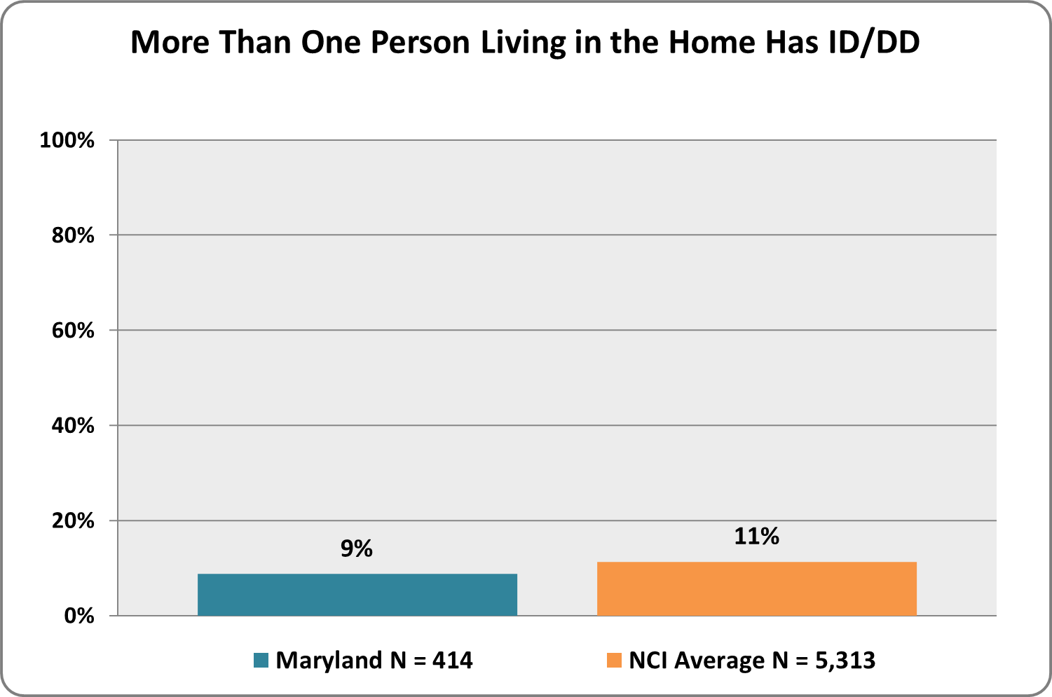 | Graph 2. Family member’s Average Age  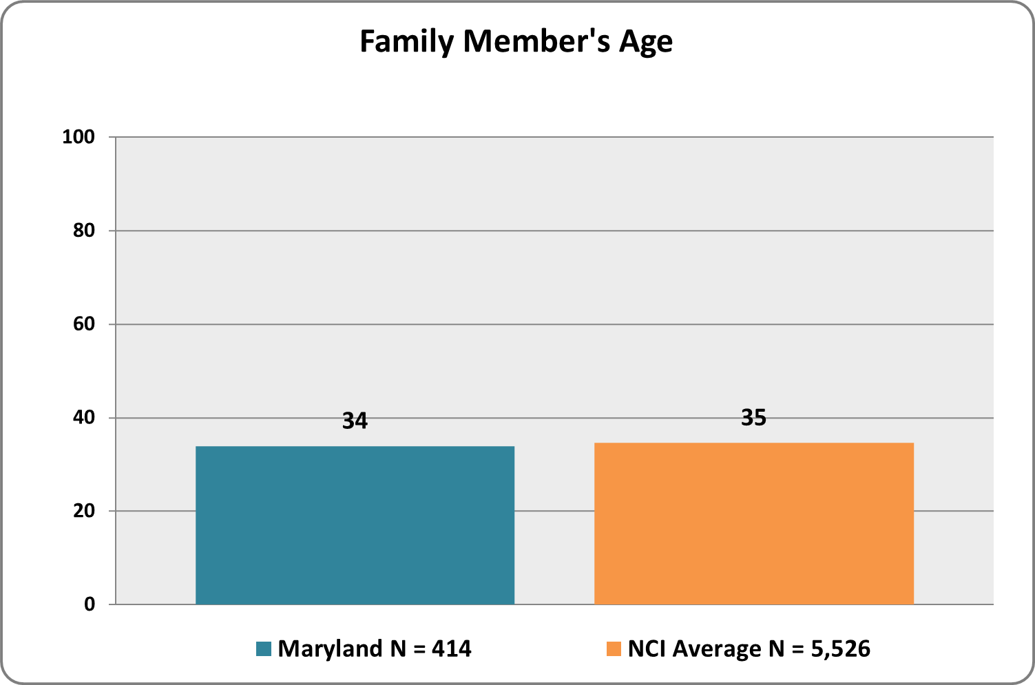
Graph 3. Family member’s Gender  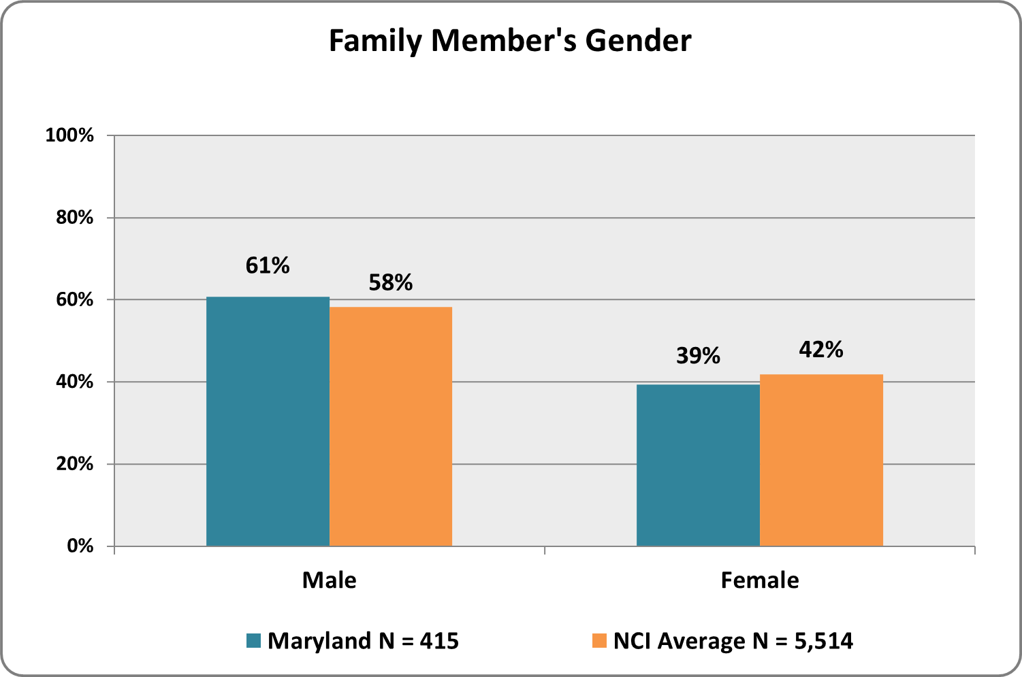 | Graph 4. family member’s Race and Ethnicity  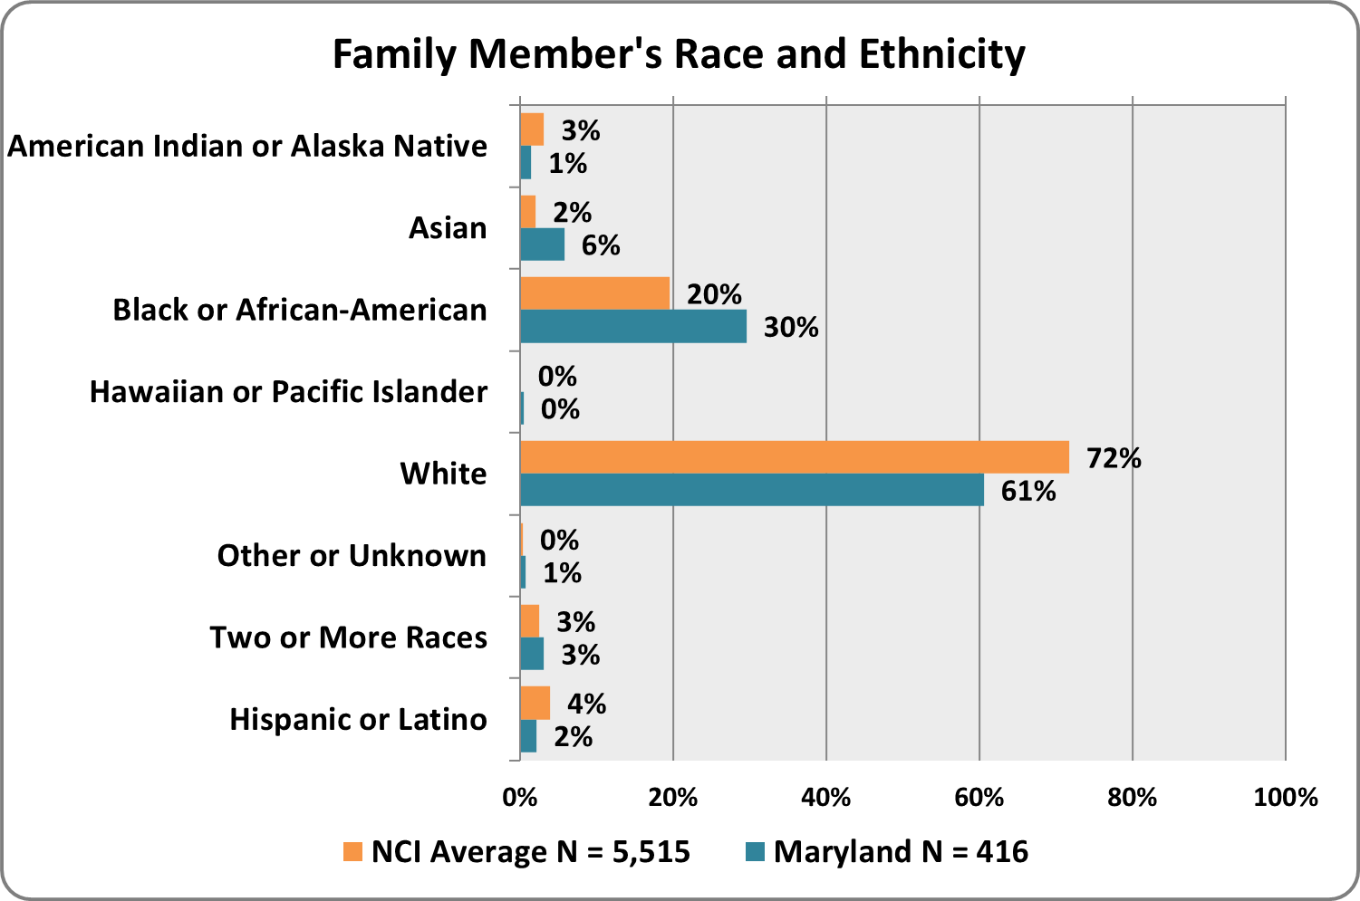

Graph 5. Family Member’s Primary Means of Expression  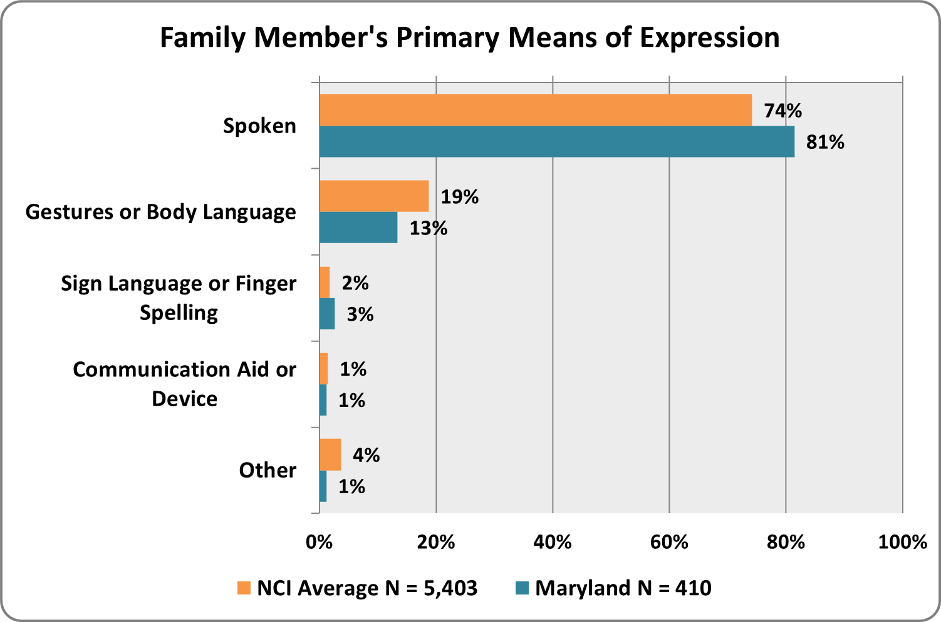 | Graph 6. Family Member’s Primary Language  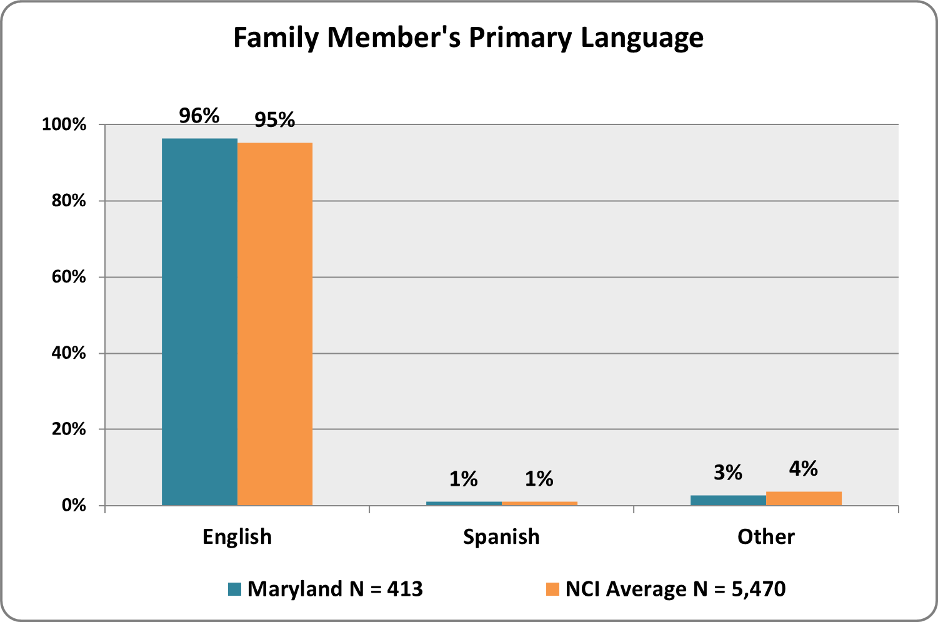
Graph 7. Family Member’s highest level of Education  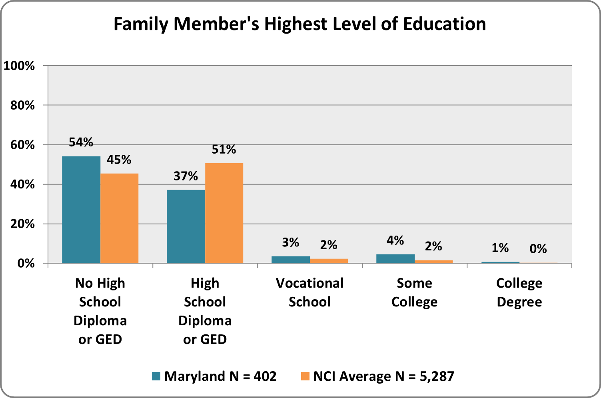 | Graph 8. Frequency of Medical Care Needed for family member  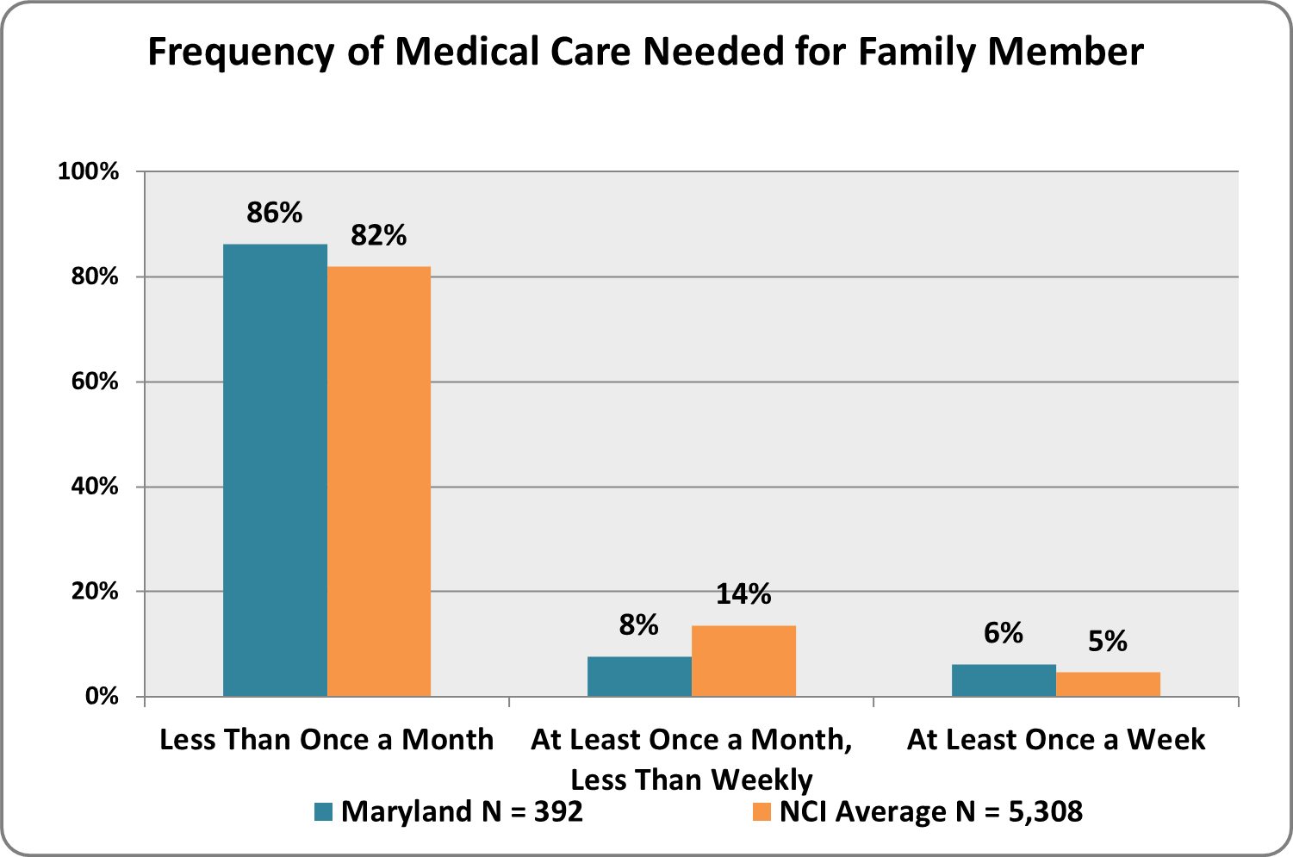
Graph 9. Amount of Help Needed With Daily Activities for Family Member  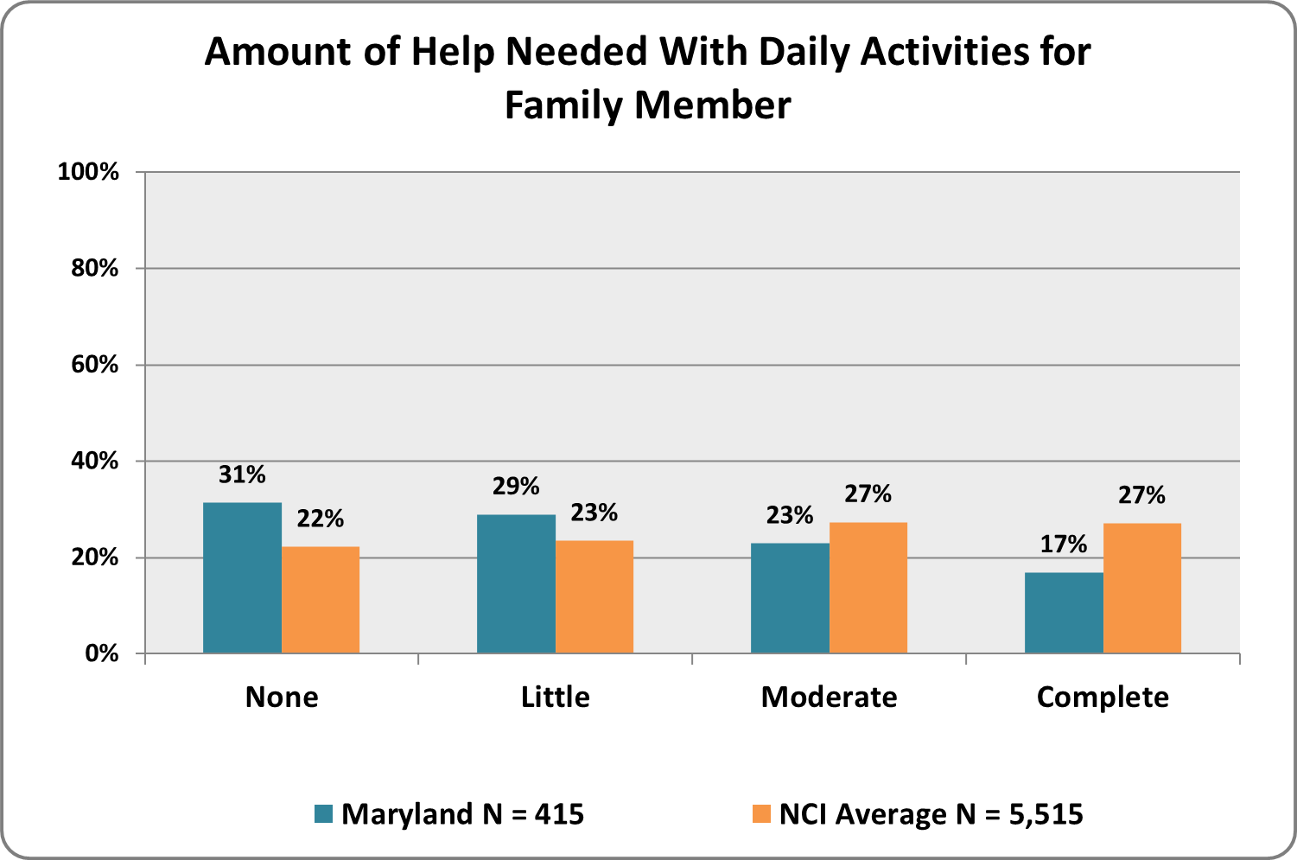 | Graph 10. Amount of Support Needed for Family Member for Self-Injurious, Disruptive, and/or Destructive Behaviors  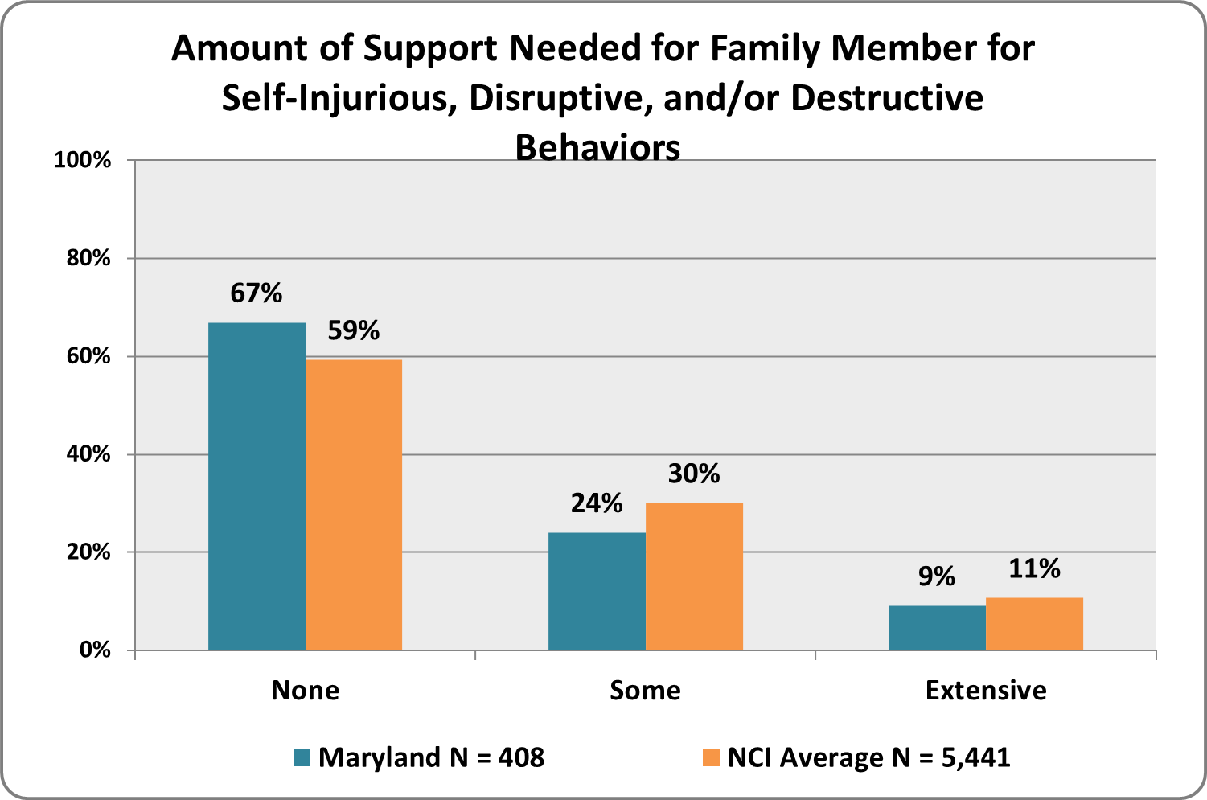
Graph 11. Family Member’s Typical Day Activities  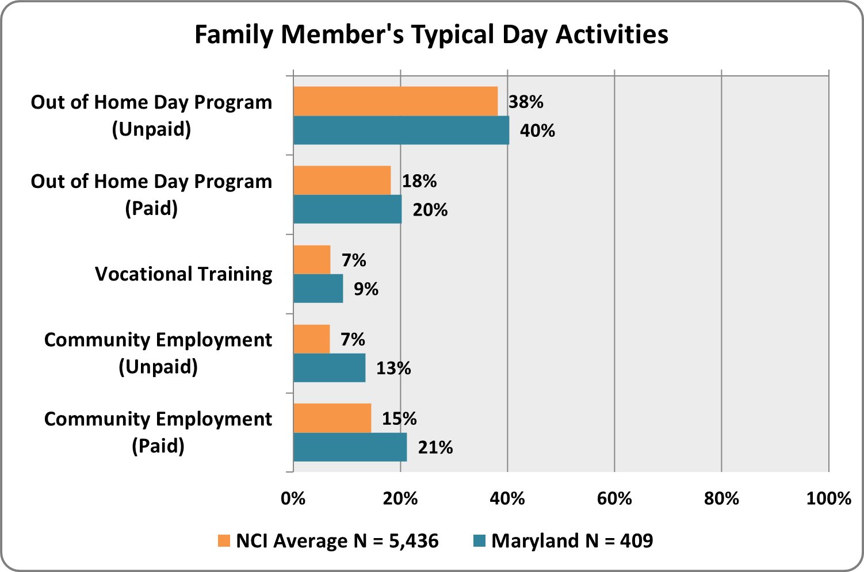 | Graph 12. Family Member’s Typical Day Activities, continued  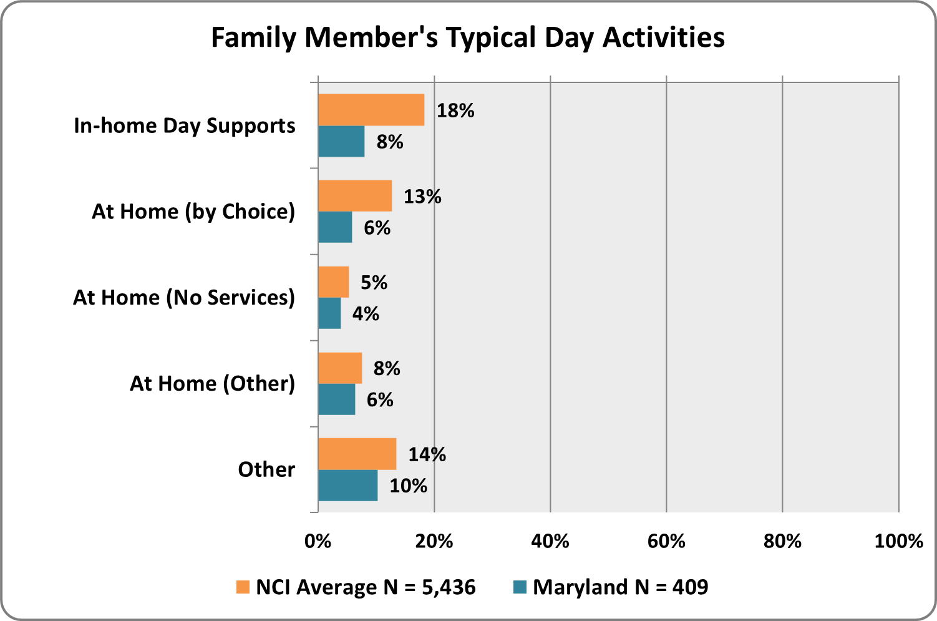

Results: Demographics of Respondent

illustrates the demographic profile of the survey respondents

Graph 13. Respondent's Age  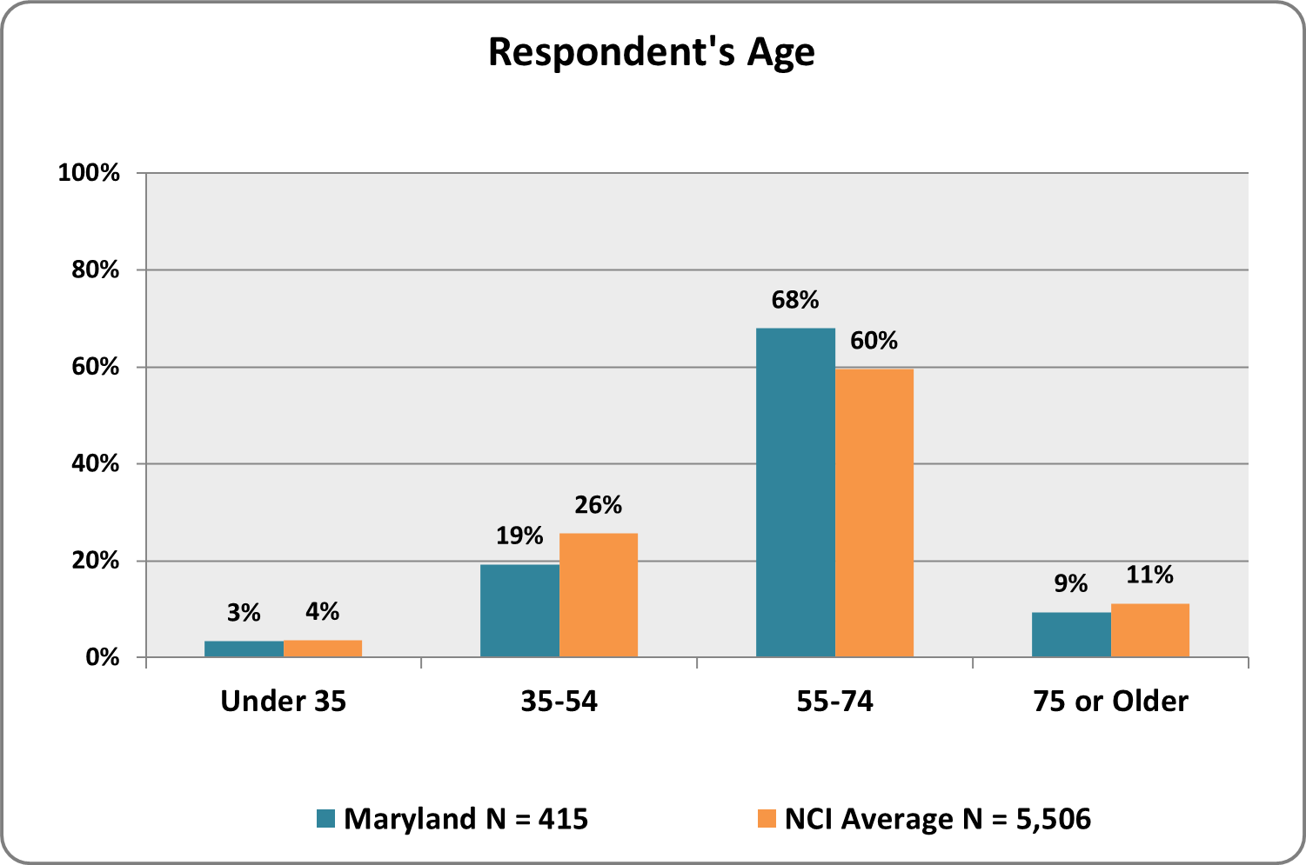 | Graph 14. Respondent’s Health  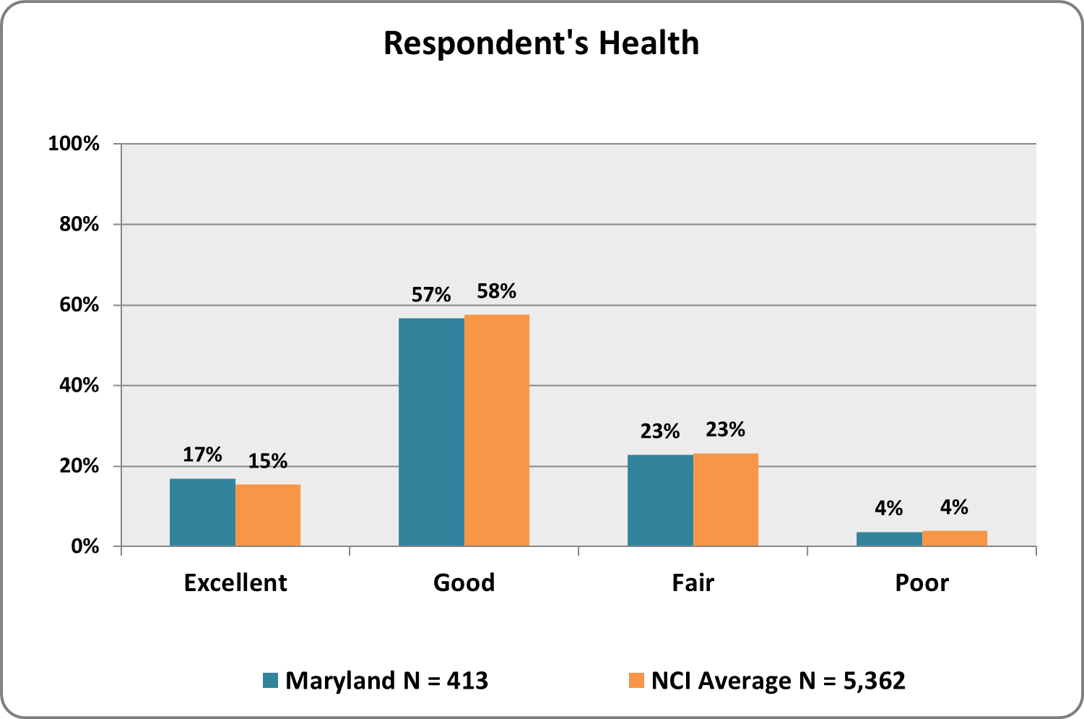
Graph 15. Relationship to Family Member Receiving services  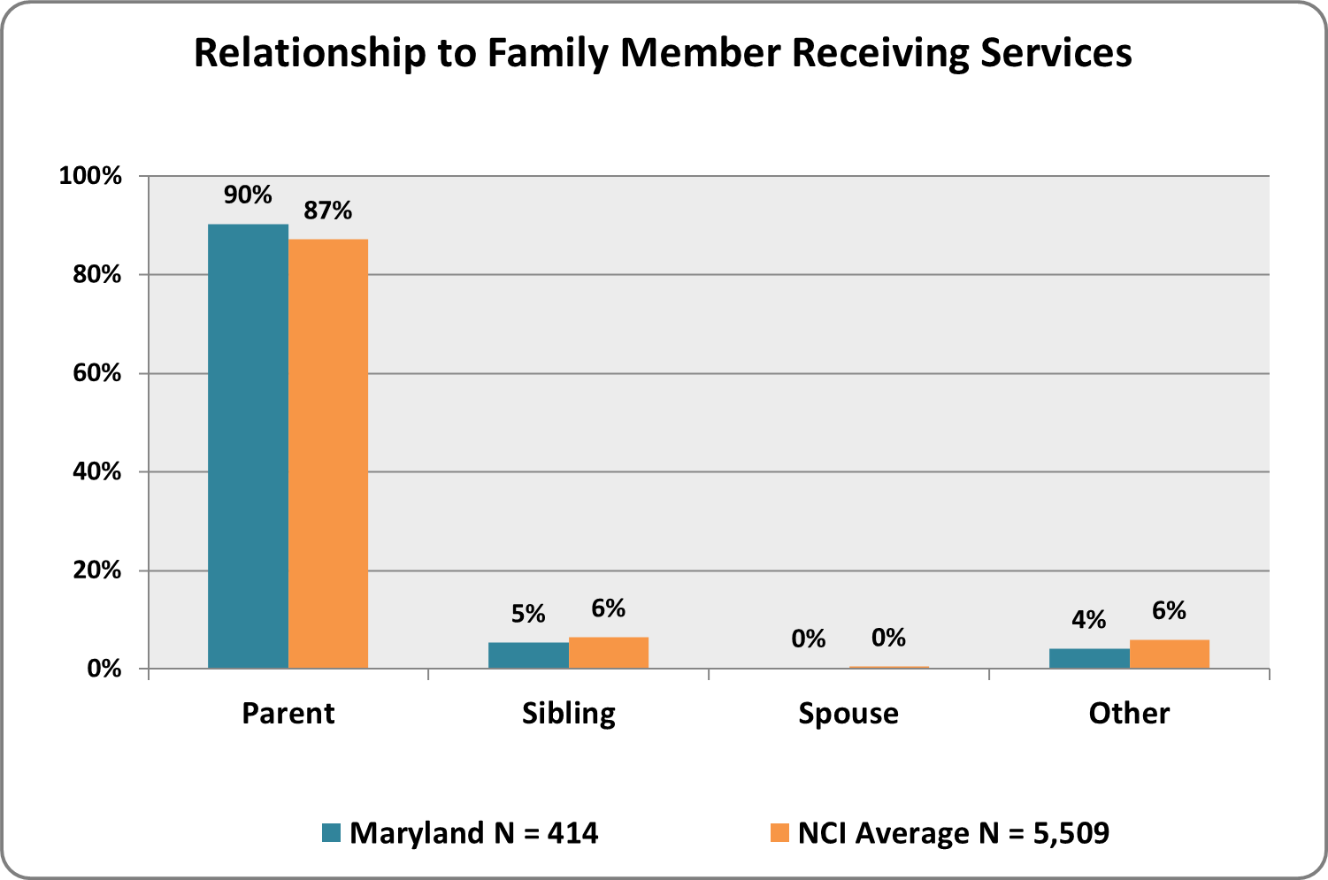 | GRaph 16. respondent is Primary Caregiver  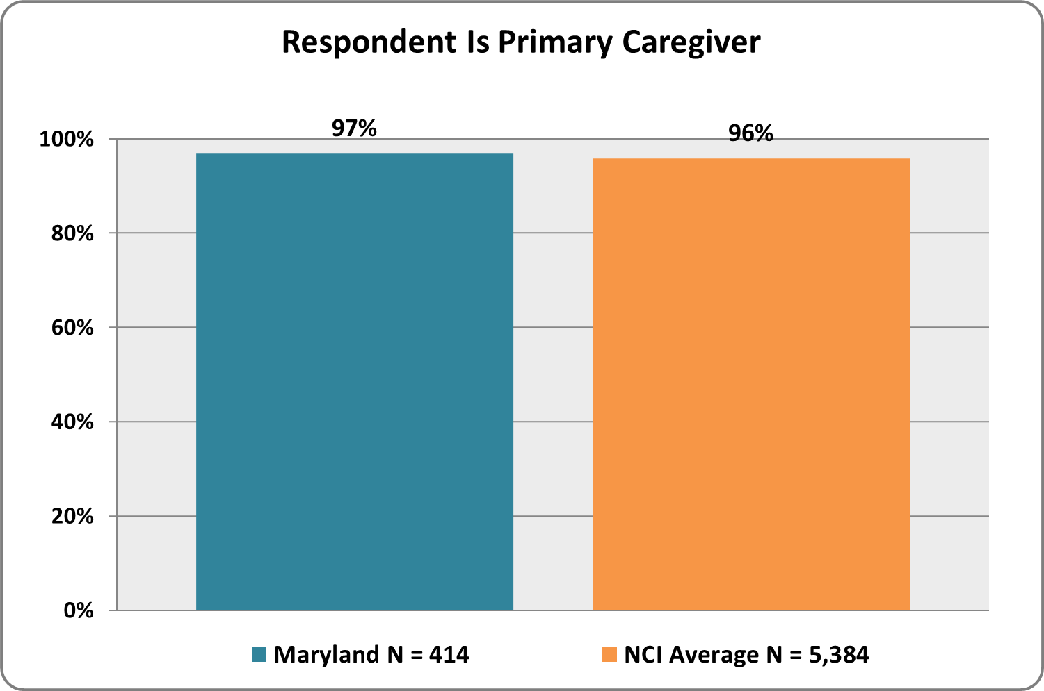

Graph 17. Number of Adults in Household (not including family member receiving services)  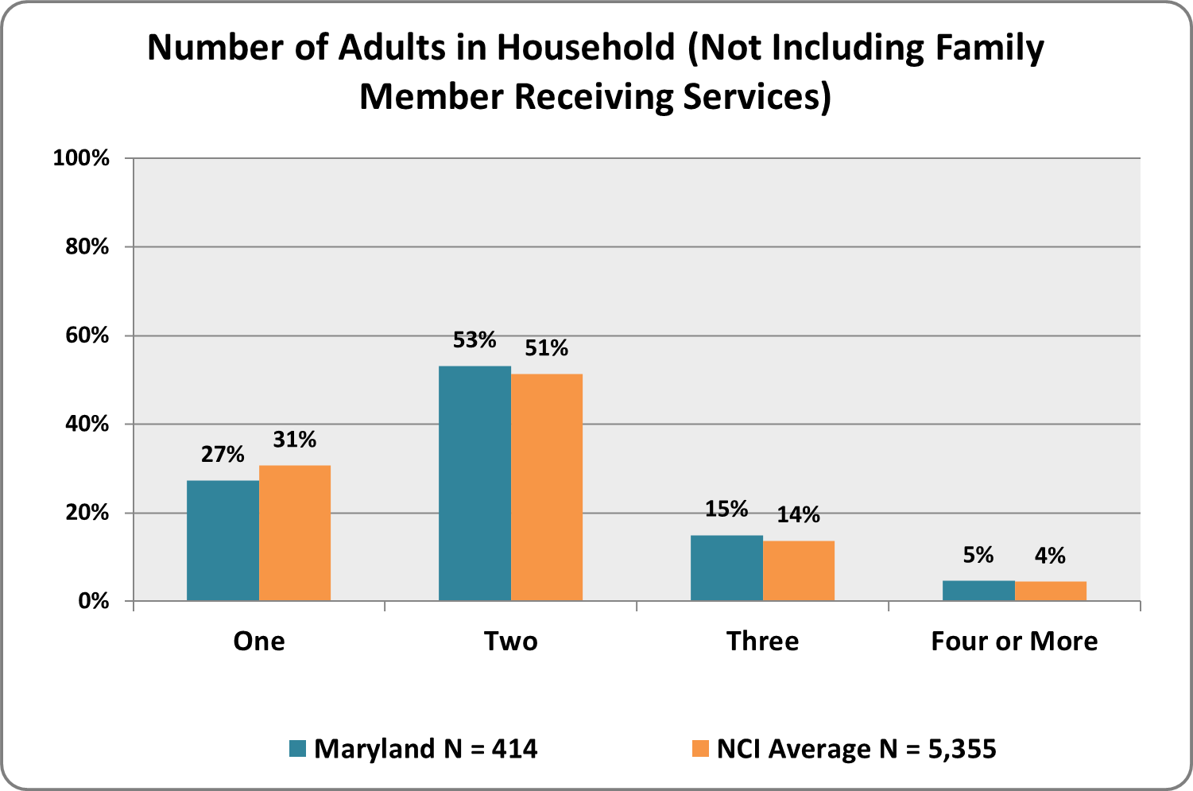 | GRaph 18. respondent is family member’s Legal Guardian or Conservator  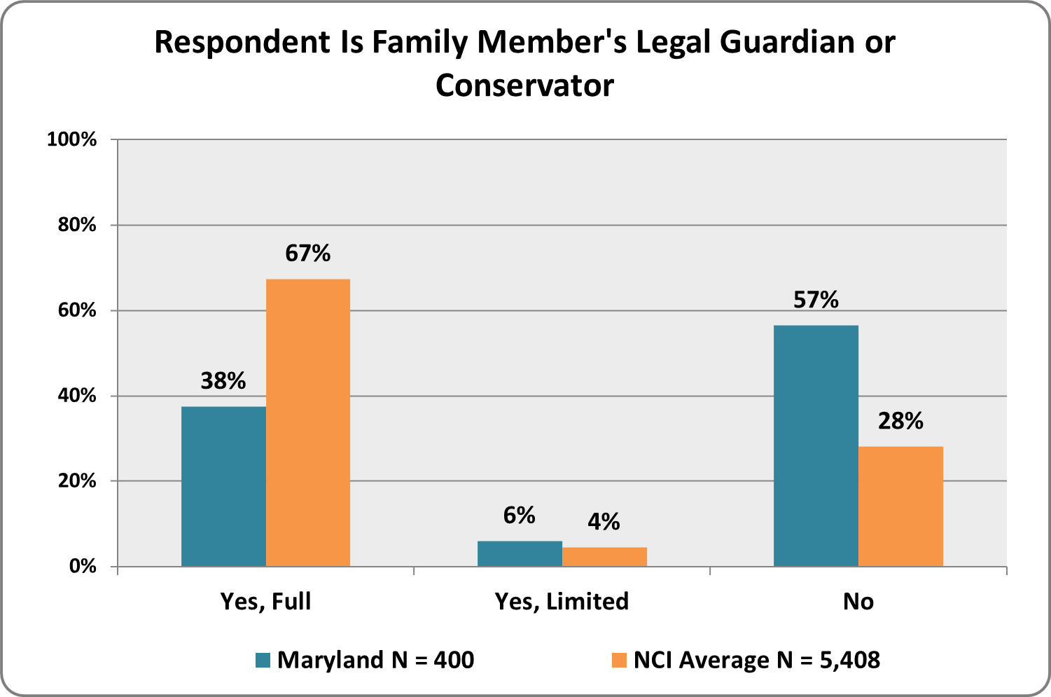
Graph 19. Respondent's Highest Level of Education  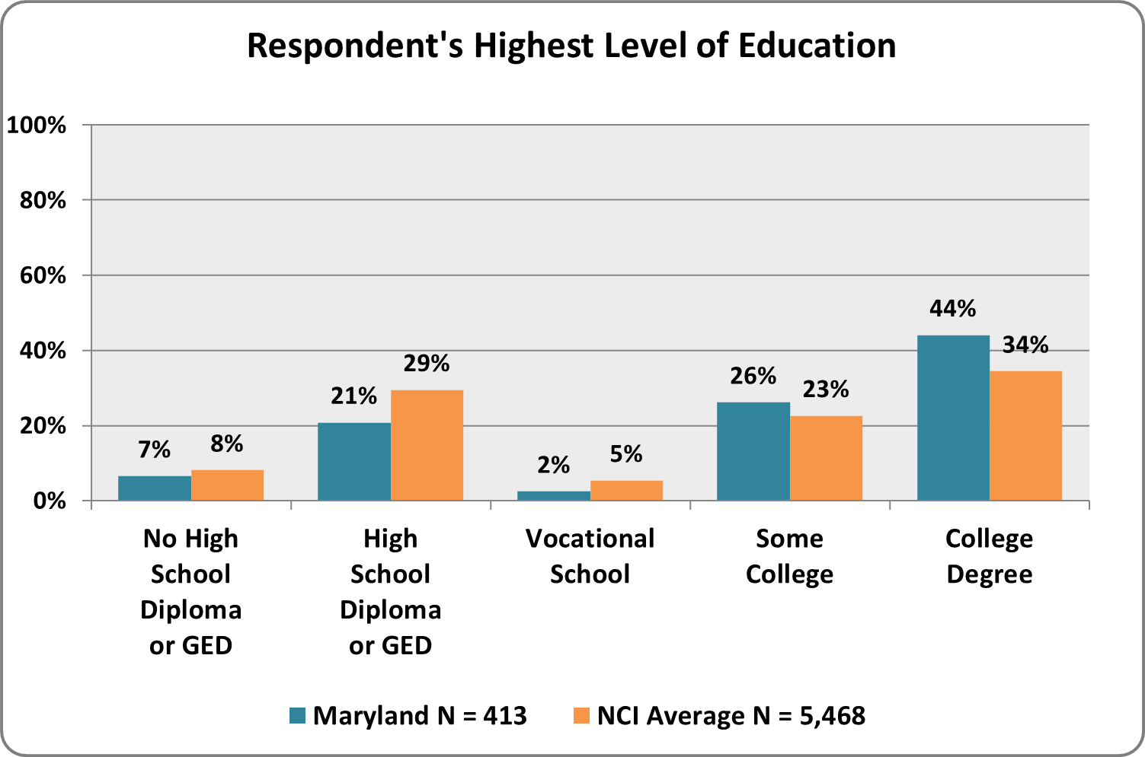 | GRaph 20. total taxable household income of wage earners in the past year  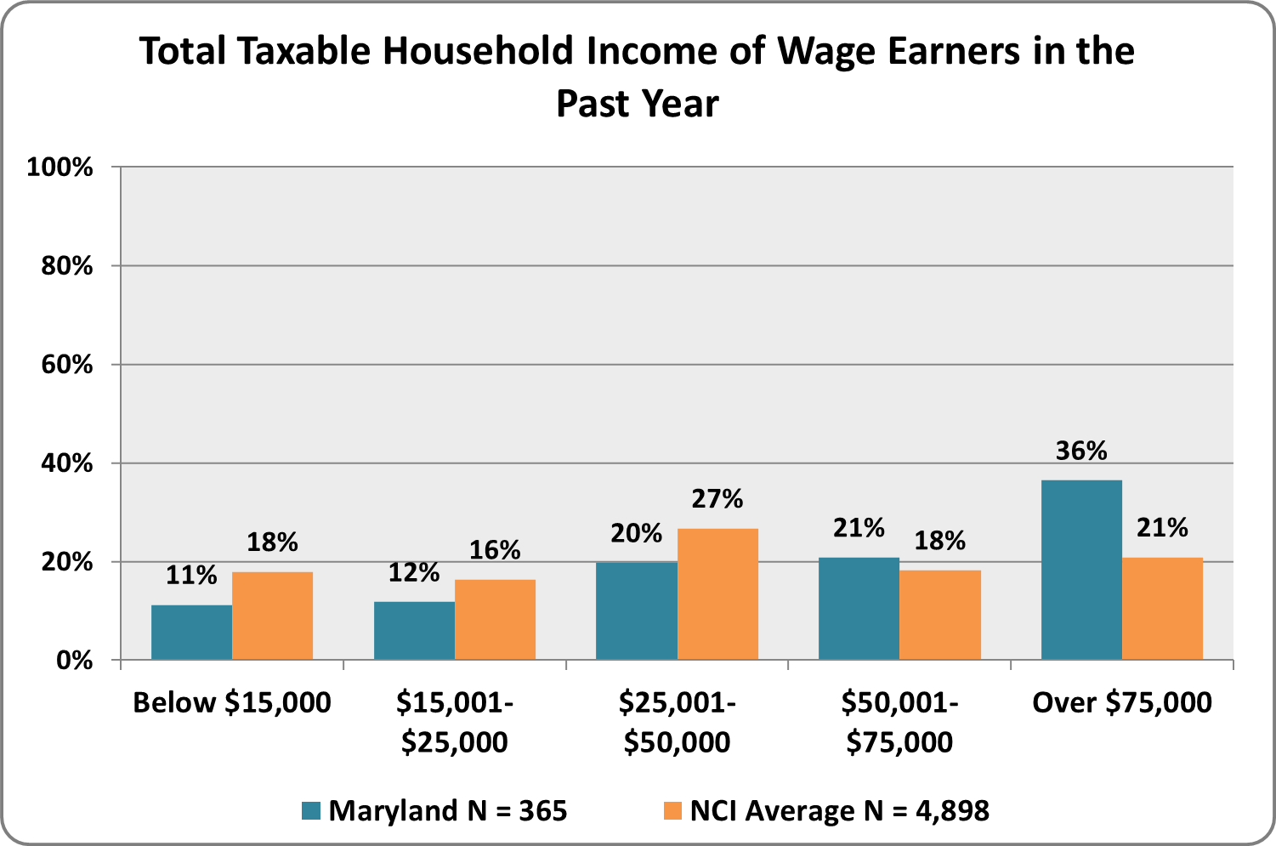

Graph 21. Out-of-Pocket Expenses for family member’s care in past year
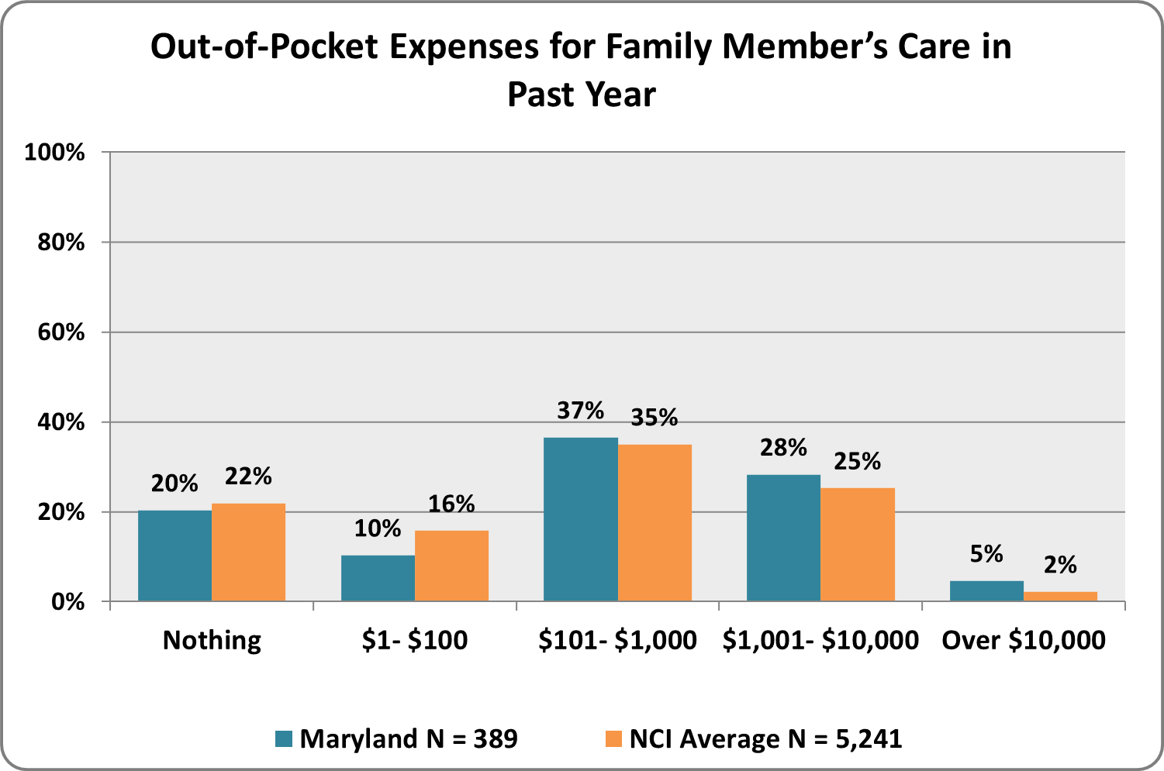

Services and Supports Received

illustrates the services and supports received by families and family members

Graph 22. Services and Supports Received
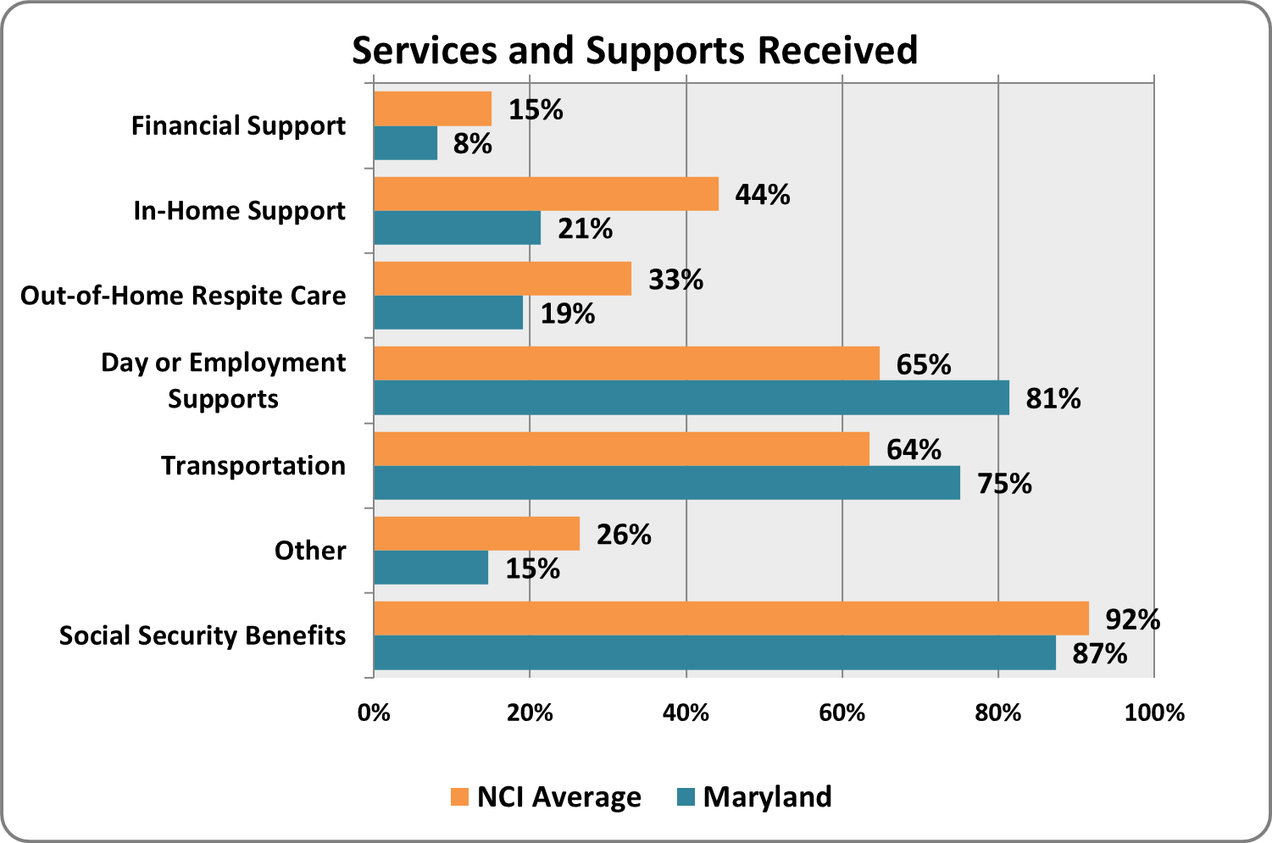

Information and Planning
families and family members with disabilities have the information and support necessary to plan for their services and supports
Graph 23. Do you get enough information to help you participate in planning services for your family?  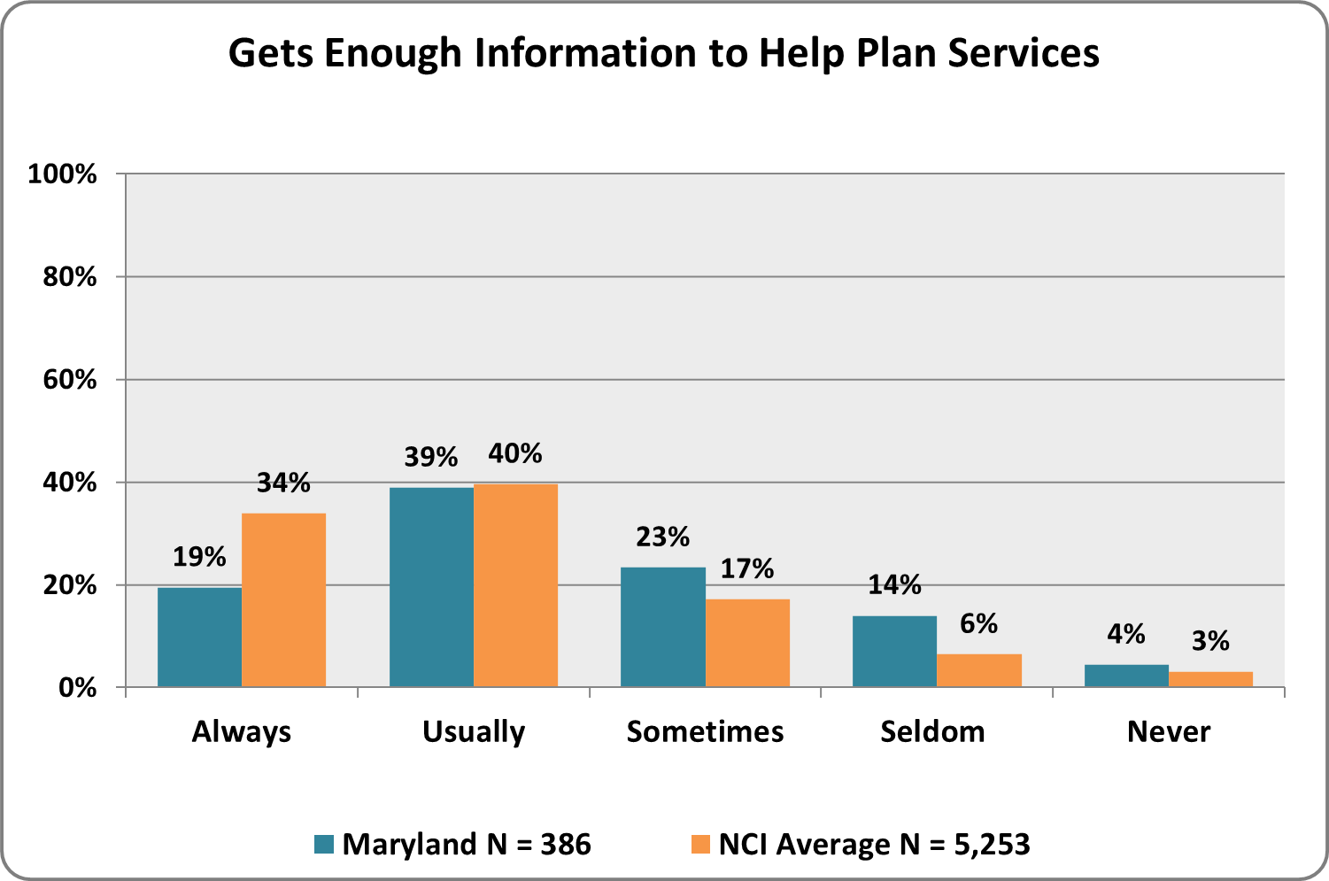 | Graph 24. Is the information you receive easy to understand?  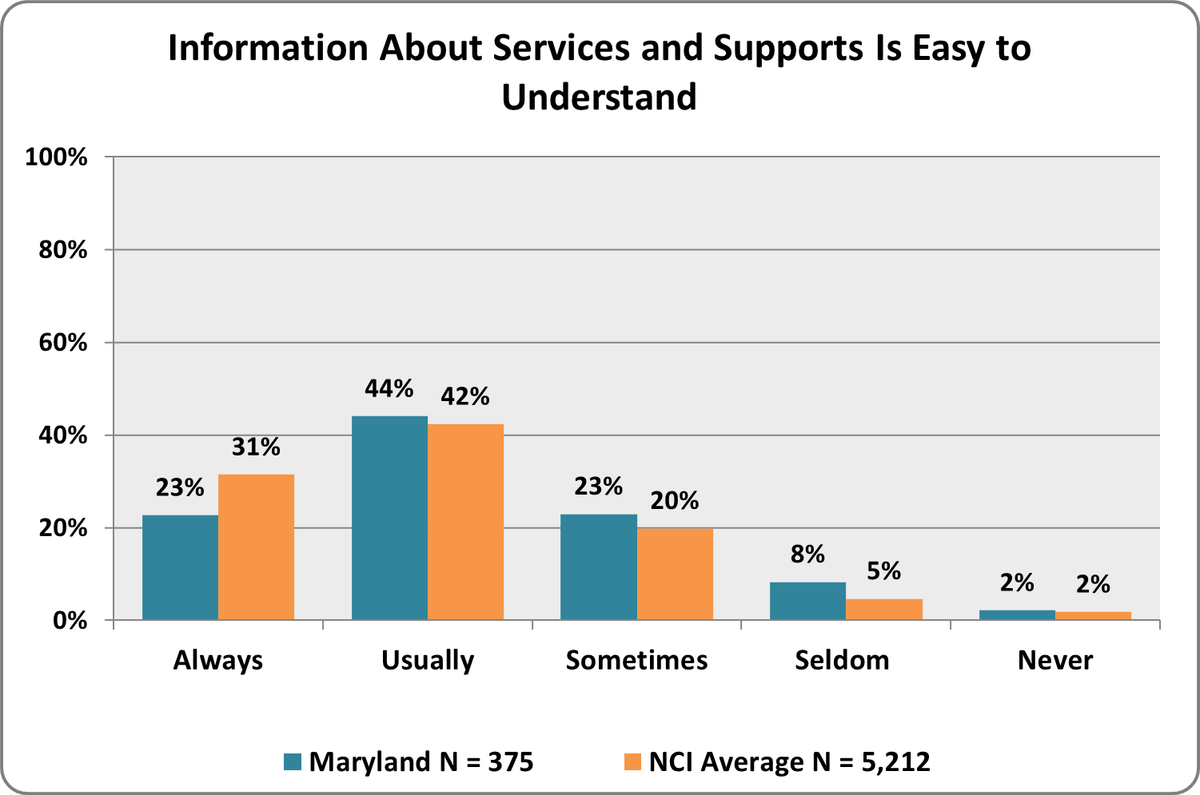
Graph 25. Does the information you receive come from your case manager/service coordinator?  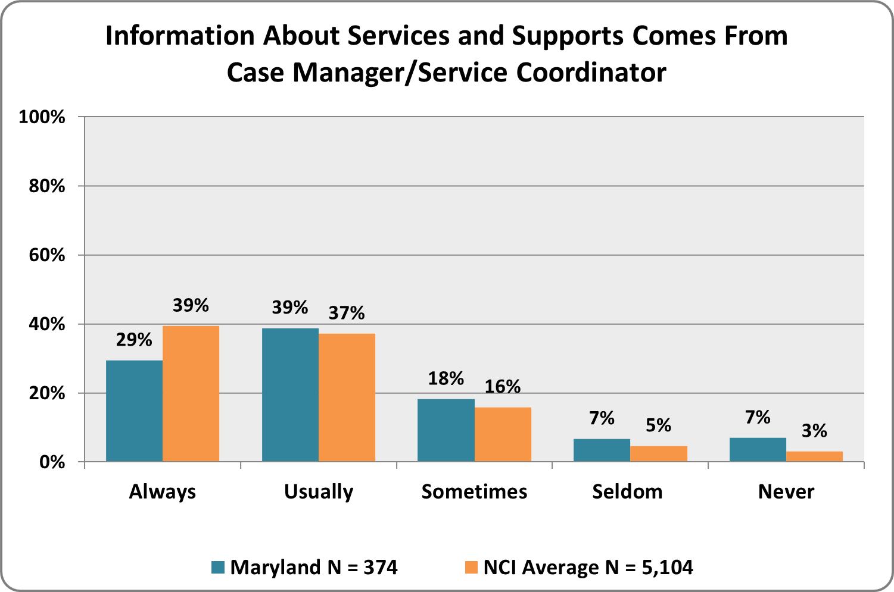 | Graph 26. Does the case manager/service coordinator respect your family’s choices and opinions?  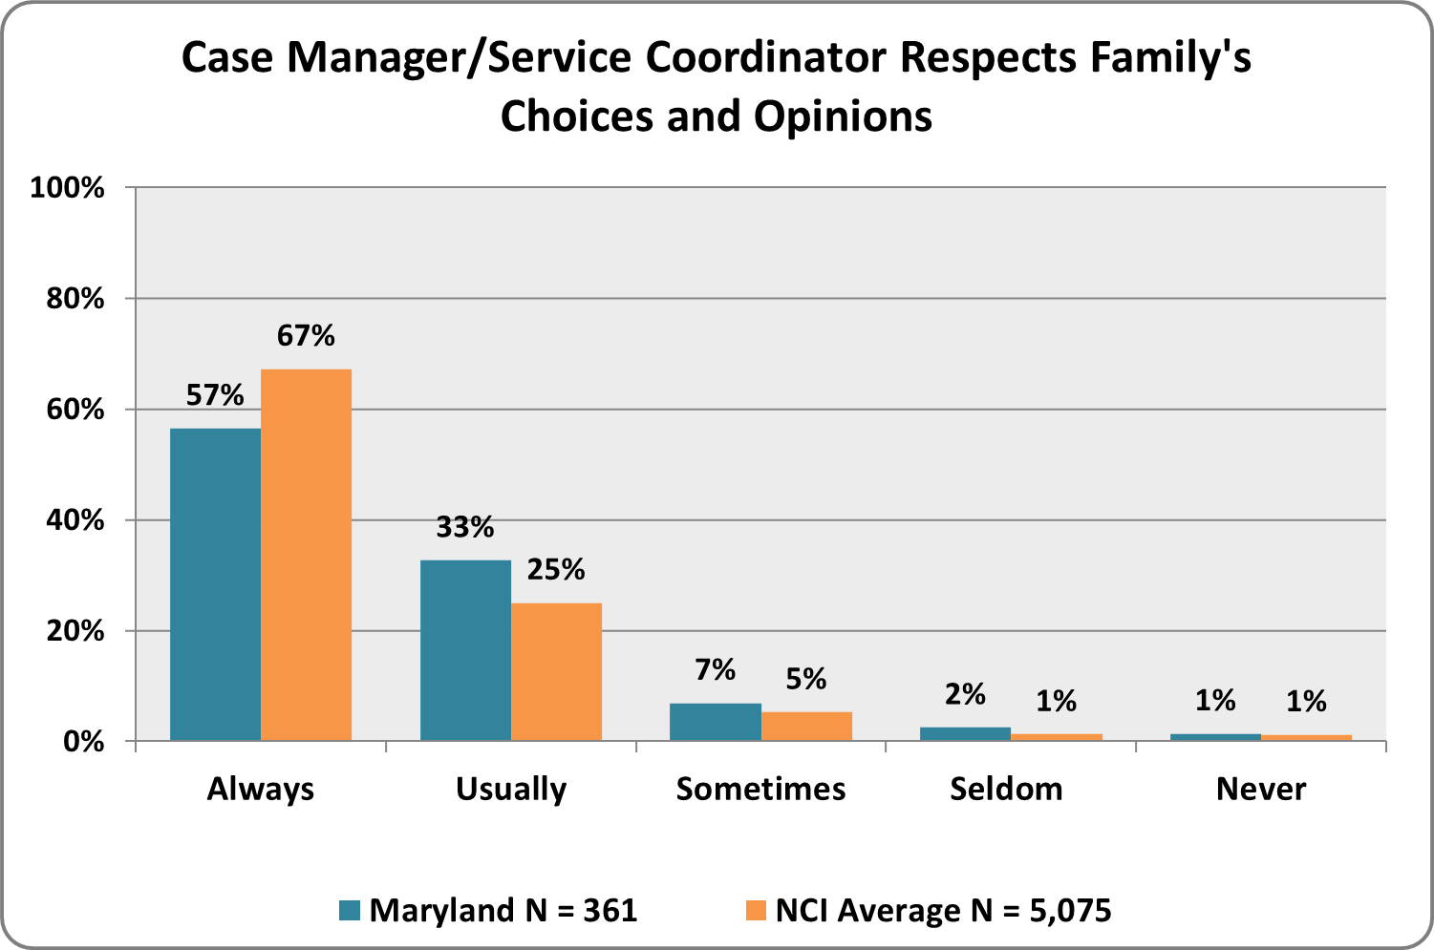

Graph 27. Does the case manager/service coordinator tell you about other public services for which your family is eligible (food stamps, Supplemental Security Income [SSI], housing subsidies, etc.)?  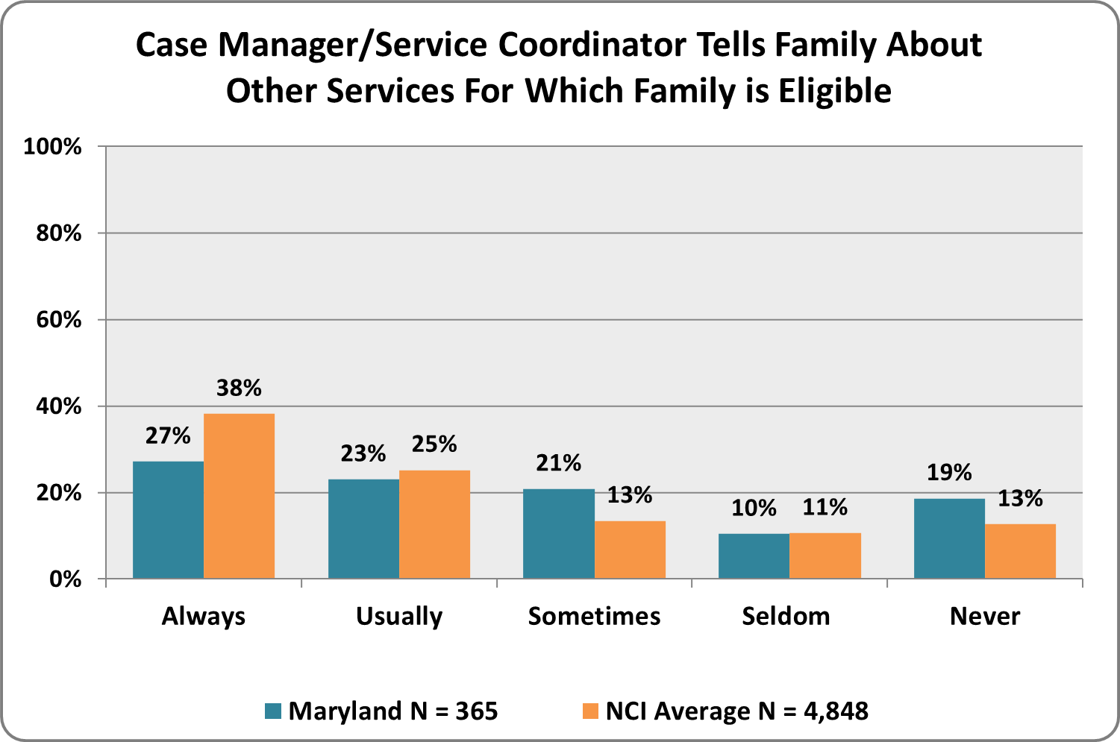 | Graph 28. Does your family member have a service plan?  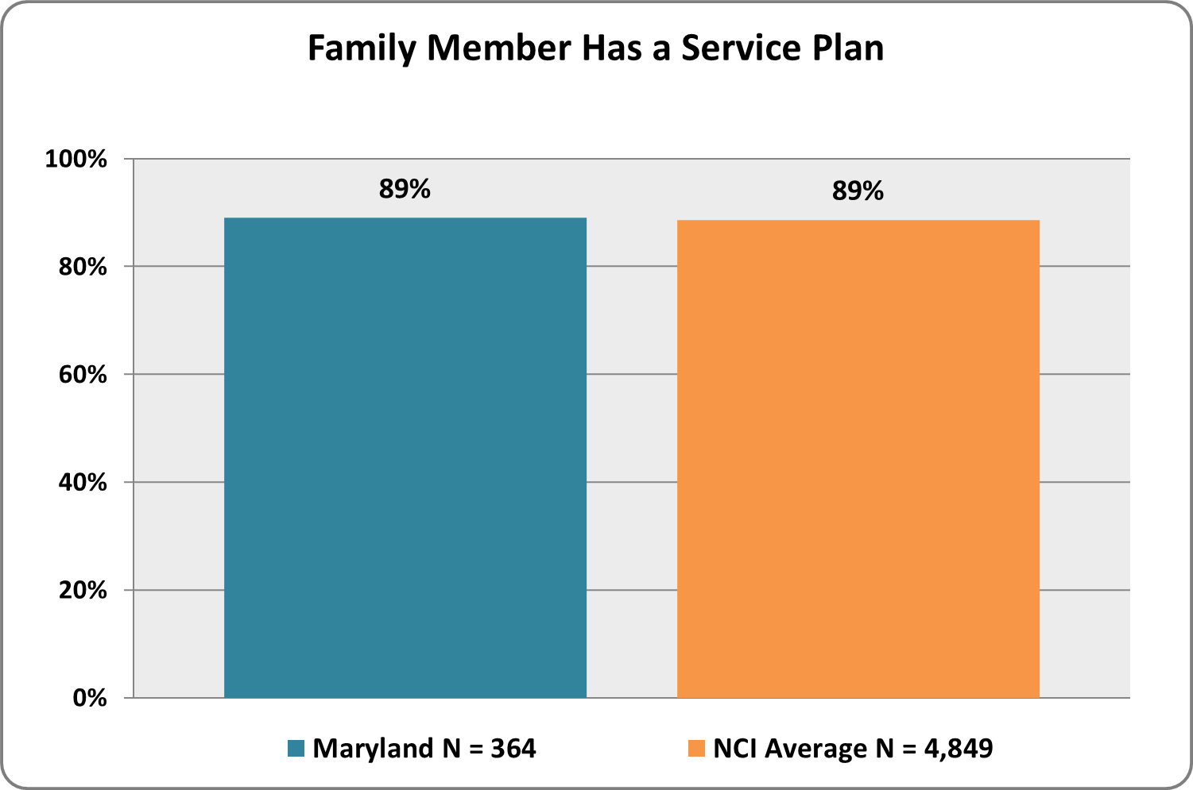
Graph 29. Does the service plan include all the services and supports your family member wants?  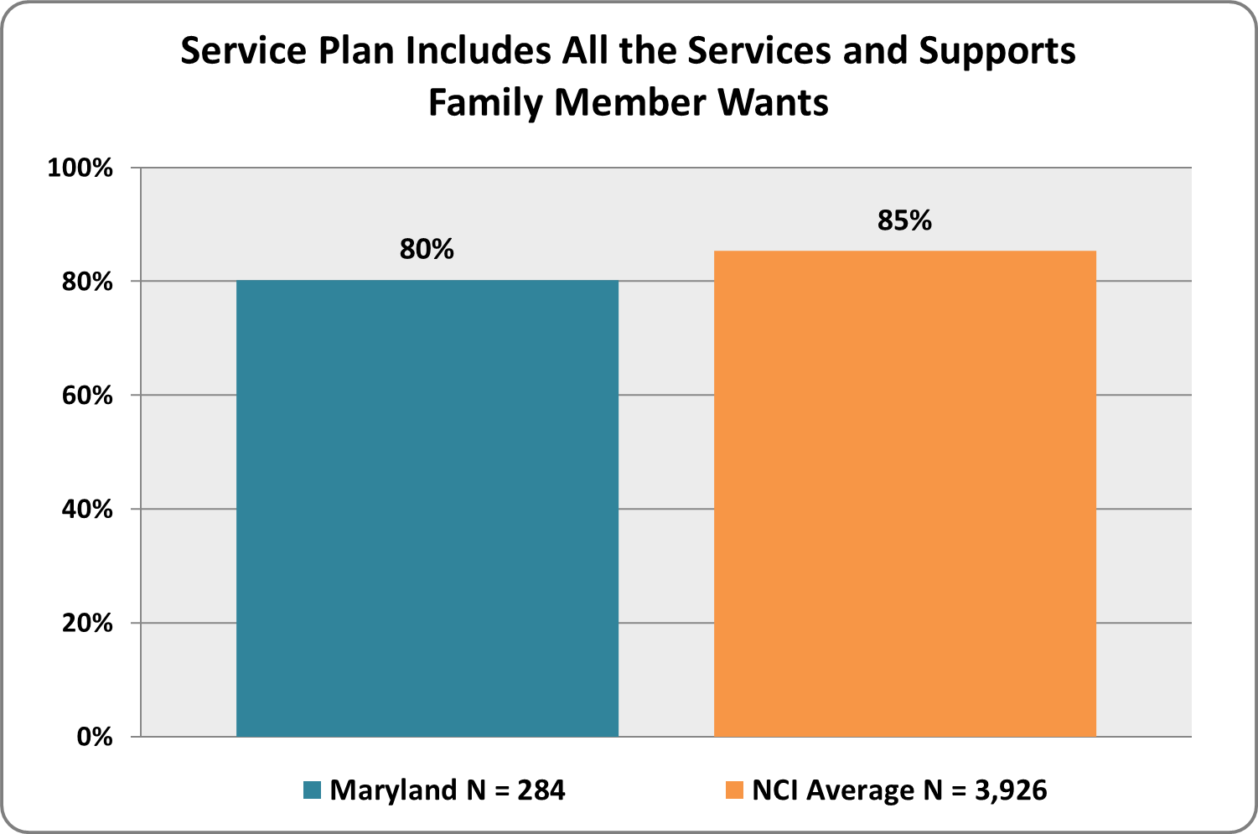 | Graph 30. Does your family member receive all the services listed in the service plan?  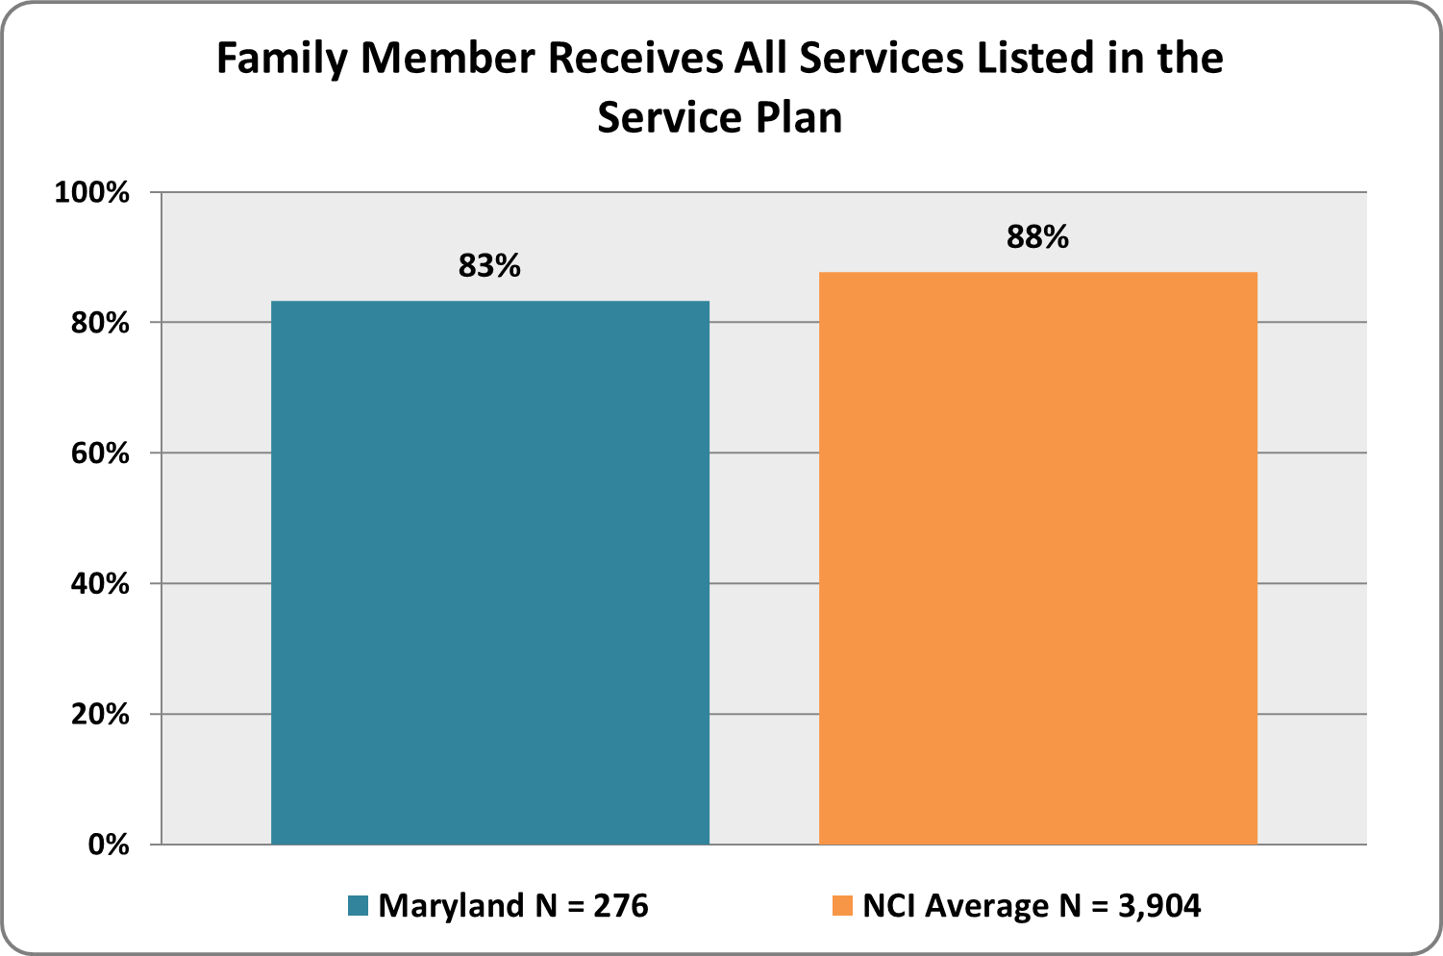

Graph 31. Did your family member help develop the service plan?  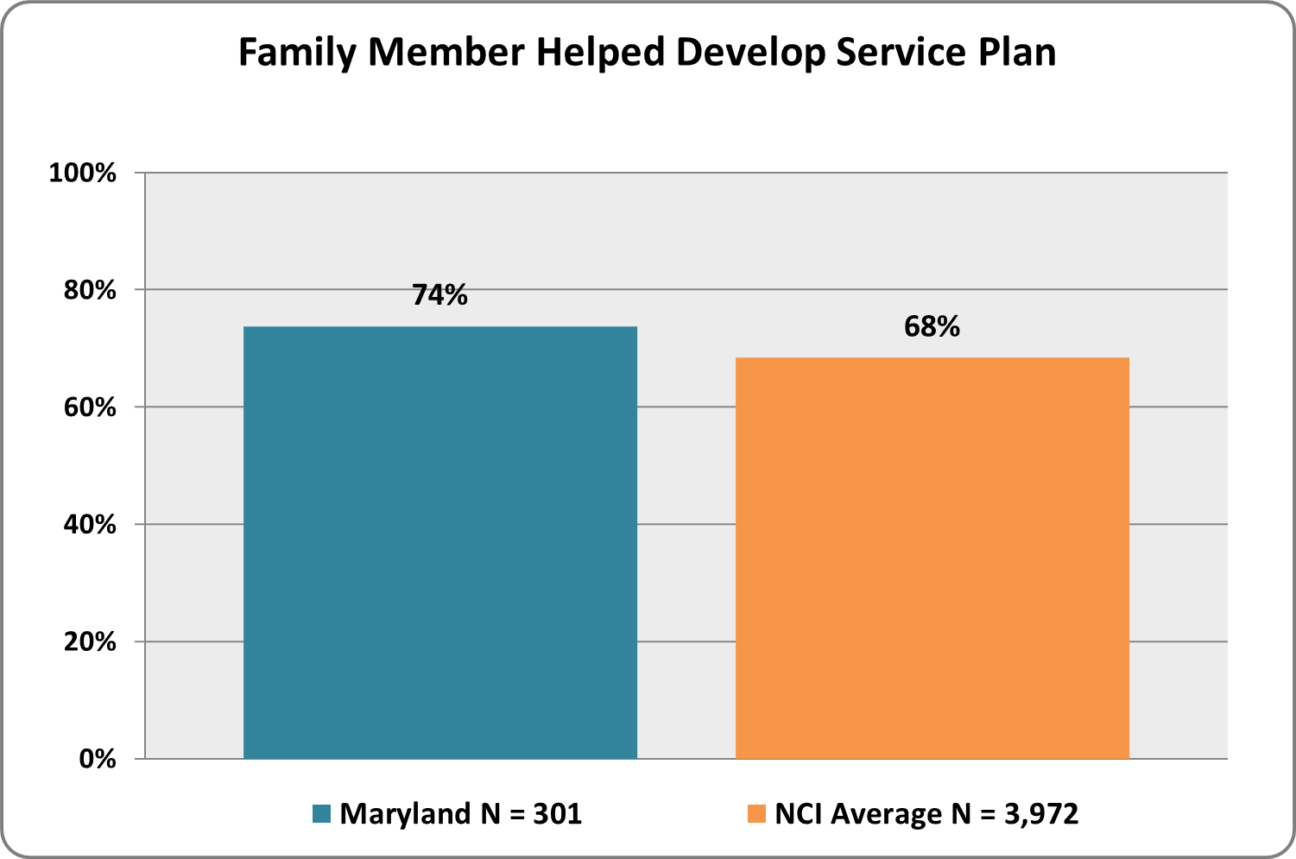 | Graph 32. Did you or another family member help develop the service plan?  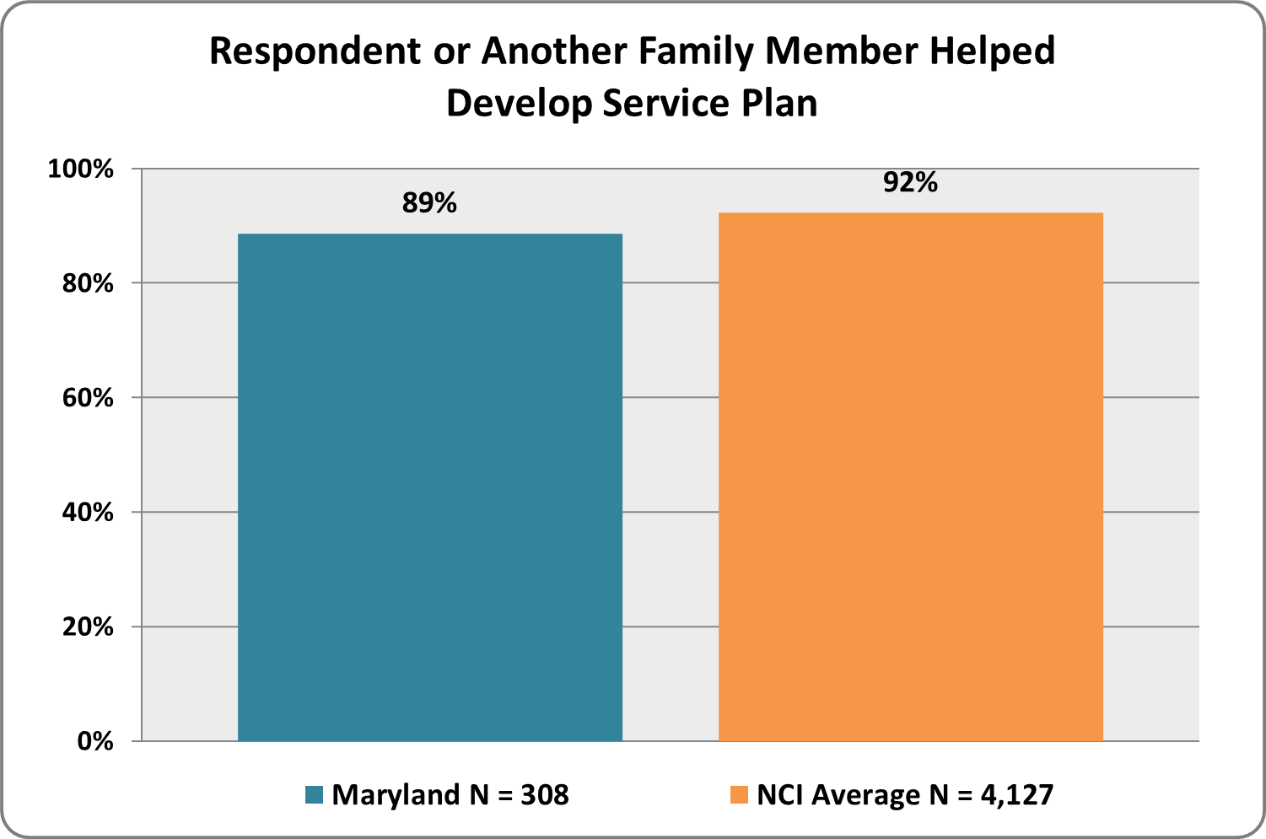
Graph 33. Does the service plan include all the services and supports your family member needs?  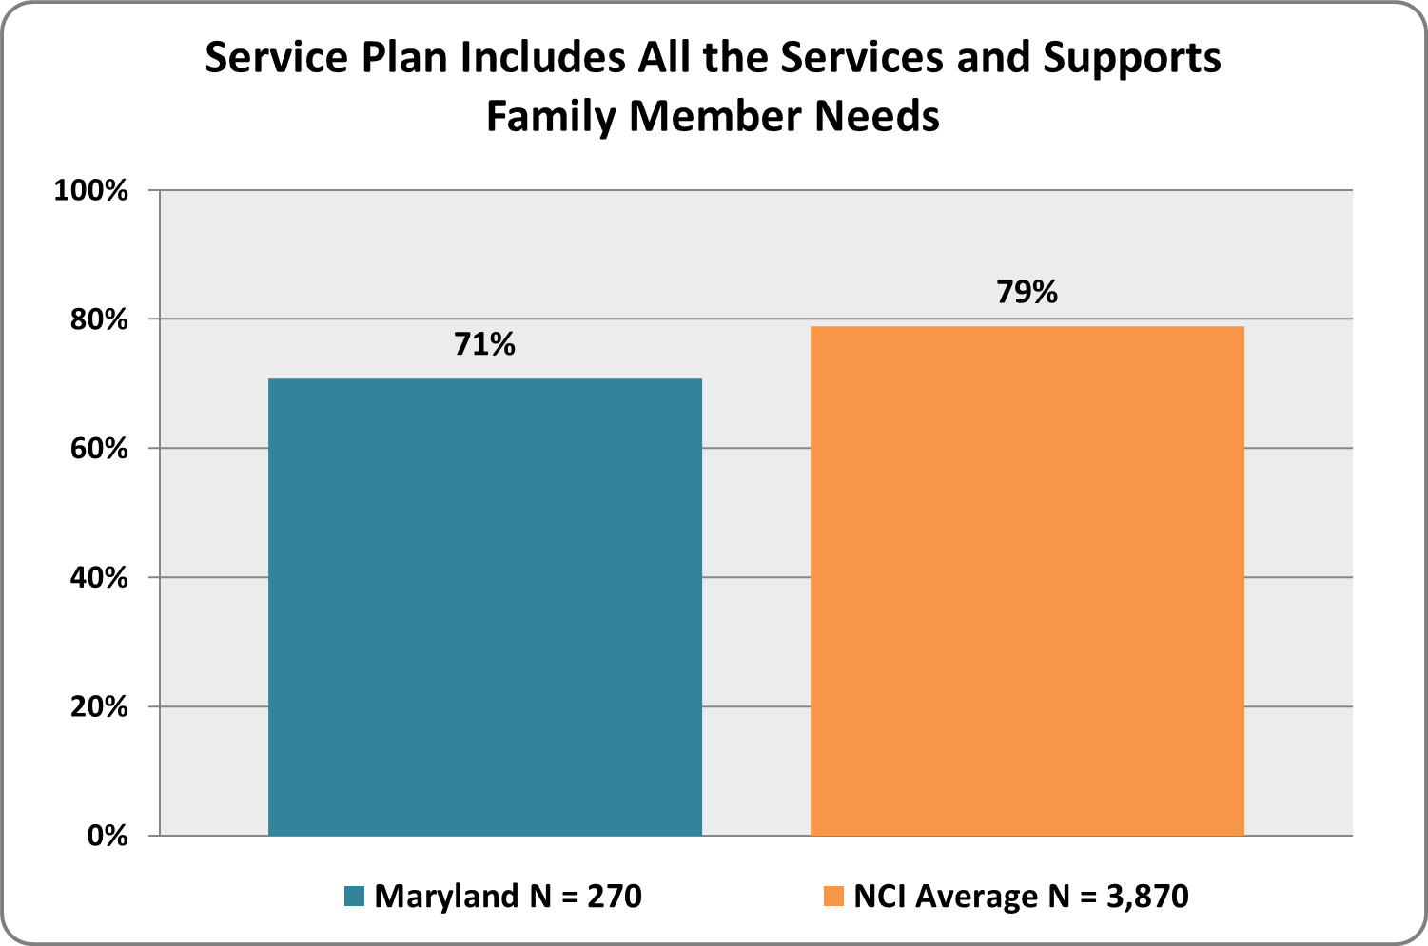 | Graph 34. Did you discuss how to handle emergencies related to your family member at the last service planning meeting?  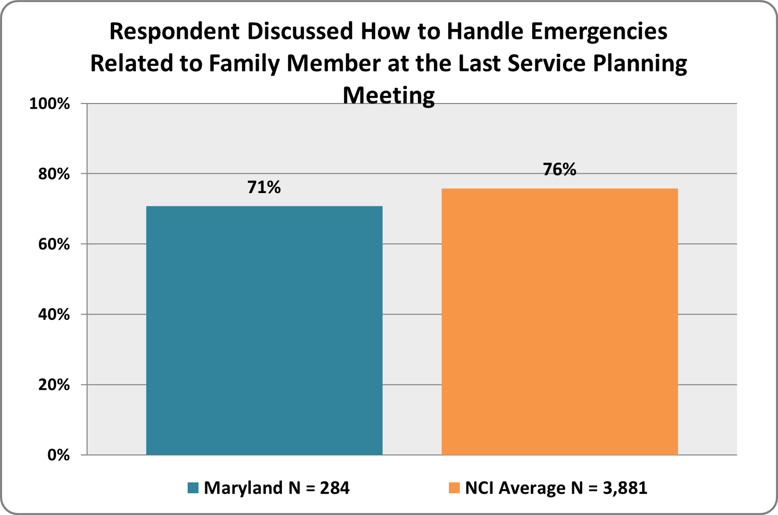

Graph 35. Have you or your family member received information about his/her rights?
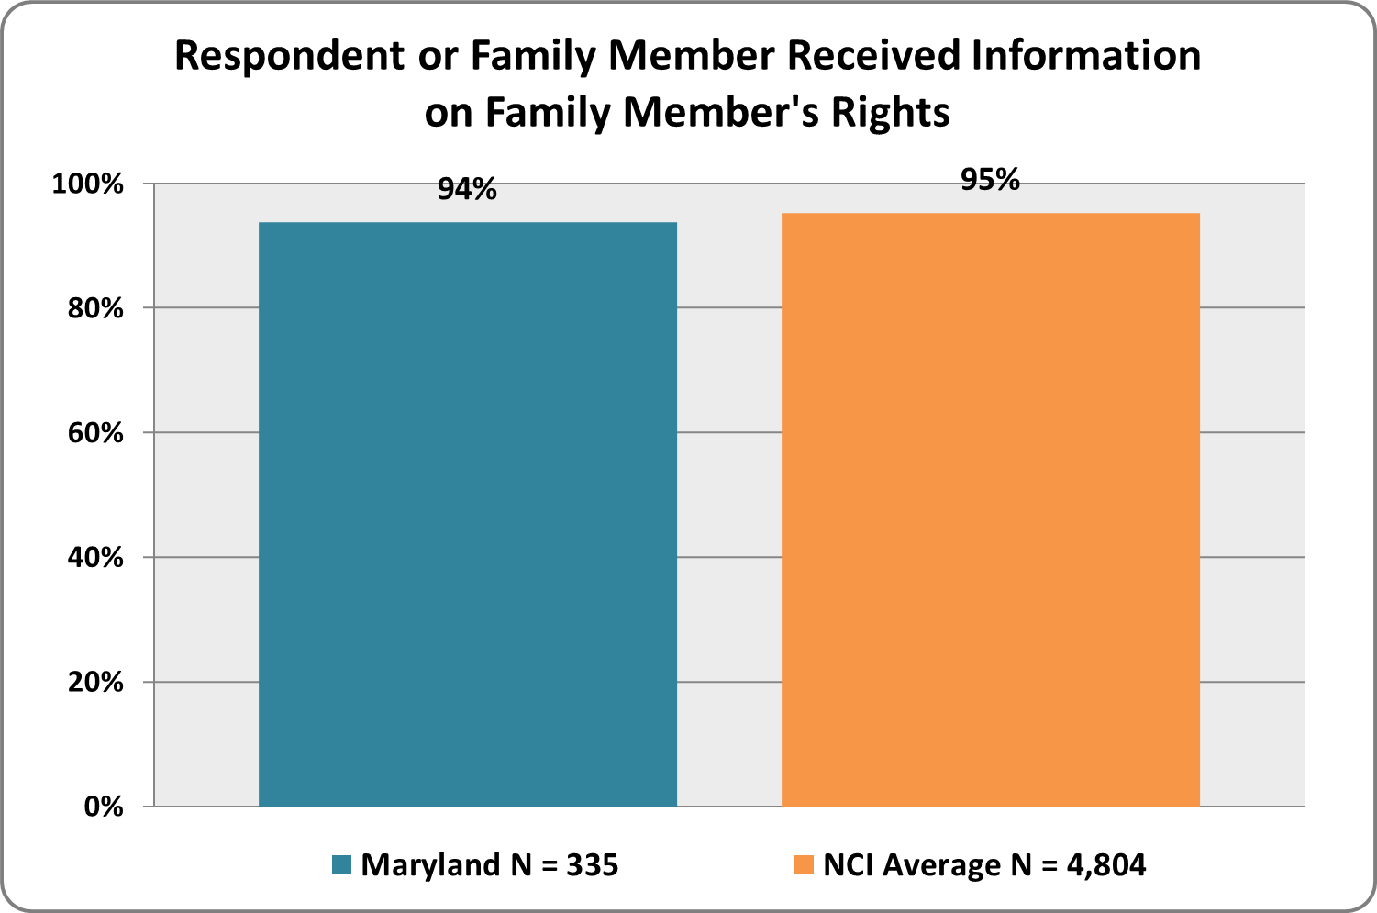

Access and Delivery

people make choices about their lives and are actively engaged in planning their services and supports

Graph 36. Are you or your family member able to contact his/her support workers when you need to?  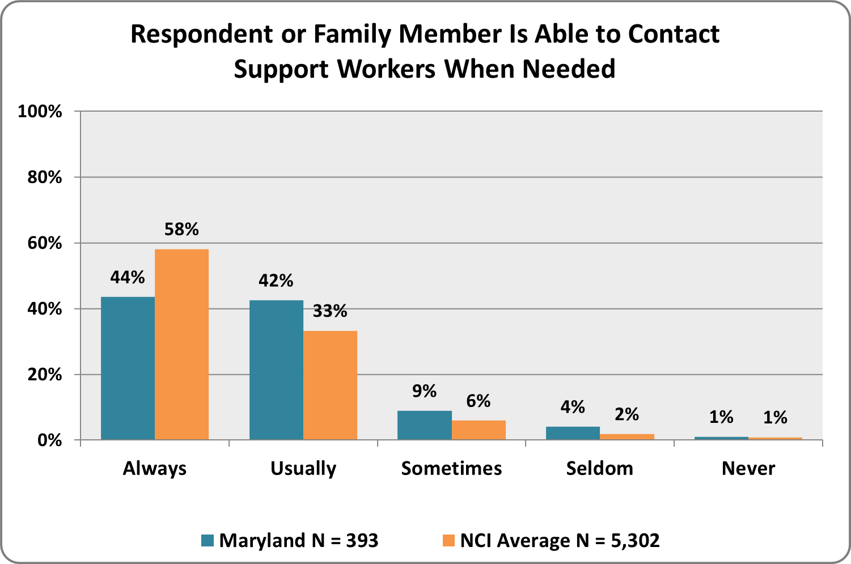 | Graph 37. Are you or your family member able to contact his/her case manager/service coordinator when you need to?  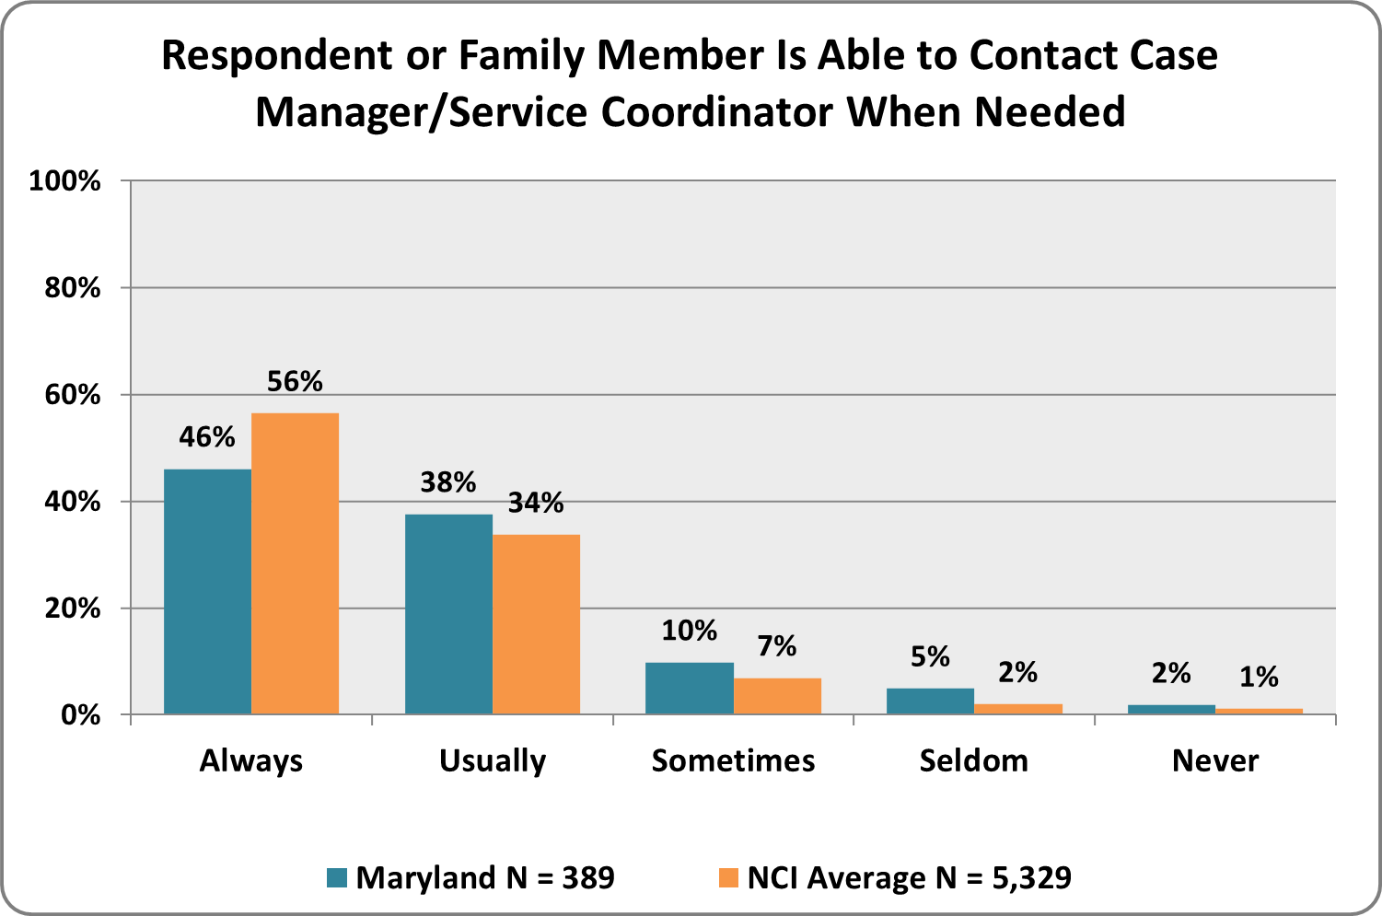
Graph 38. Are services and supports available when your family member needs them?  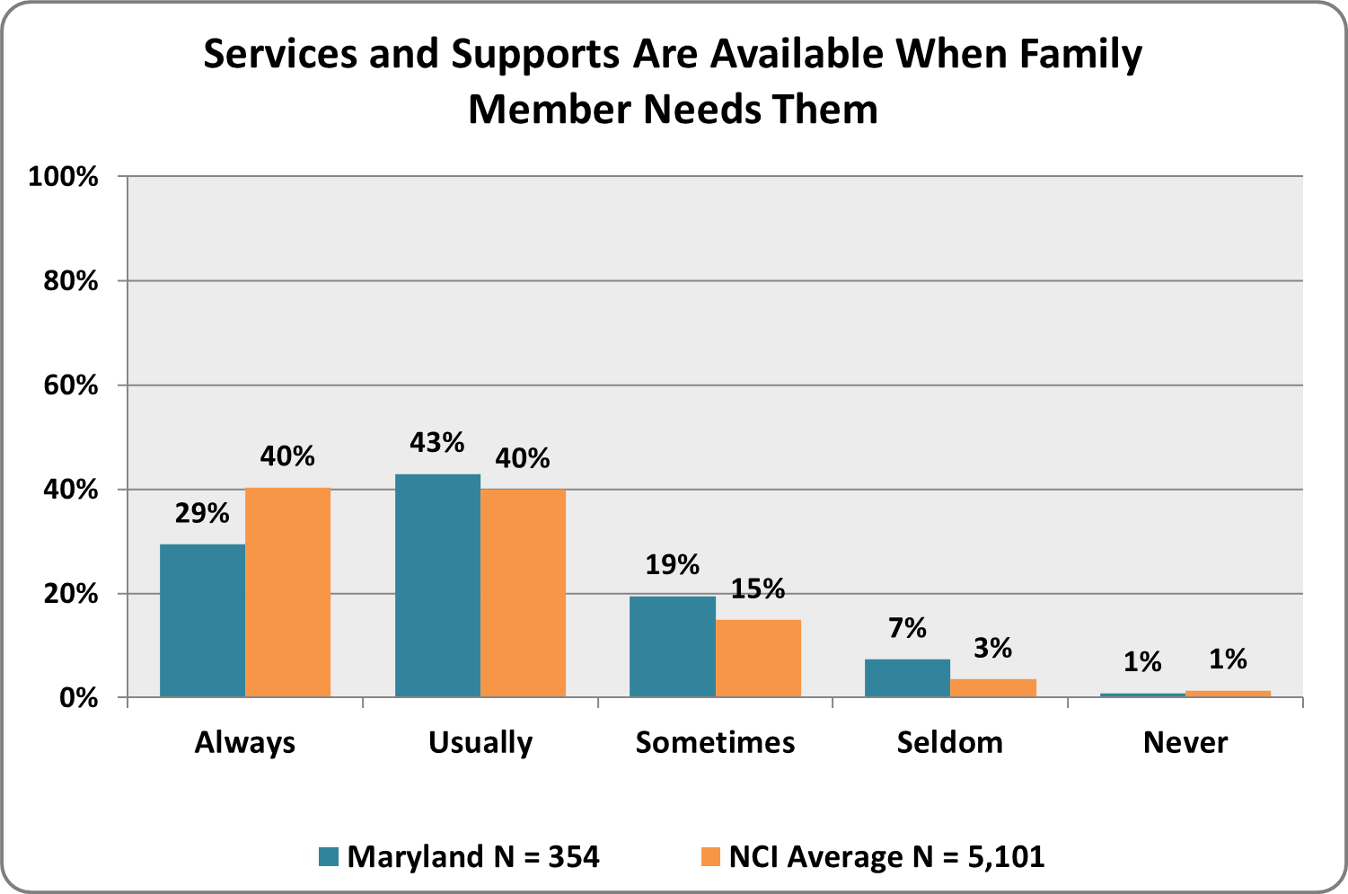 | Graph 39. Are services and supports available within a reasonable distance from your home?  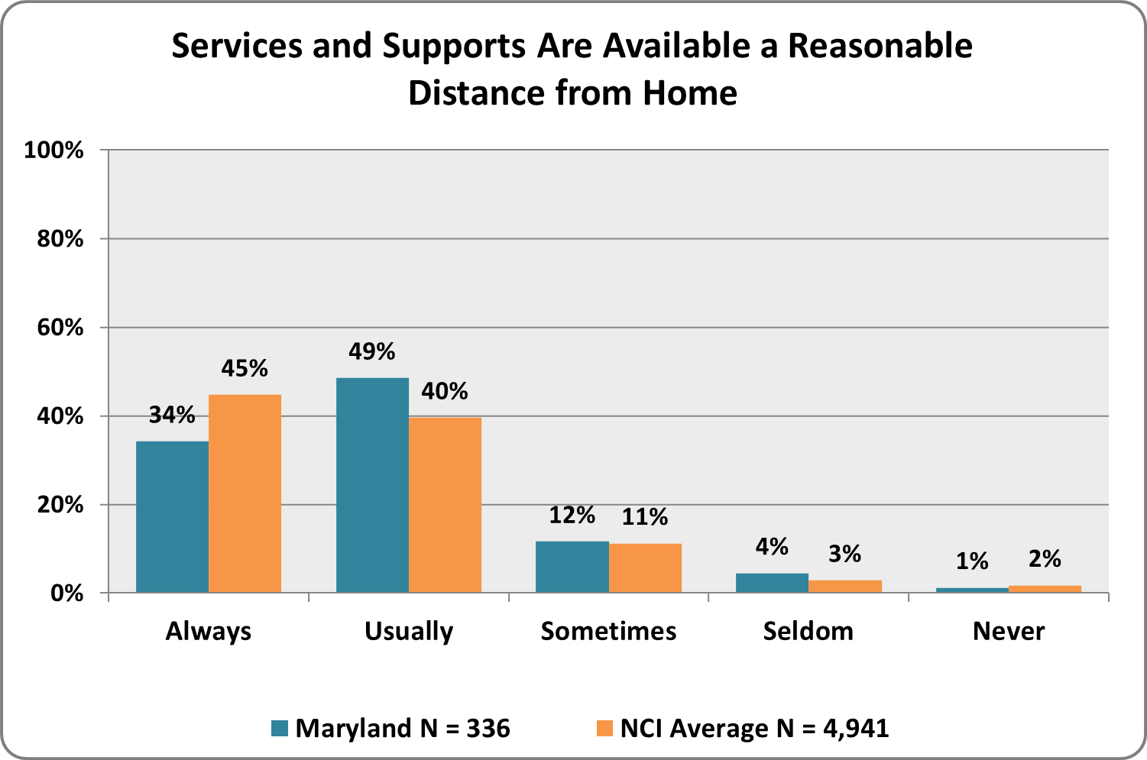
Graph 40. Do the services and supports change when your family member’s needs change?  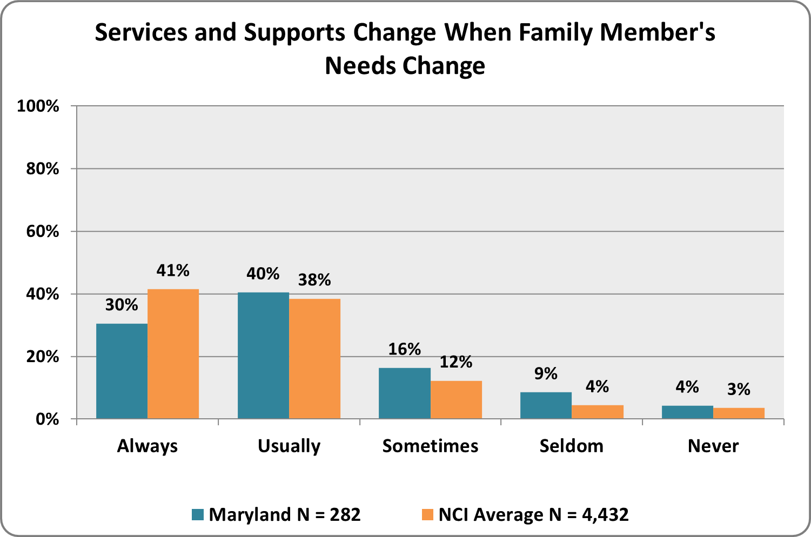 | Graph 41. If English is your primary language, do support workers speak to you effectively?  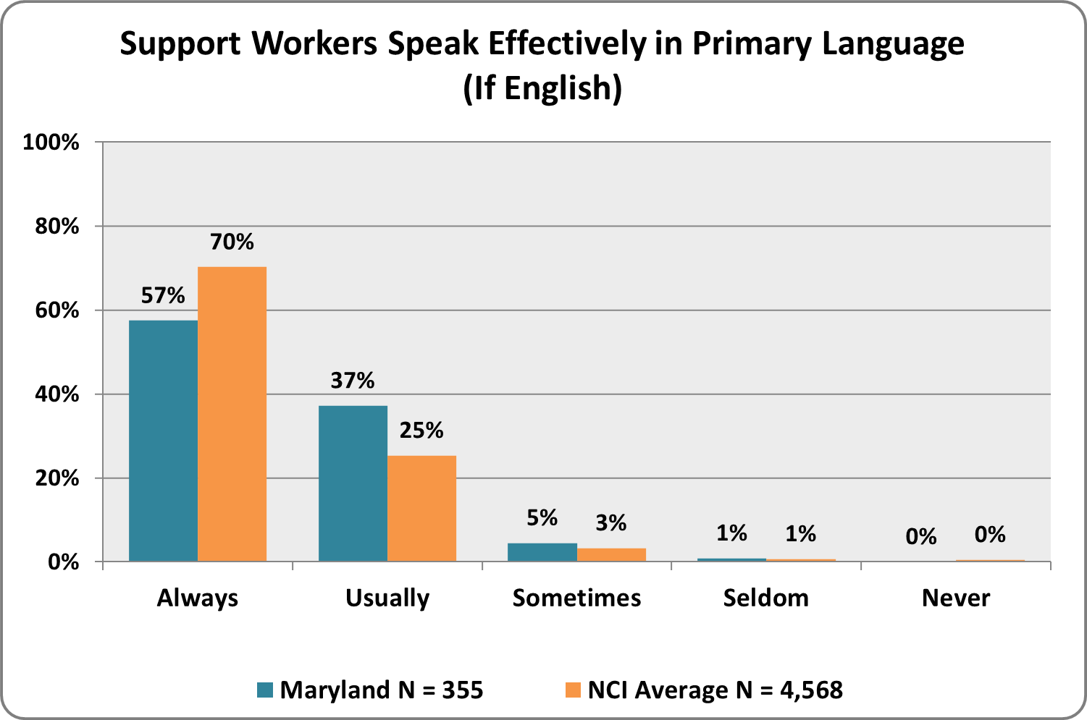
graph 42. If your family member does not communicate verbally (for example, uses gestures or sign language), are there support workers who can communicate with him/her?  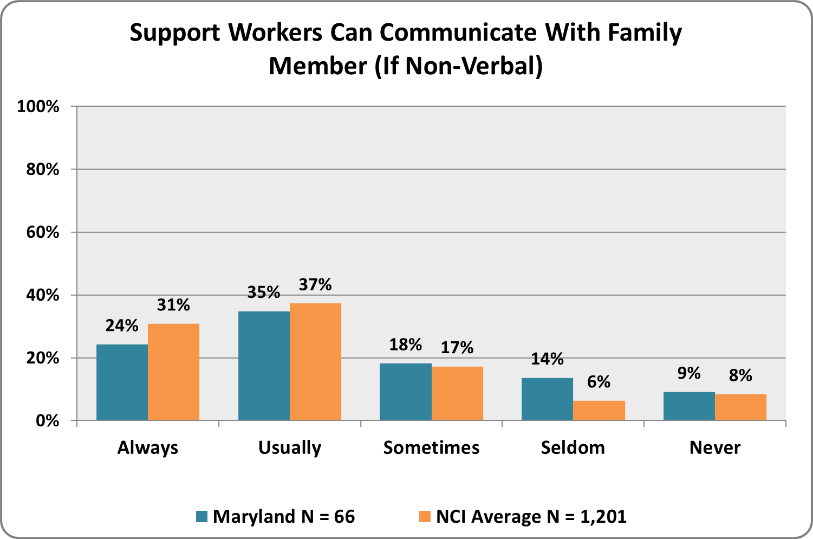 | Graph 43. Are services delivered in a way that is respectful to your family’s culture?  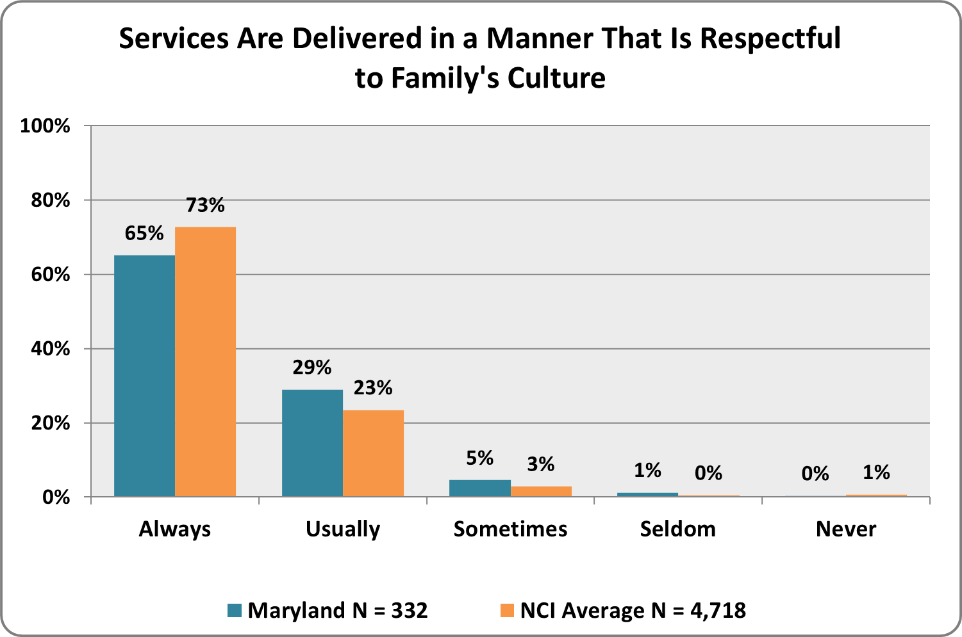
Graph 44. Does your family member have access to the special equipment or accommodations that s/he needs (for example, wheelchair, ramp, communication board)?  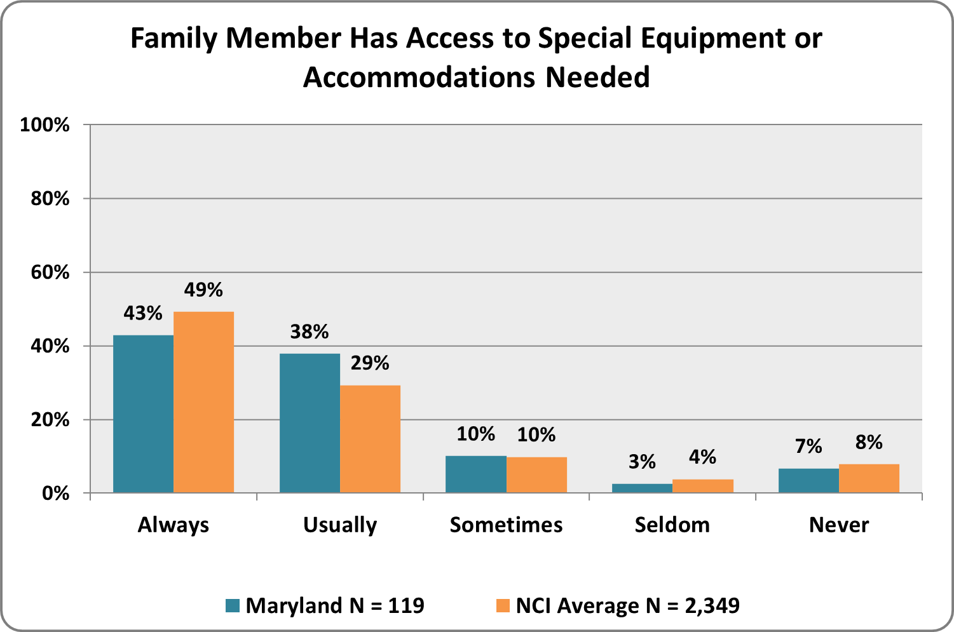 | Graph 45. Do you feel that your family member’s day/employment setting is a healthy and safe environment?  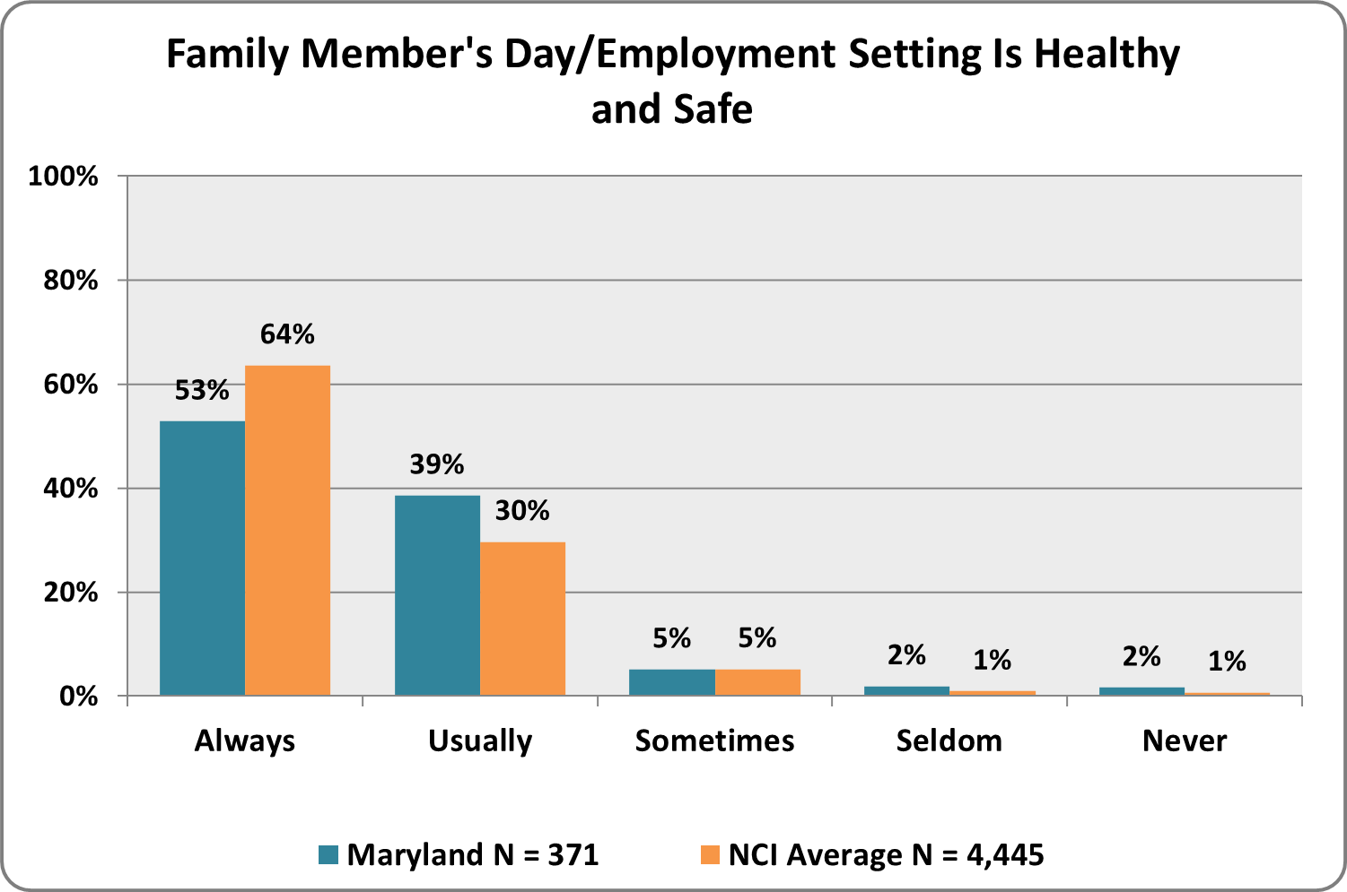
Graph 46. Do support workers have the right training to meet your family’s needs?  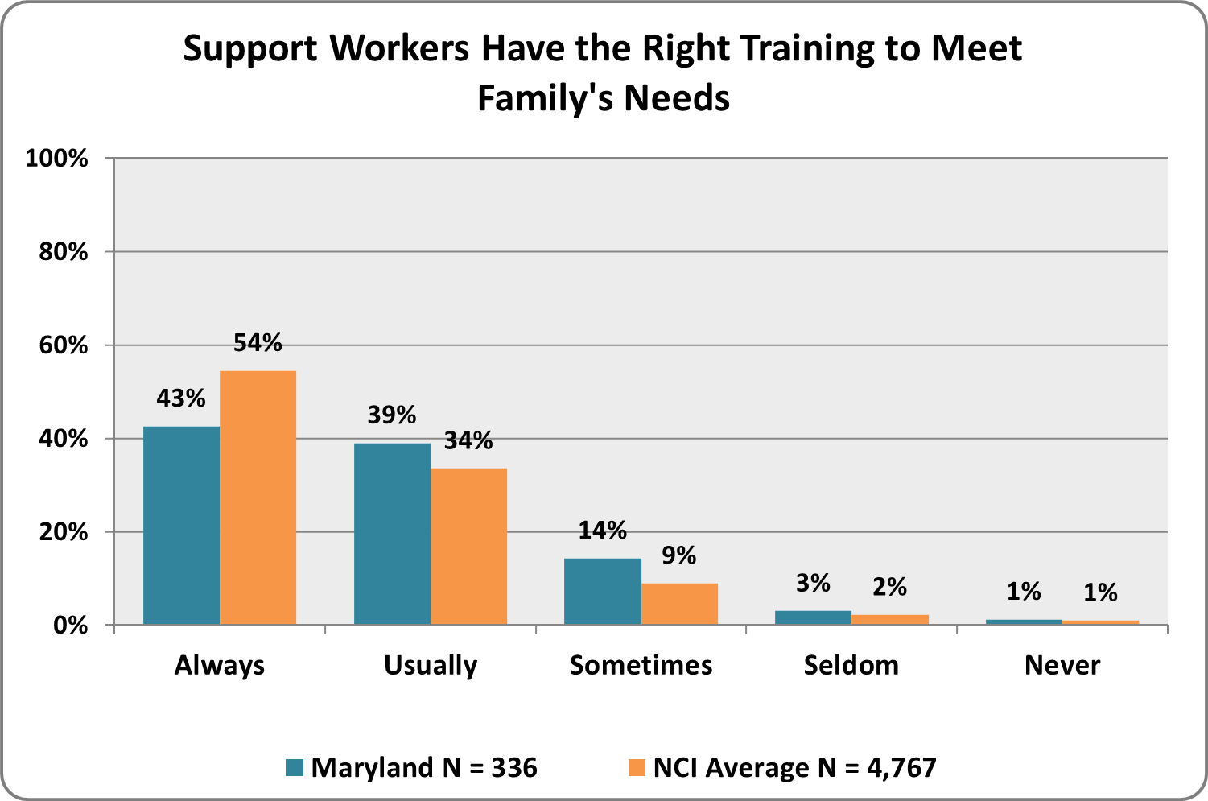 | Graph 47. Do the support workers who come to your home arrive on time and when scheduled?  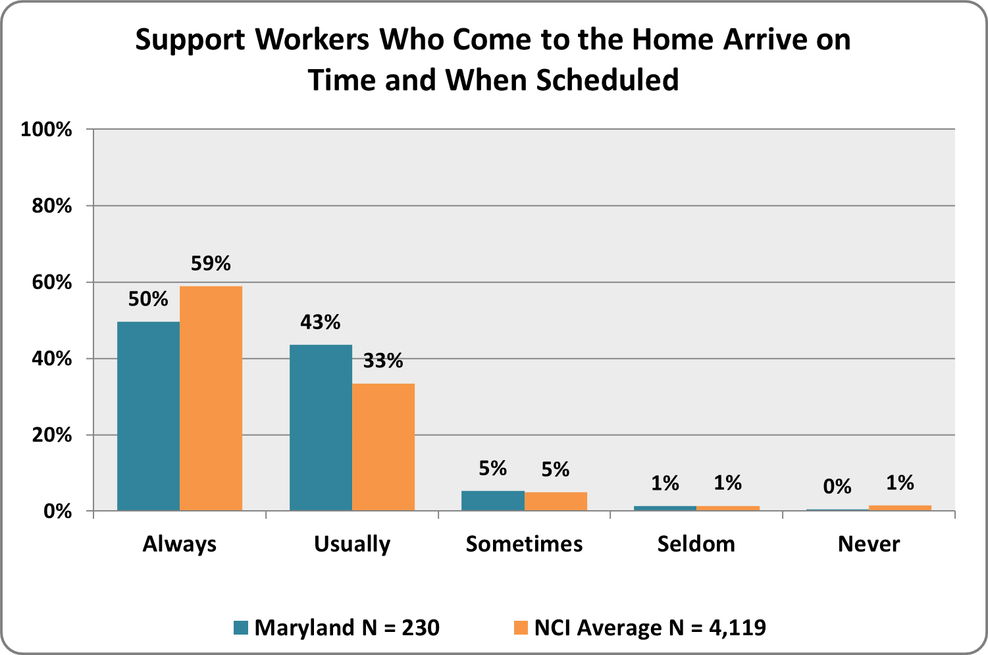
Graph 48. If your family member transitioned from school services to state funded services in the past year, were you happy with the transition process?  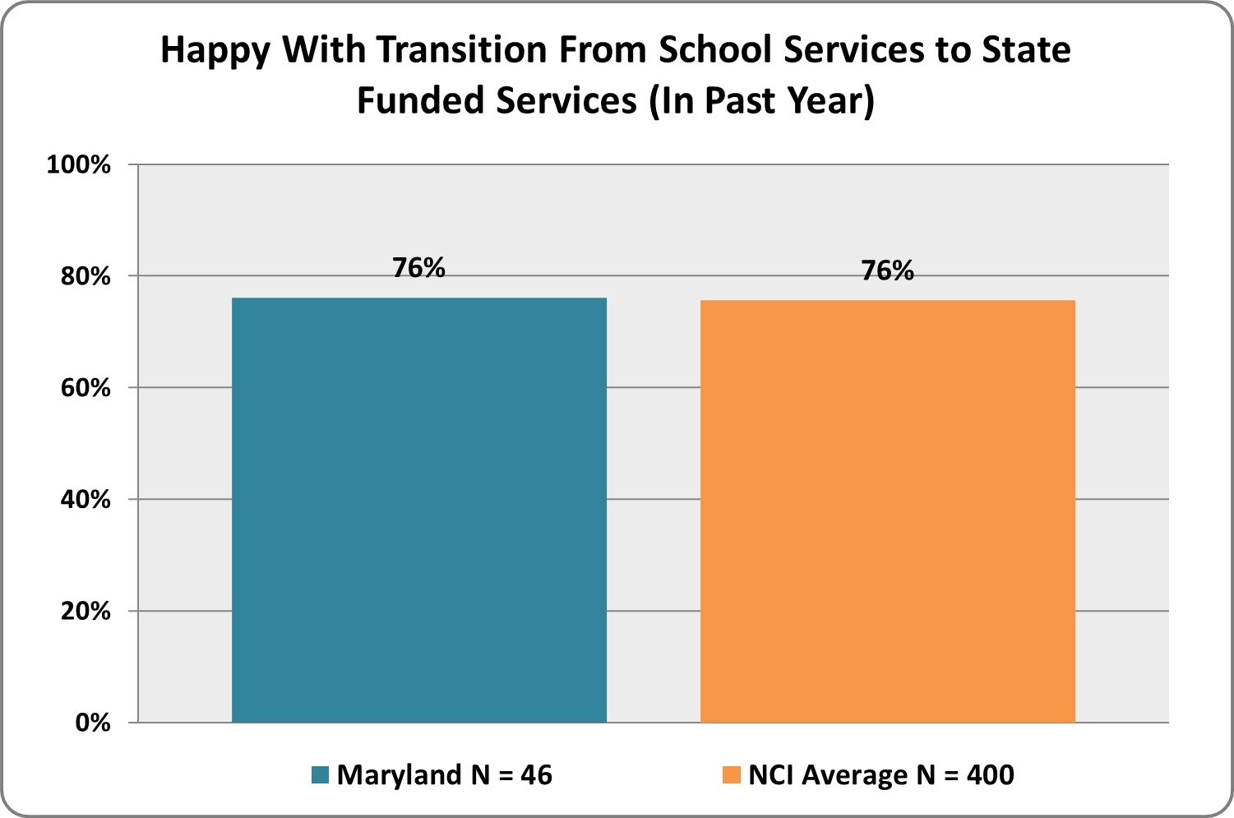 |  |  |  |  | Graph 49. If you asked for crisis or emergency services in the past year, were services provided when needed?  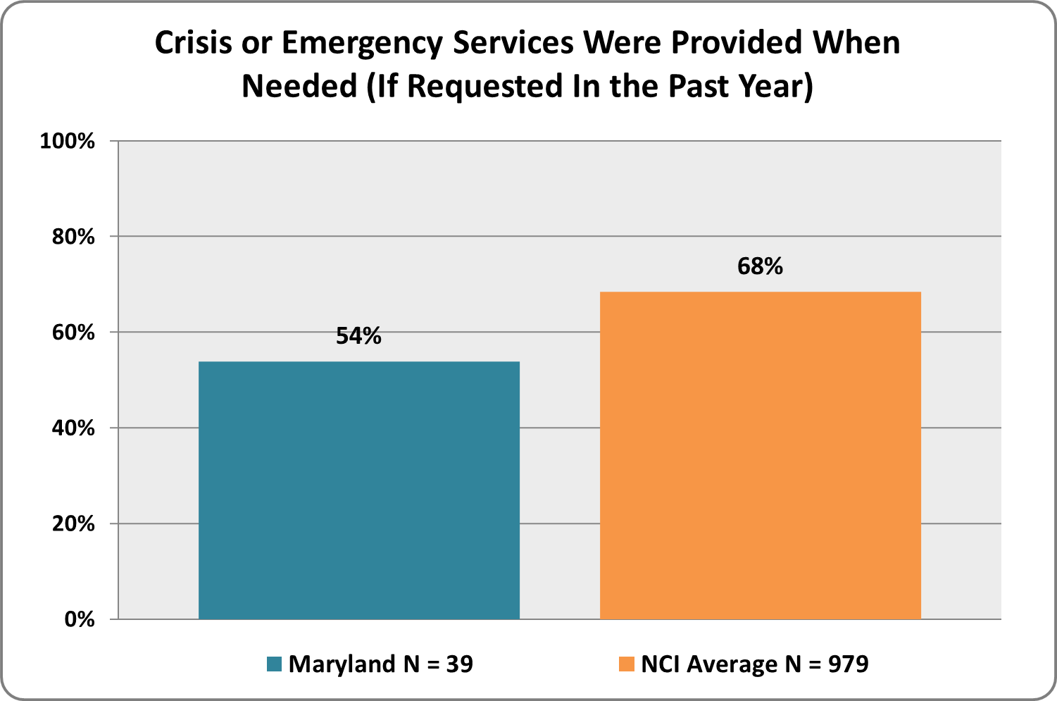
 | Graph 50. Do you have access to health services for your family member?  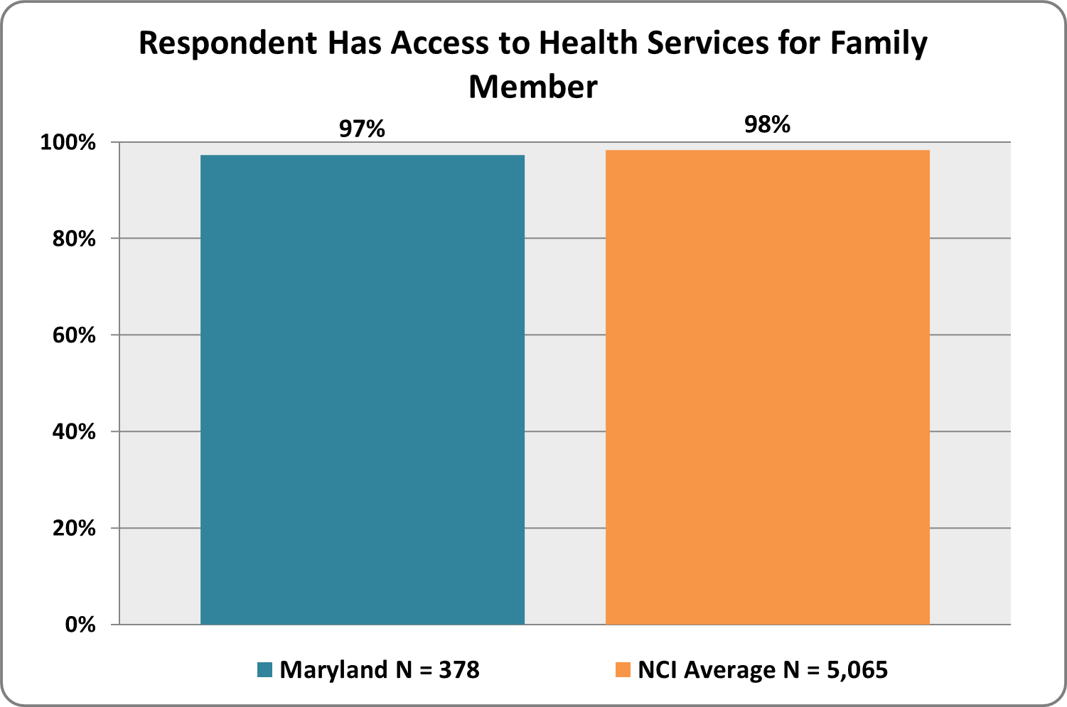 |  |  |  |  | Graph 51. If you have access to health services for your family member, are you satisfied with the quality of those providers?  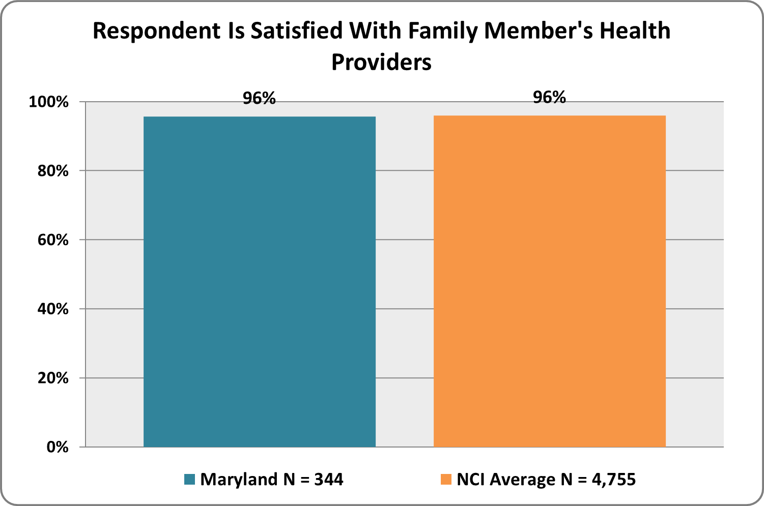
 |  |  | Graph 52. Do you have access to dental services for your family member?  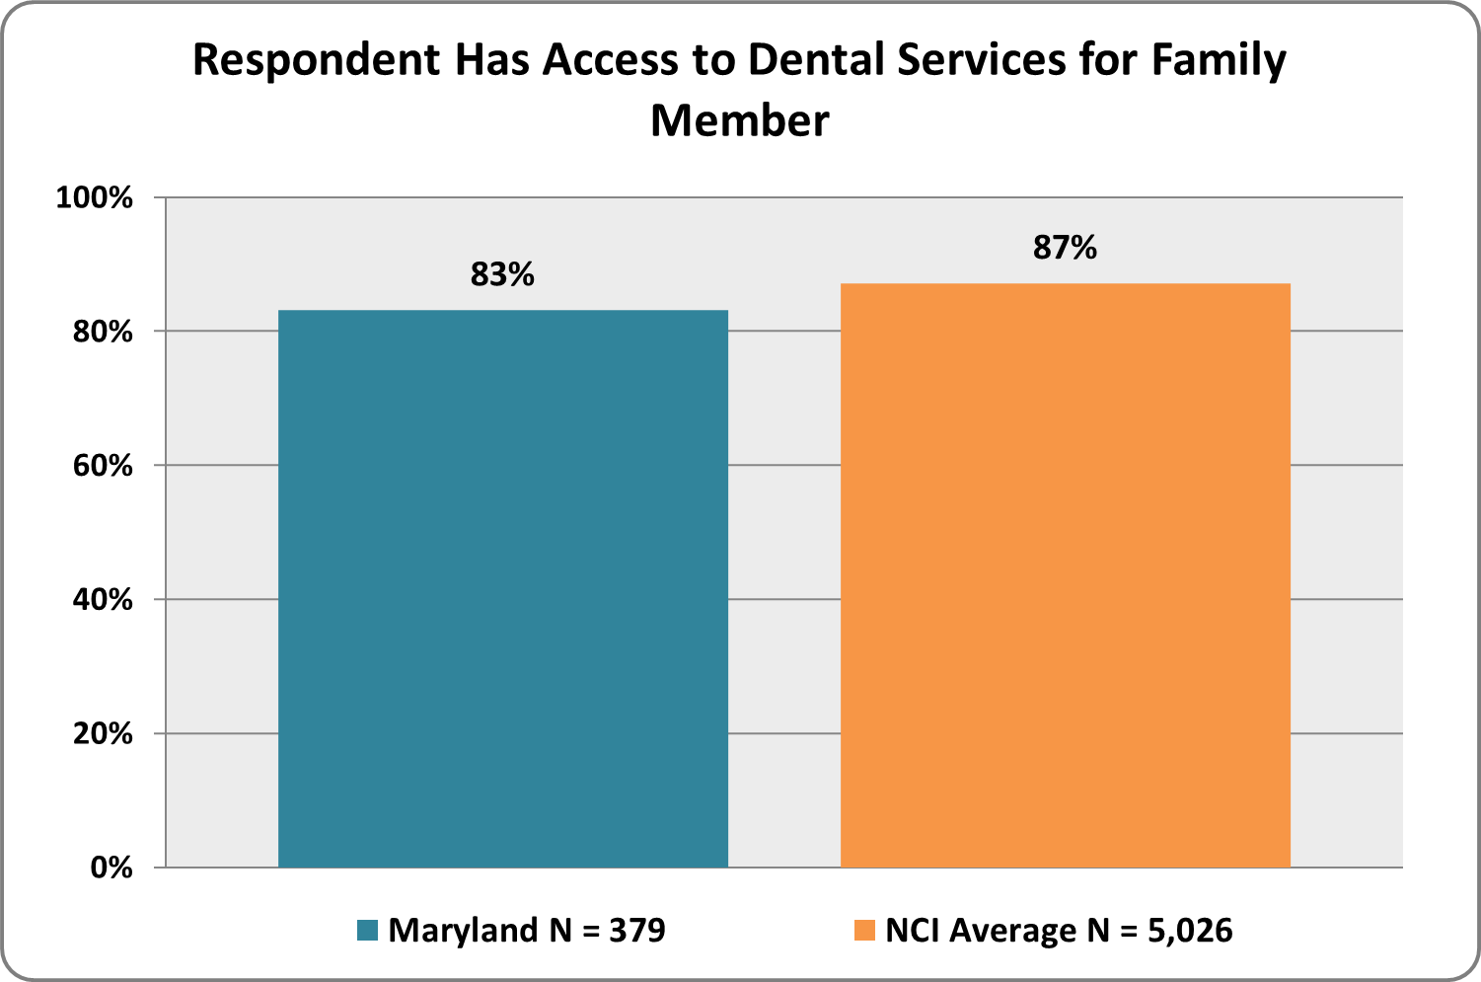 |  |  |  |  | Graph 53. If you have access to dental services for your family member, are you satisfied with the quality of those providers?  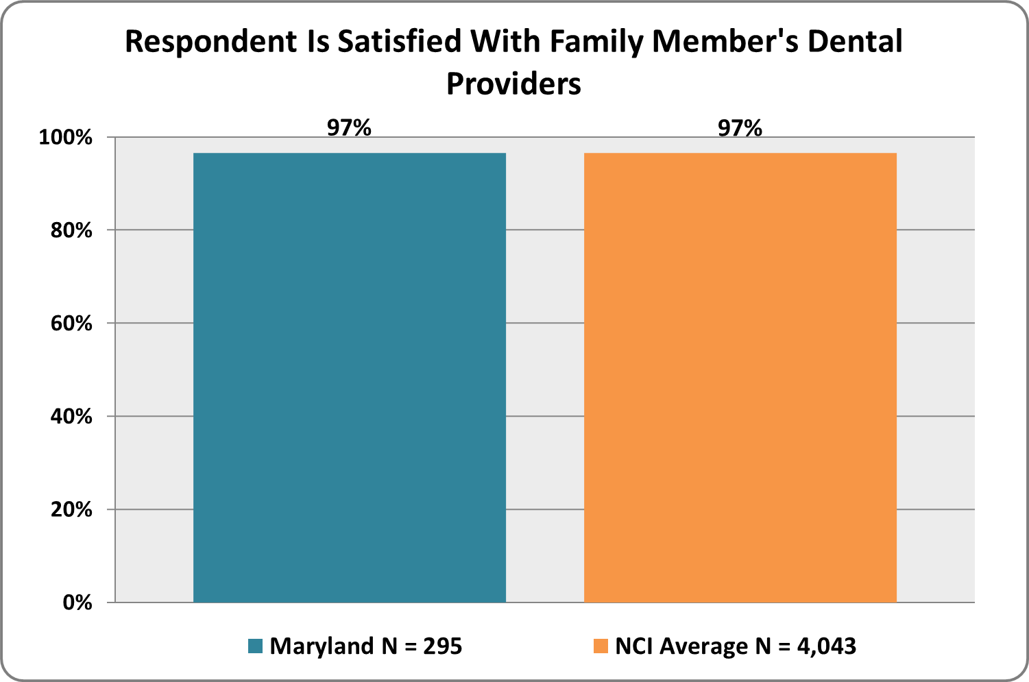
 |  |  | Graph 54. Are you able to get medications needed for your family member?  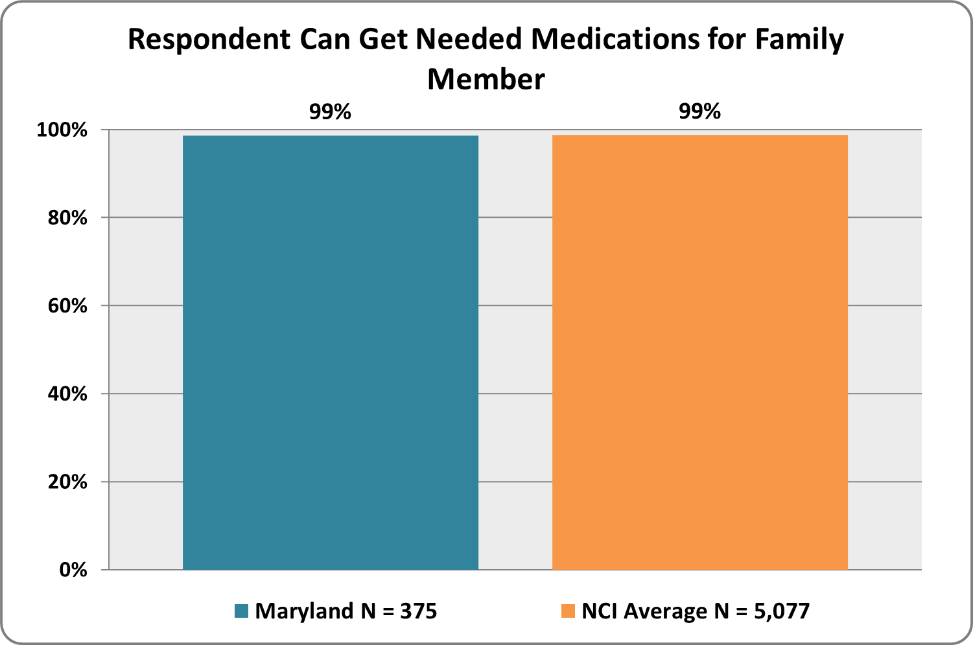 |  |  |  |  | Graph 55. If you are able to get medications needed for your family member, are you satisfied with how your family member’s medication needs are monitored?  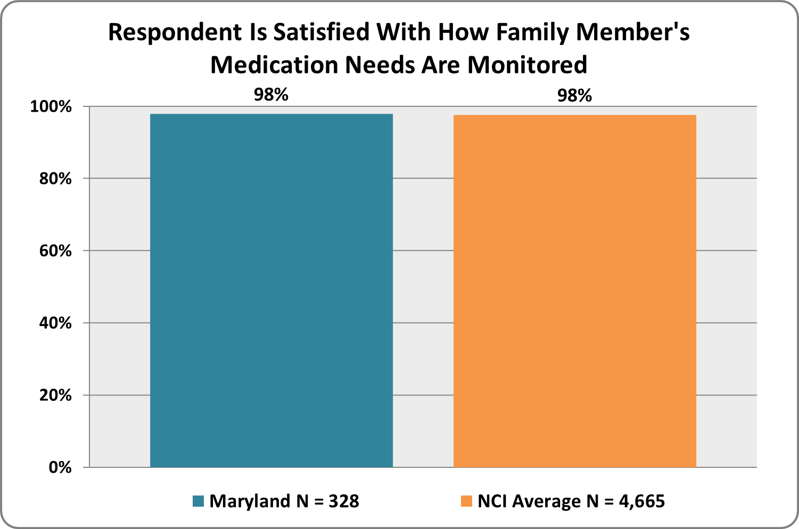
 |  |  |  | Graph 56. If needed, do you have access to mental health services for your family member?  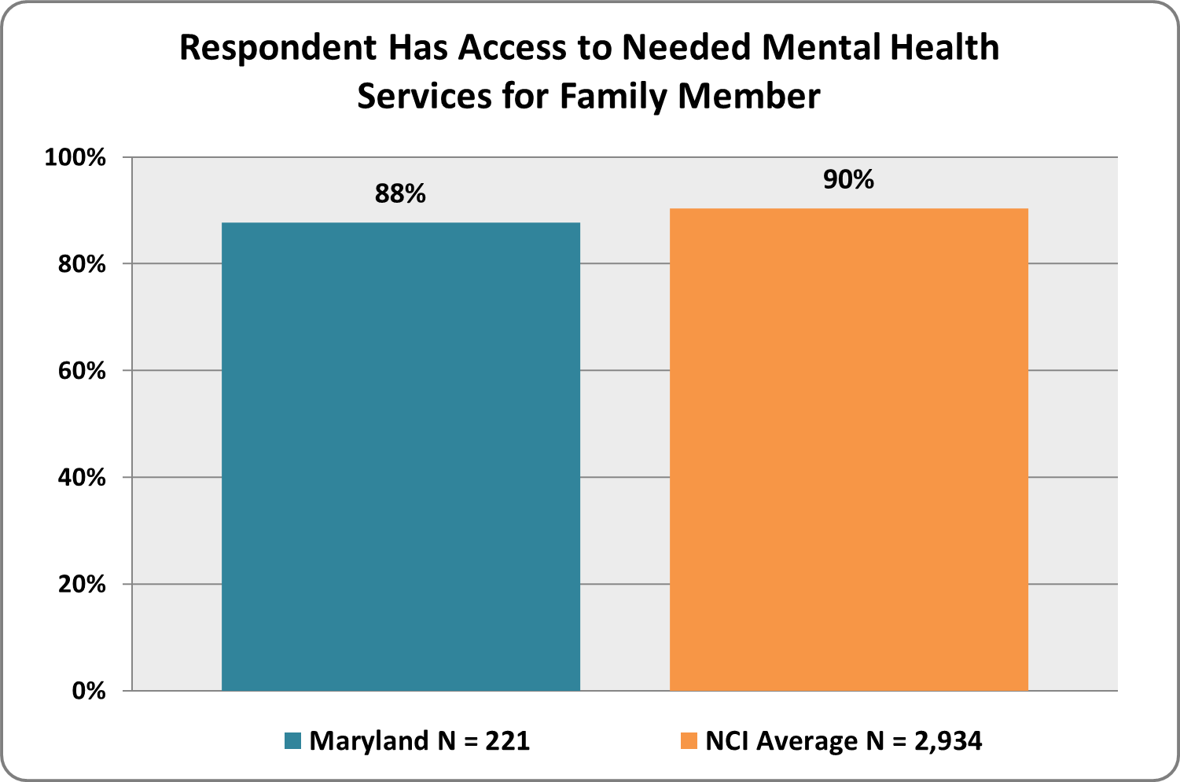 |  |  |  |  | Graph 57. If you have access to mental health services needed for your family member, are you satisfied with the quality of those providers?  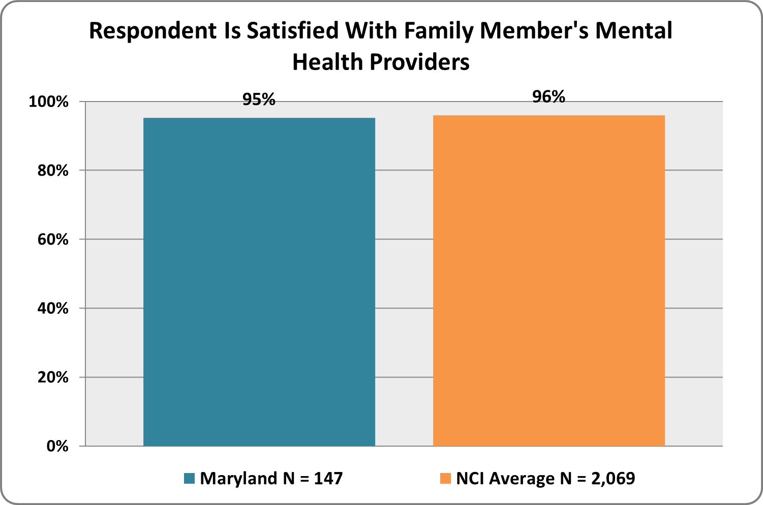
 |  |  |  | Graph 58. If you need respite services, do you have access to them?  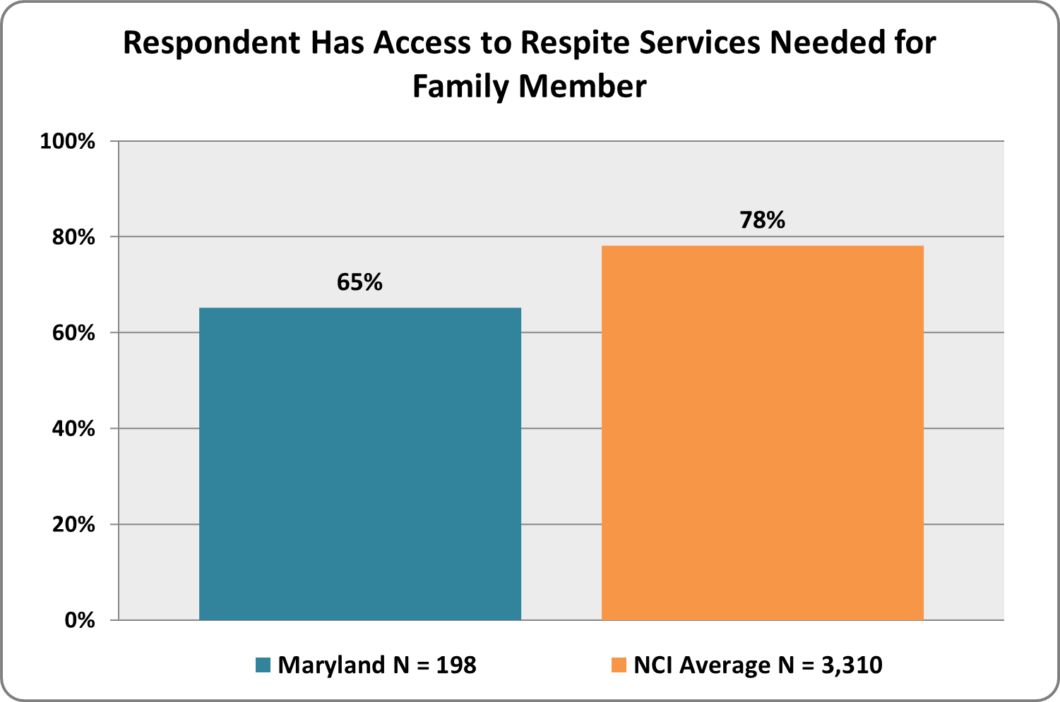 |  |  |  |  | Graph 59. If you have access to respite services, are you satisfied with the quality of those providers?  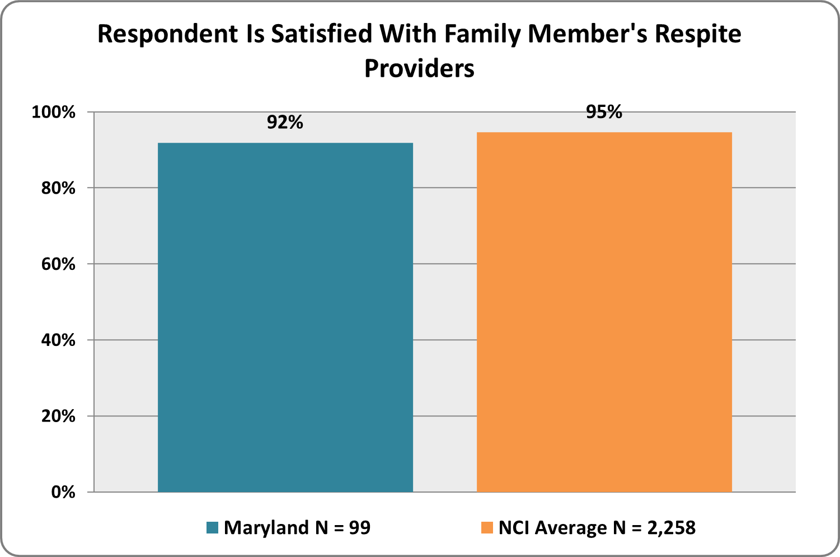

Graph 60. Are there services your family member needs that are not currently offered or available?
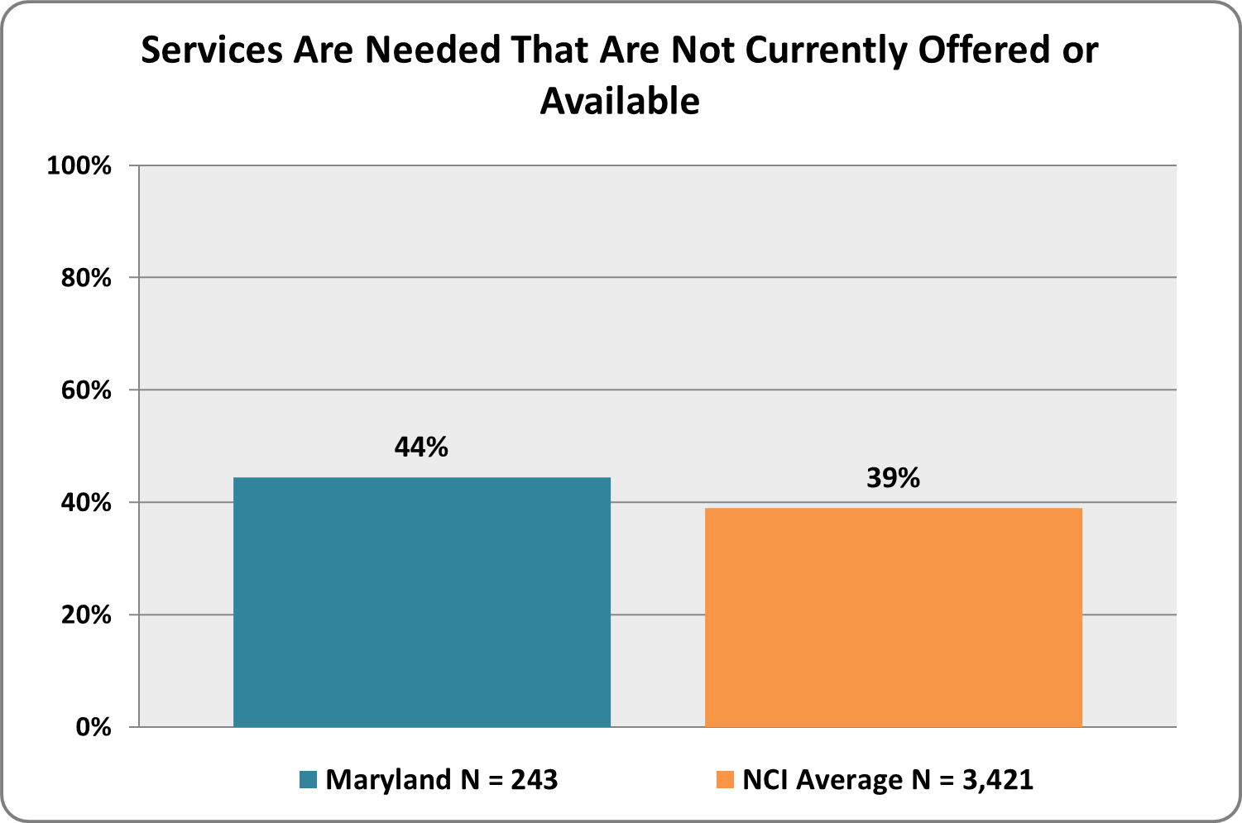

Choice and Control

families and family members with disabilities determine the services and supports they receive and the individuals or agencies who provide them
Graph 61. Do you choose the provider agencies who work with your family?  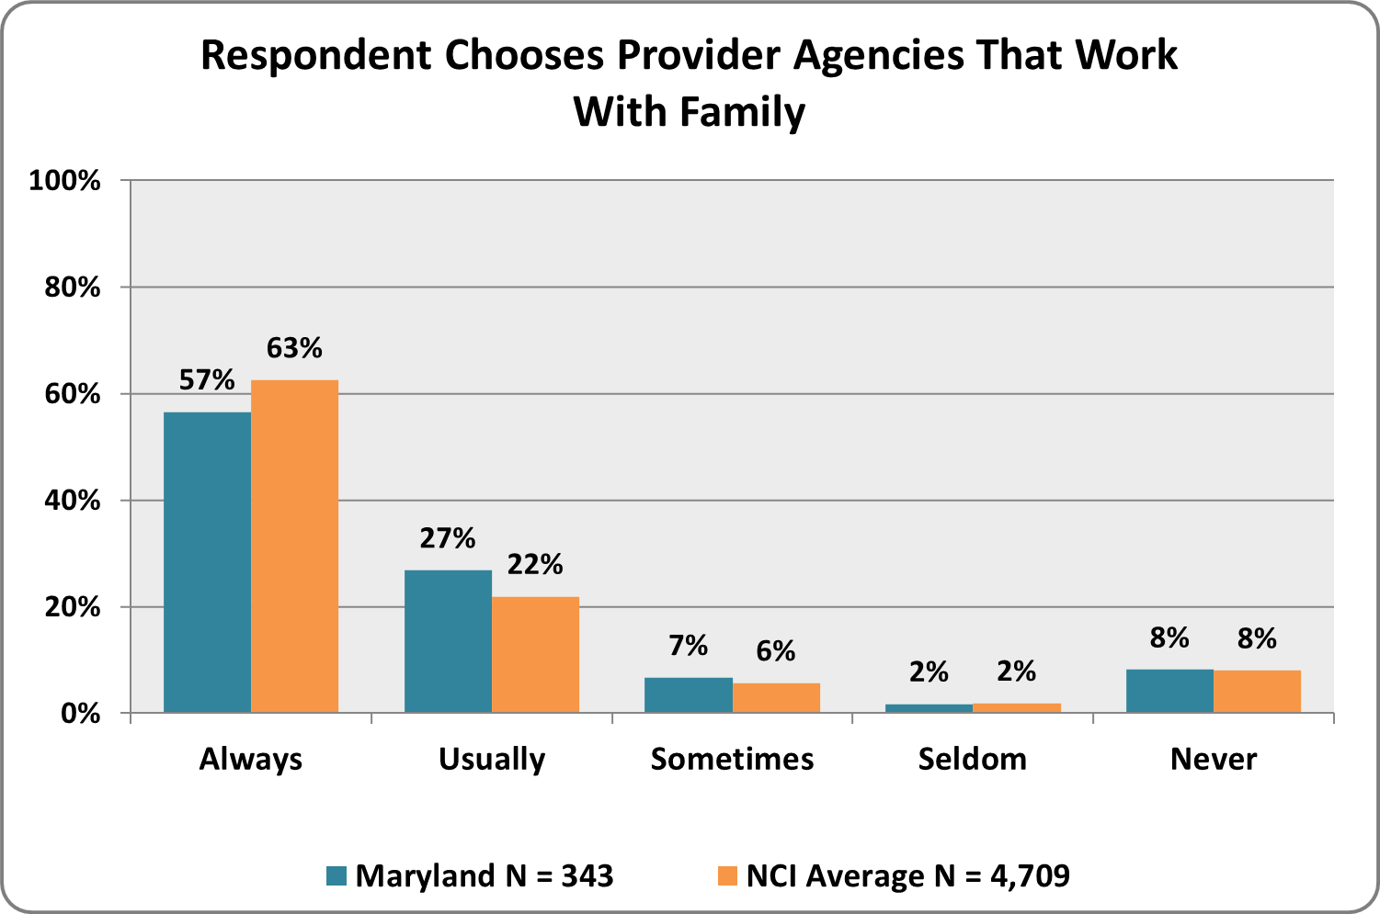 | Graph 62. Does your family member choose the provider agencies who work with your family?  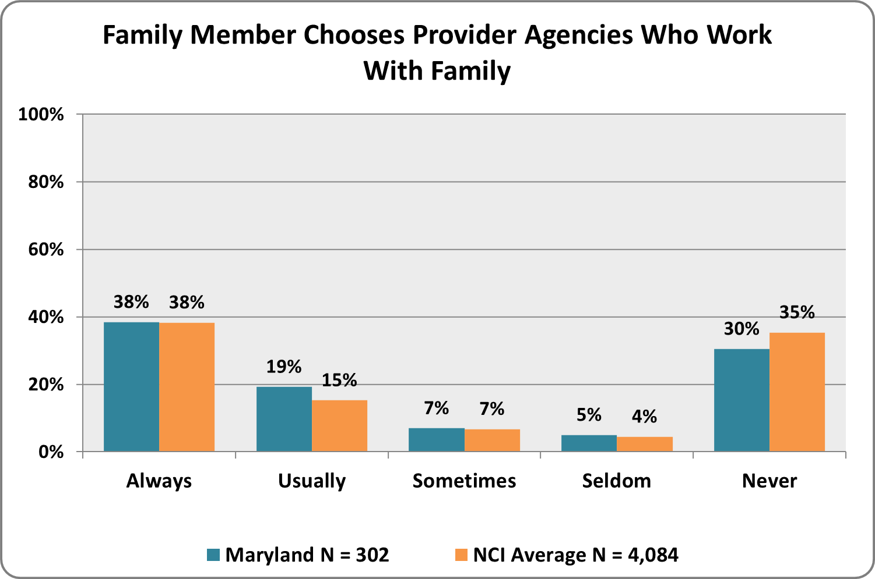
Graph 63. Can you choose a different provider agency if you want to?  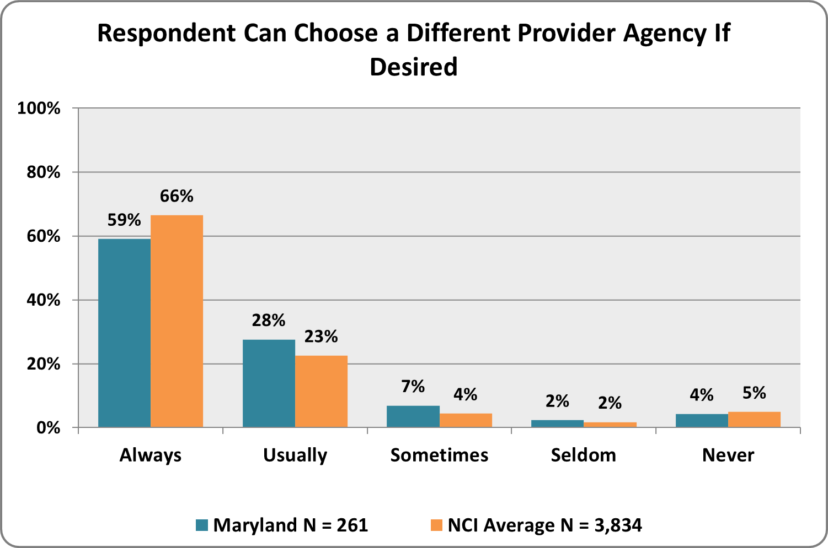 | Graph 64. Do you choose the individual support workers who work directly with your family?  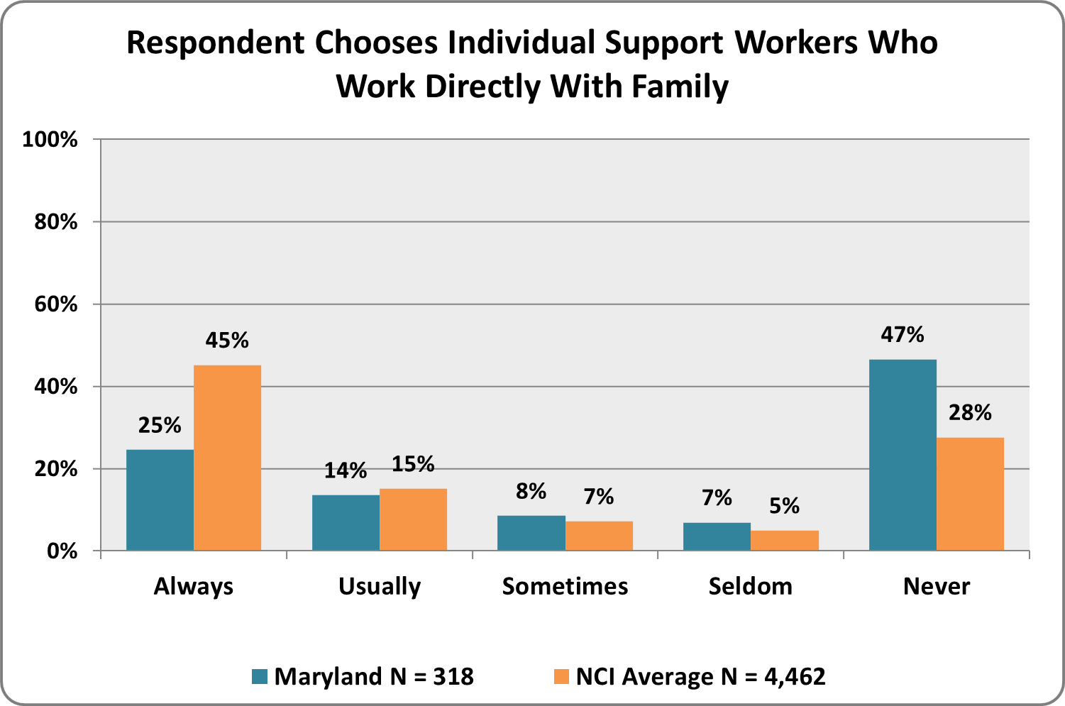

Graph 65. Does your family member choose the individual support workers who work directly with your family?  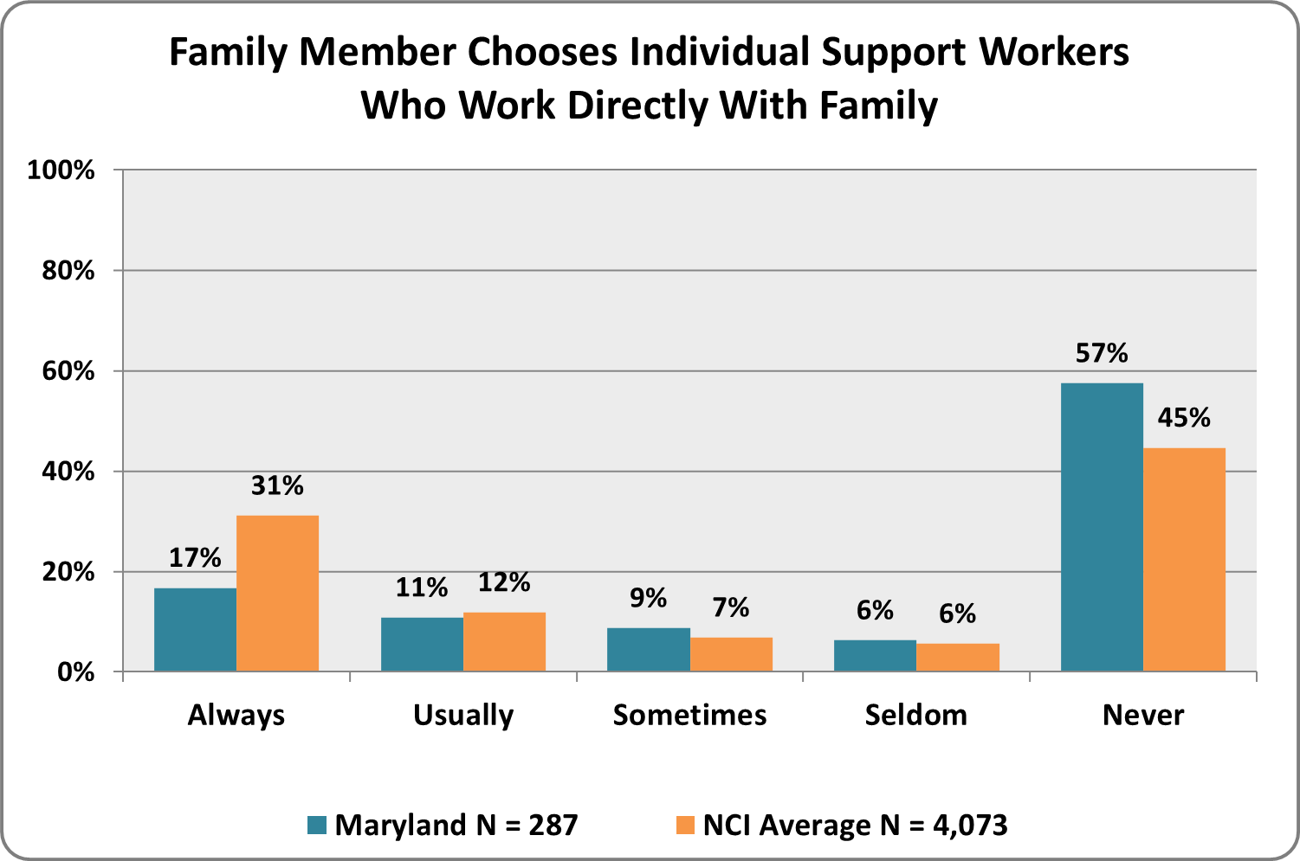 | Graph 66. Can you choose different support workers if you want to?  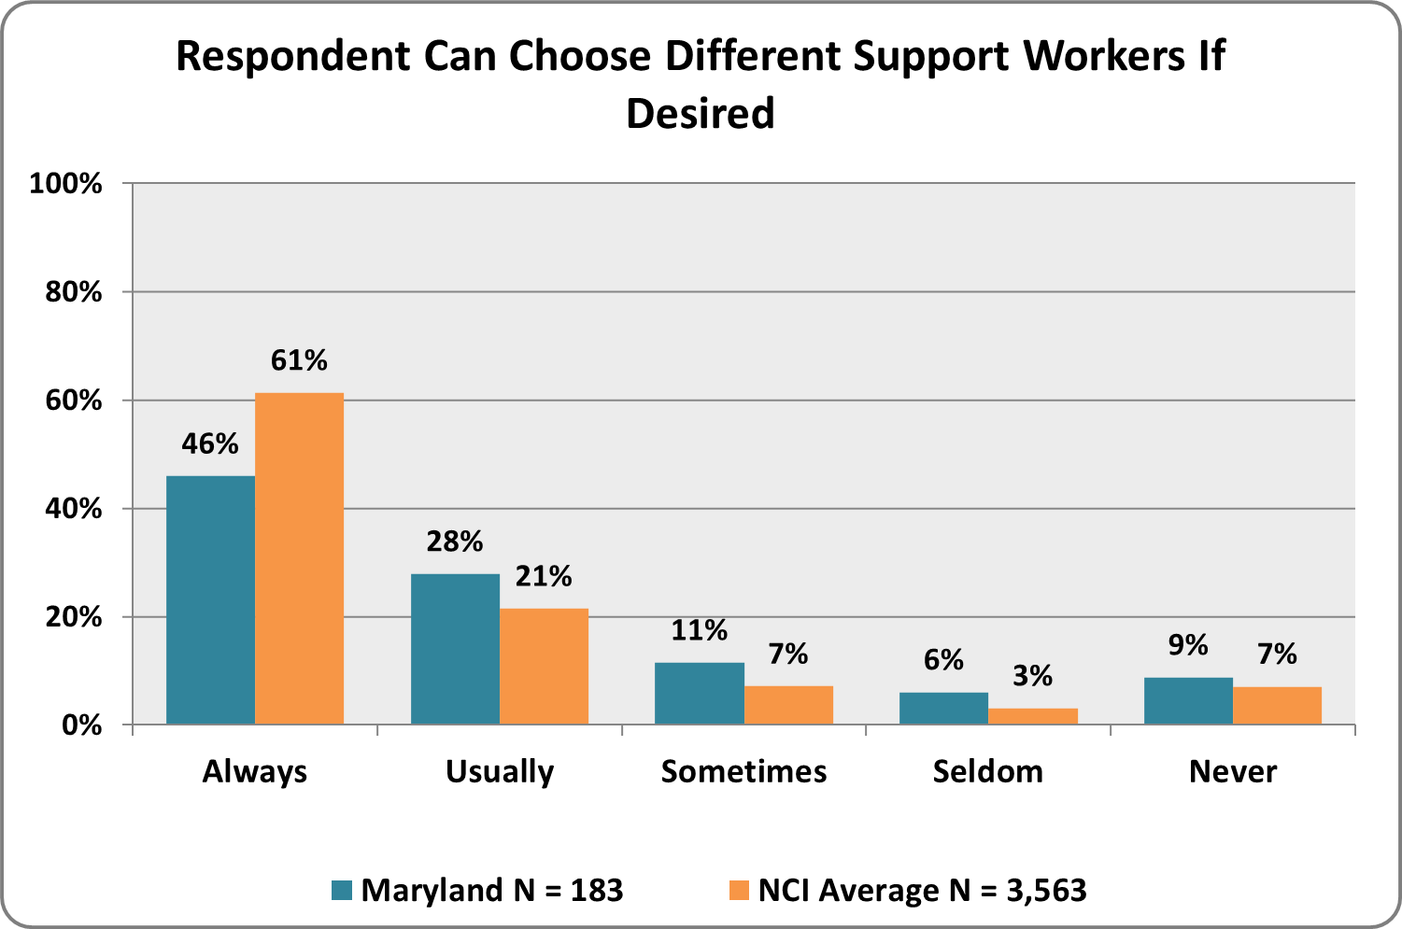
Graph 67. Did you choose your family member’s case manager/service coordinator?  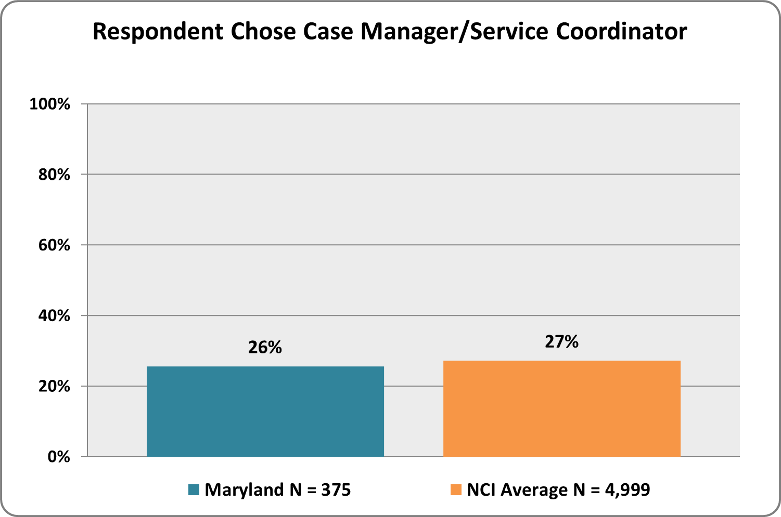 | Graph 68. Did your family member choose his/her case manager/service coordinator?  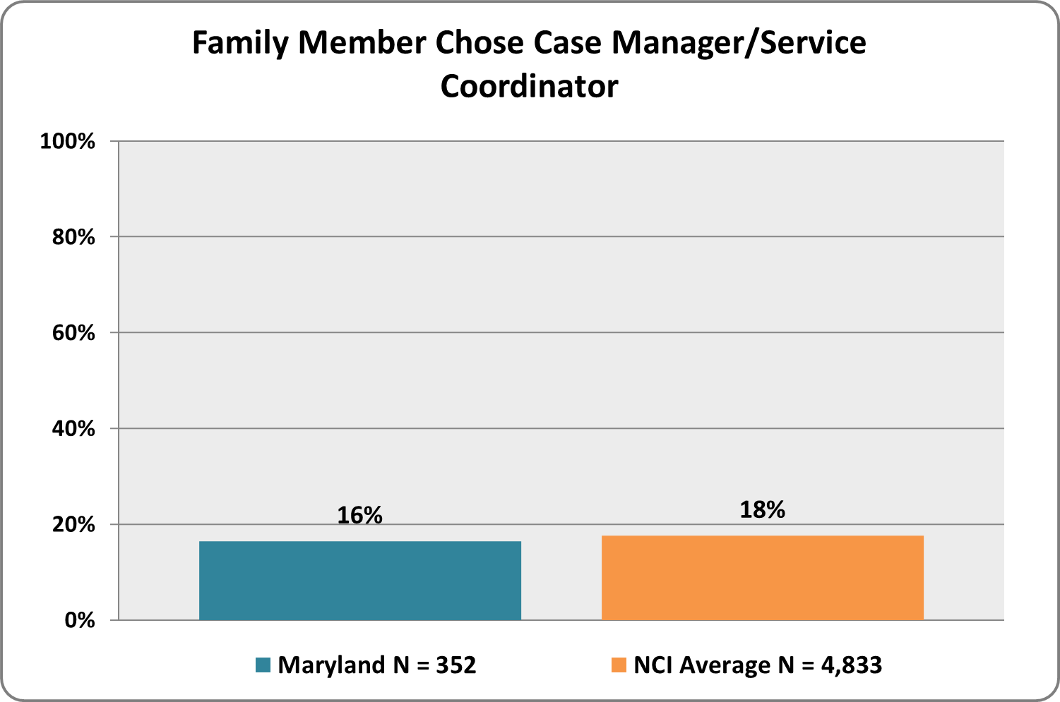

Graph 69. Do you have control and/or input over the hiring and management of your family member’s support workers?  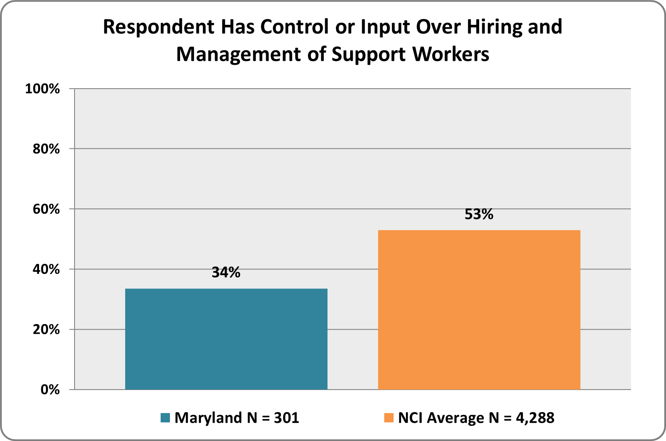 | Graph 70. Does your family member have control and/or input over the hiring and management of his/her support workers?  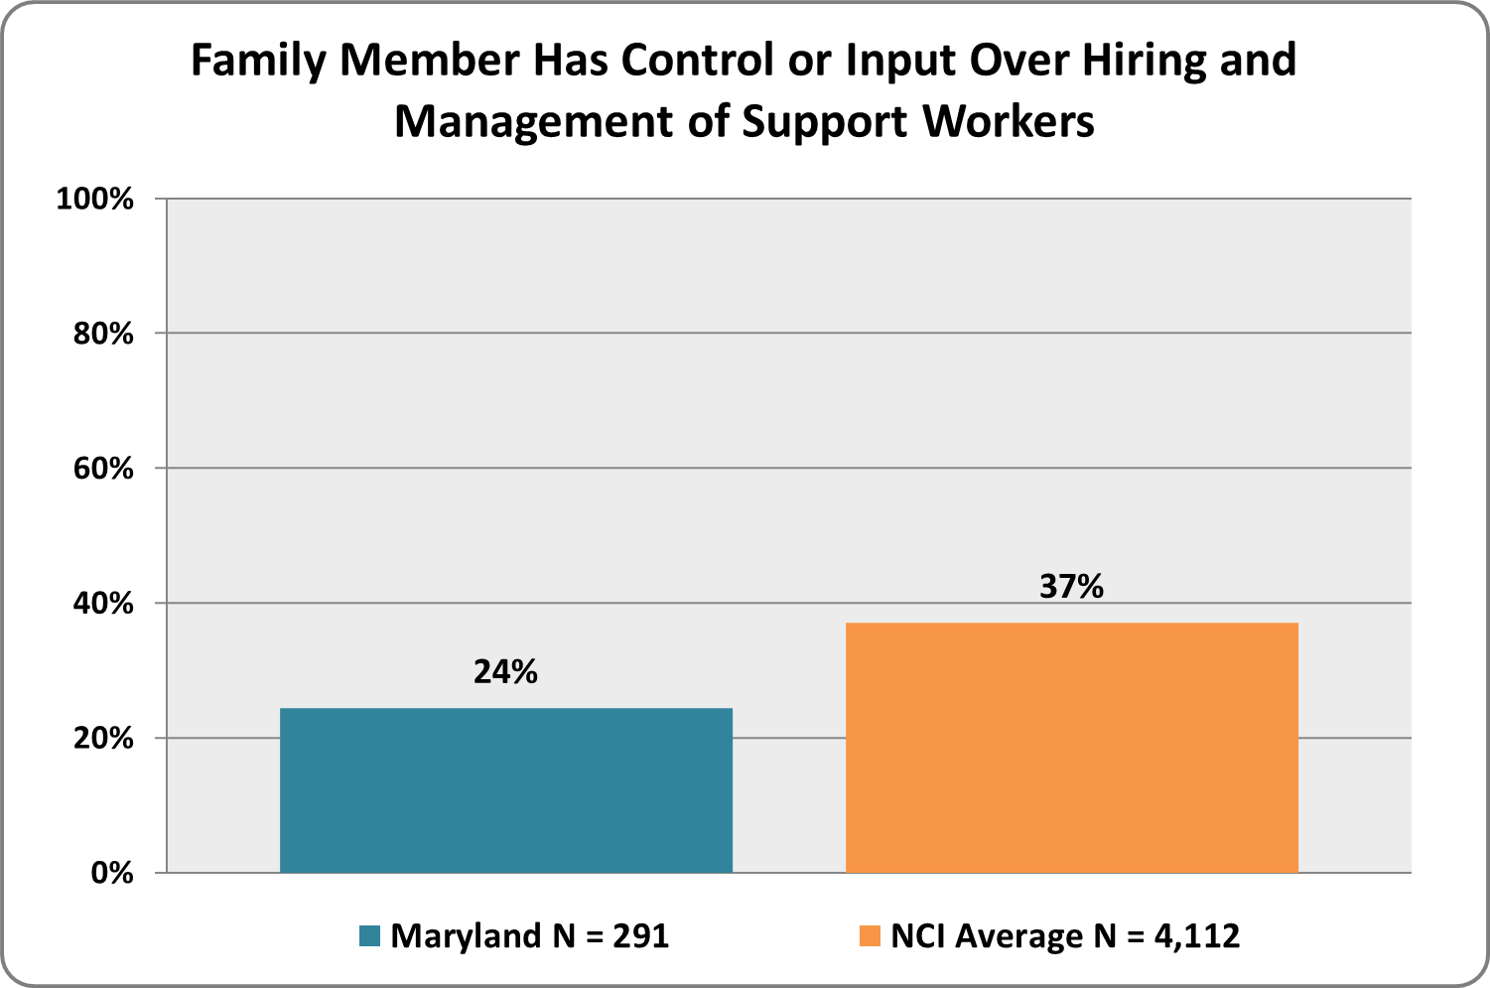
Graph 71. Do you know how much money is spent by the ID/DD agency on behalf of your family member with a developmental disability?*  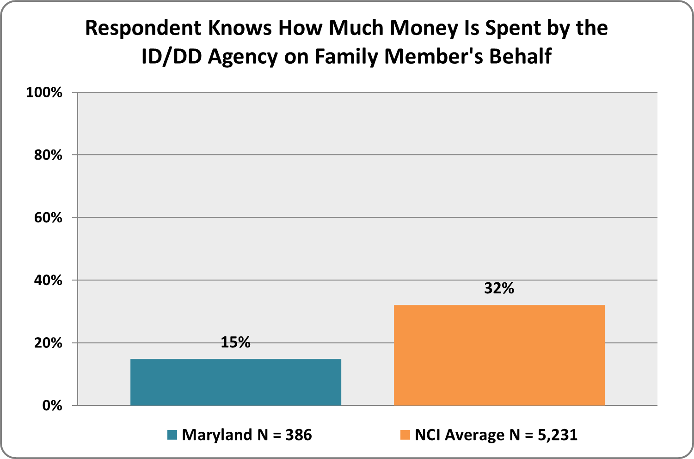 | Graph 72. Does your family member know how much money is spent by the ID/DD agency on his/her behalf?*  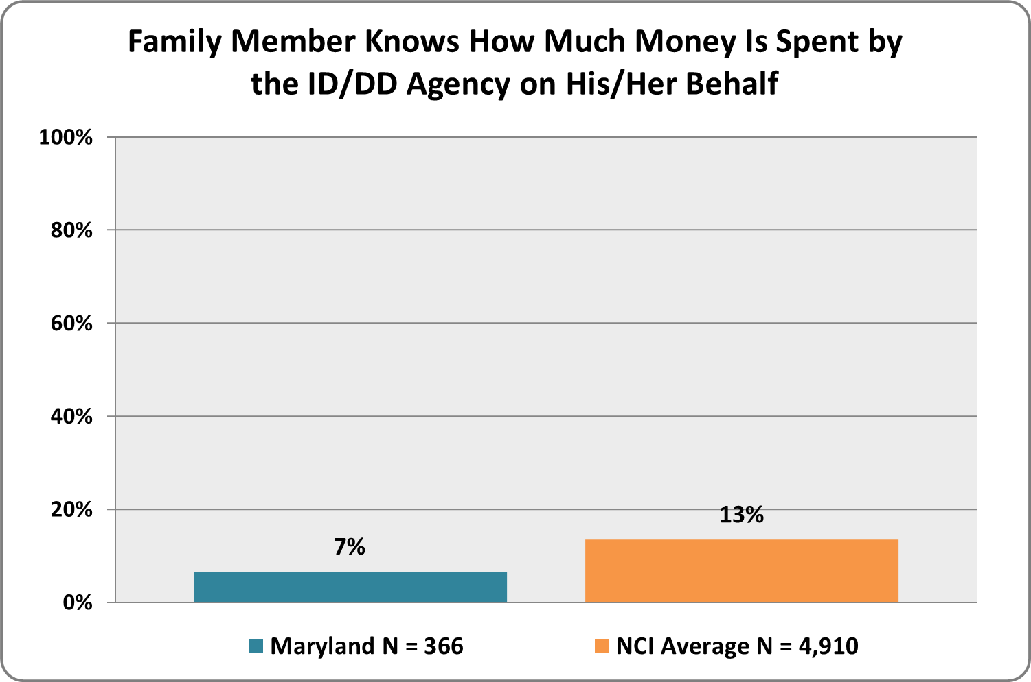
*’Don’t Know’ responses were included in ‘No’ responses for this question.
Graph 73. Do you have a say in how id/dd agency money is spent on your family member’s behalf?  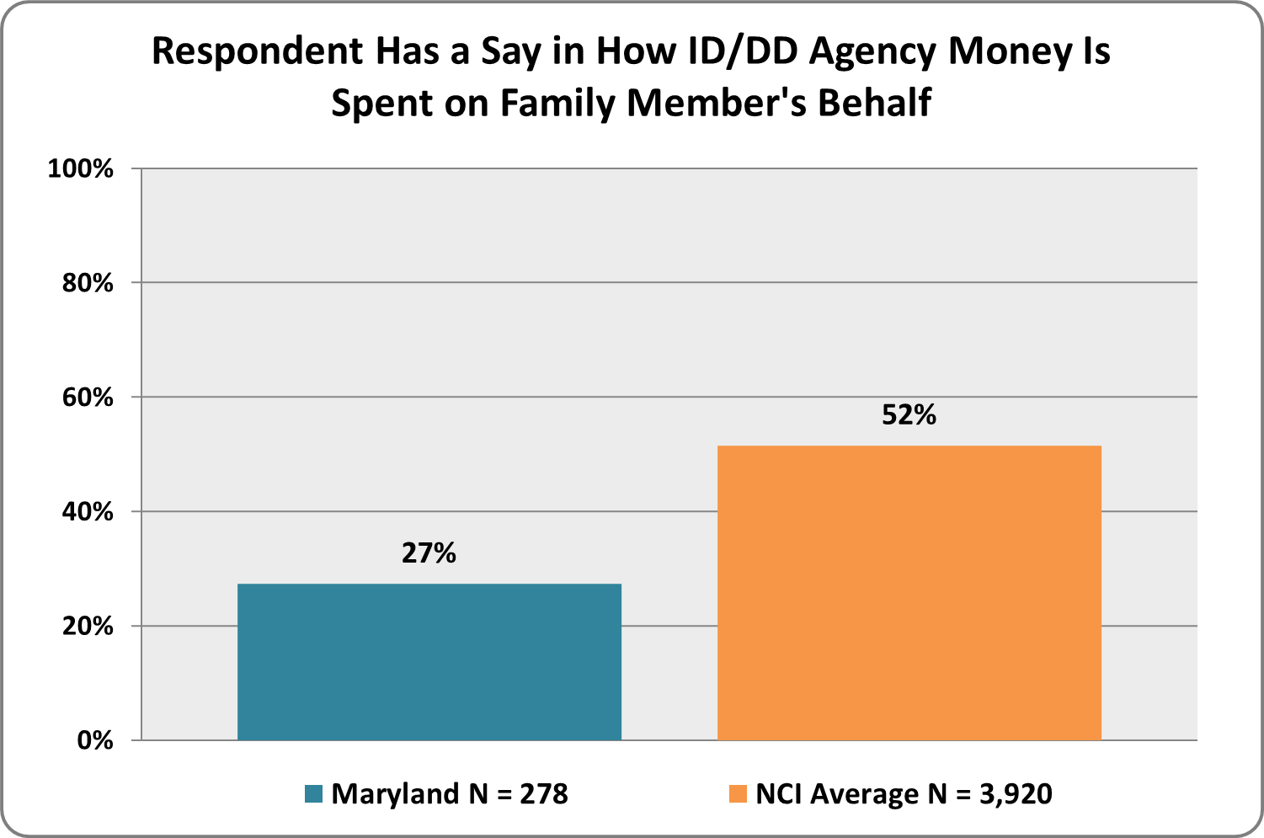 | Graph 74. If you have a say in how ID/DD agency money is spent, do you have all the information you need to make decisions about how to spend this money?  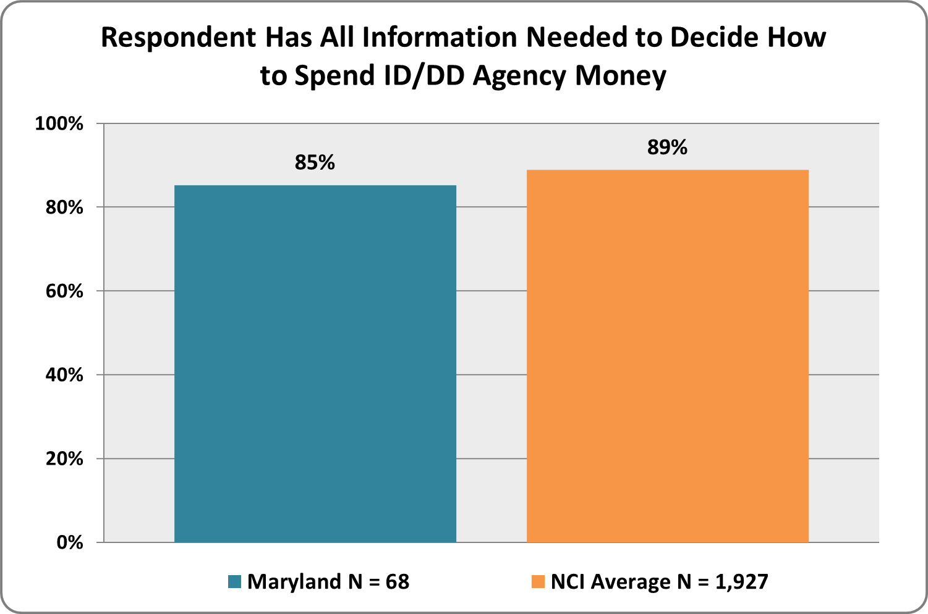
Graph 75. Does your family member have a say in how Id/dd agency money is spent on his/her behalf?  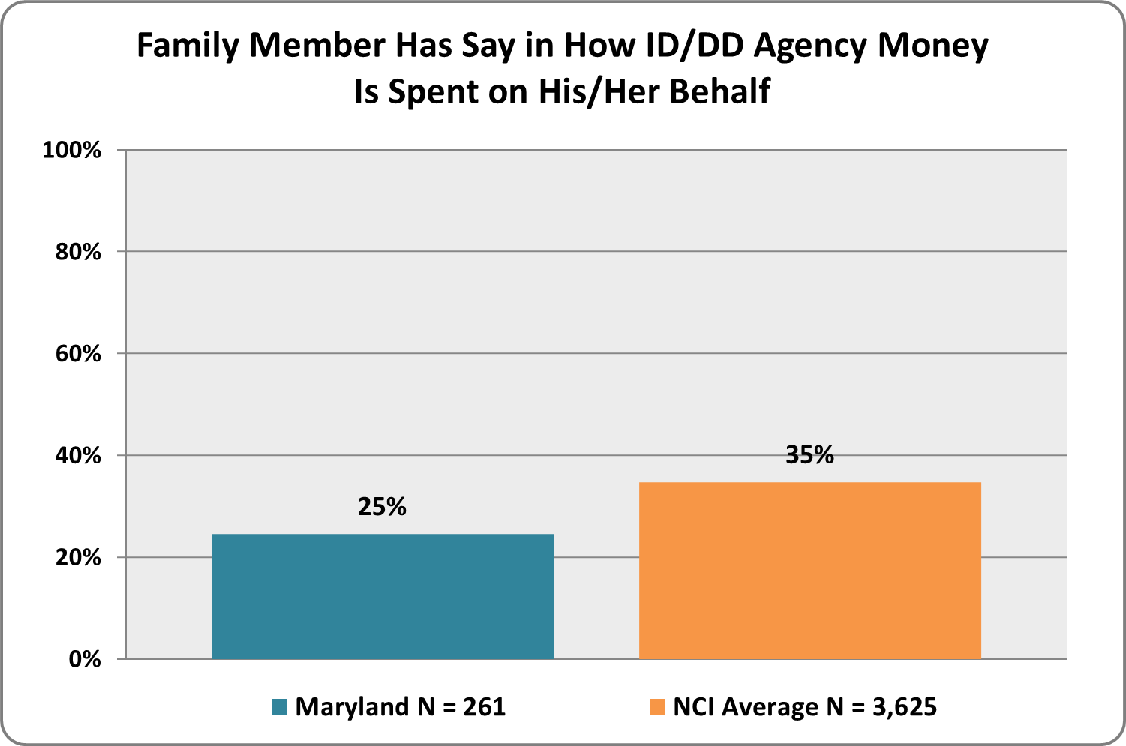 | Graph 76. If your family member has a say in how id/dd agency money is spent, does s/he have all the information needed to make decisions about how to spend this money?  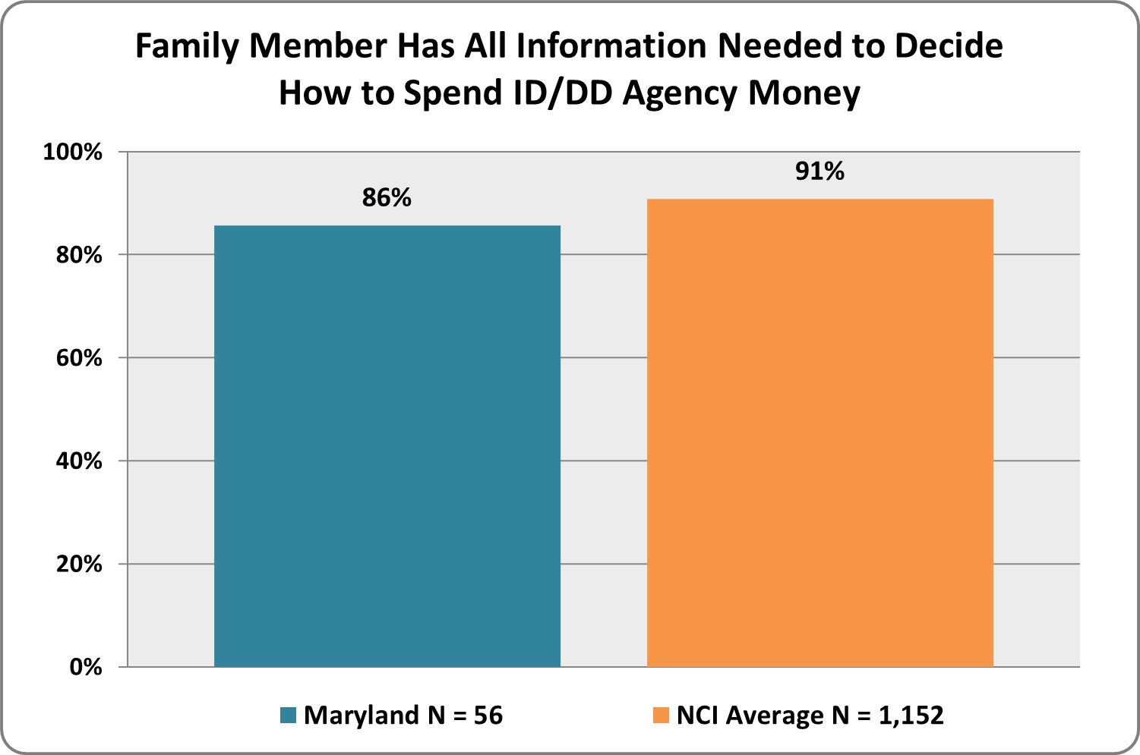

Community Connections
family members with disabilities use integrated community services and participate in everyday community activities
Graph 77. Does your family member participate in community activities (such as going out to a restaurant, movie, or sporting event)?  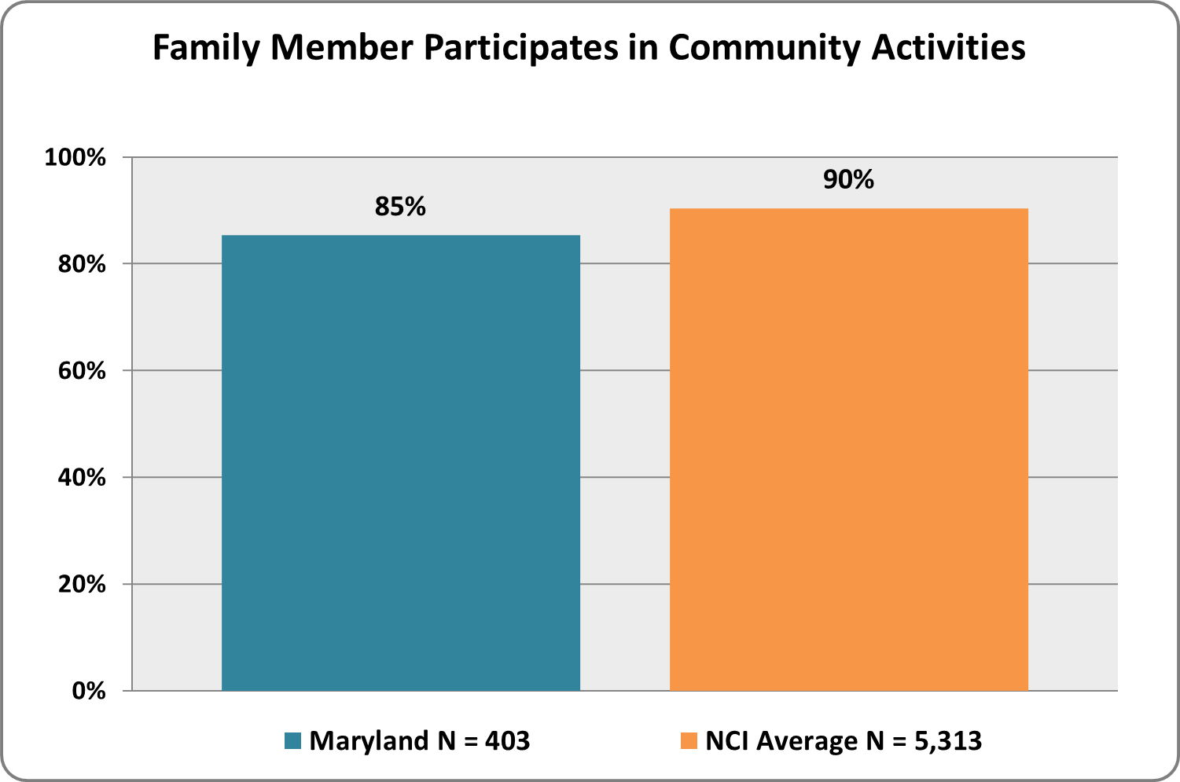 | Graph 78. If your family member doesn't participate in community activities, why not?  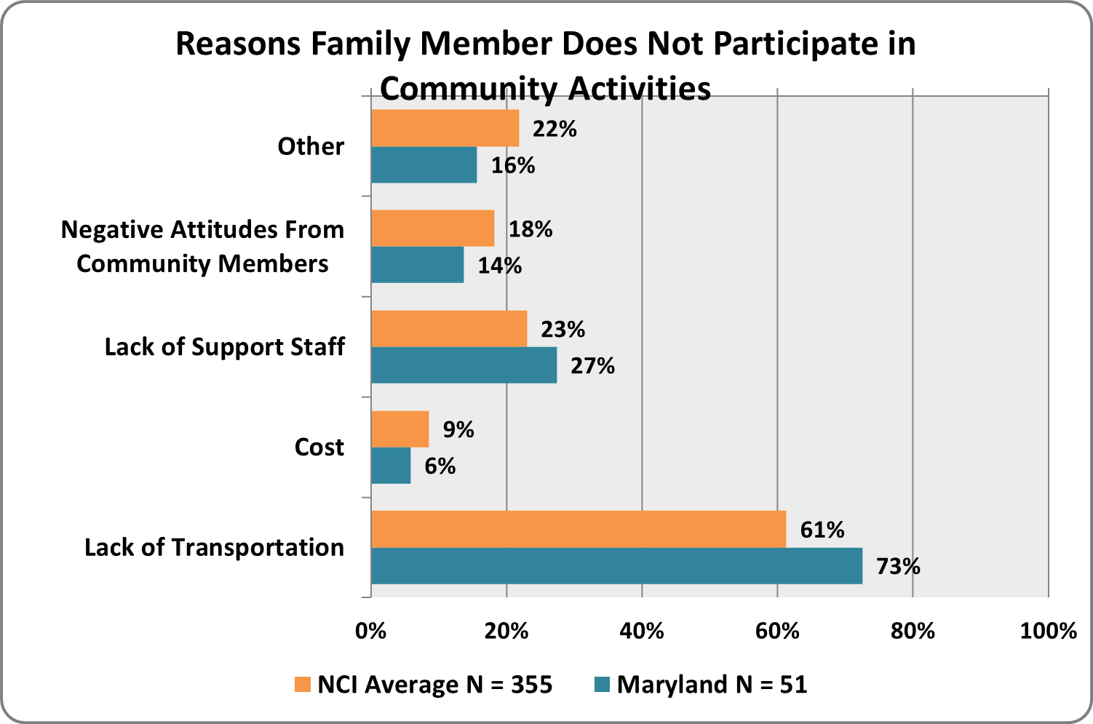
Graph 79. Does your family member have friends or relationships with persons other than paid support workers or family?  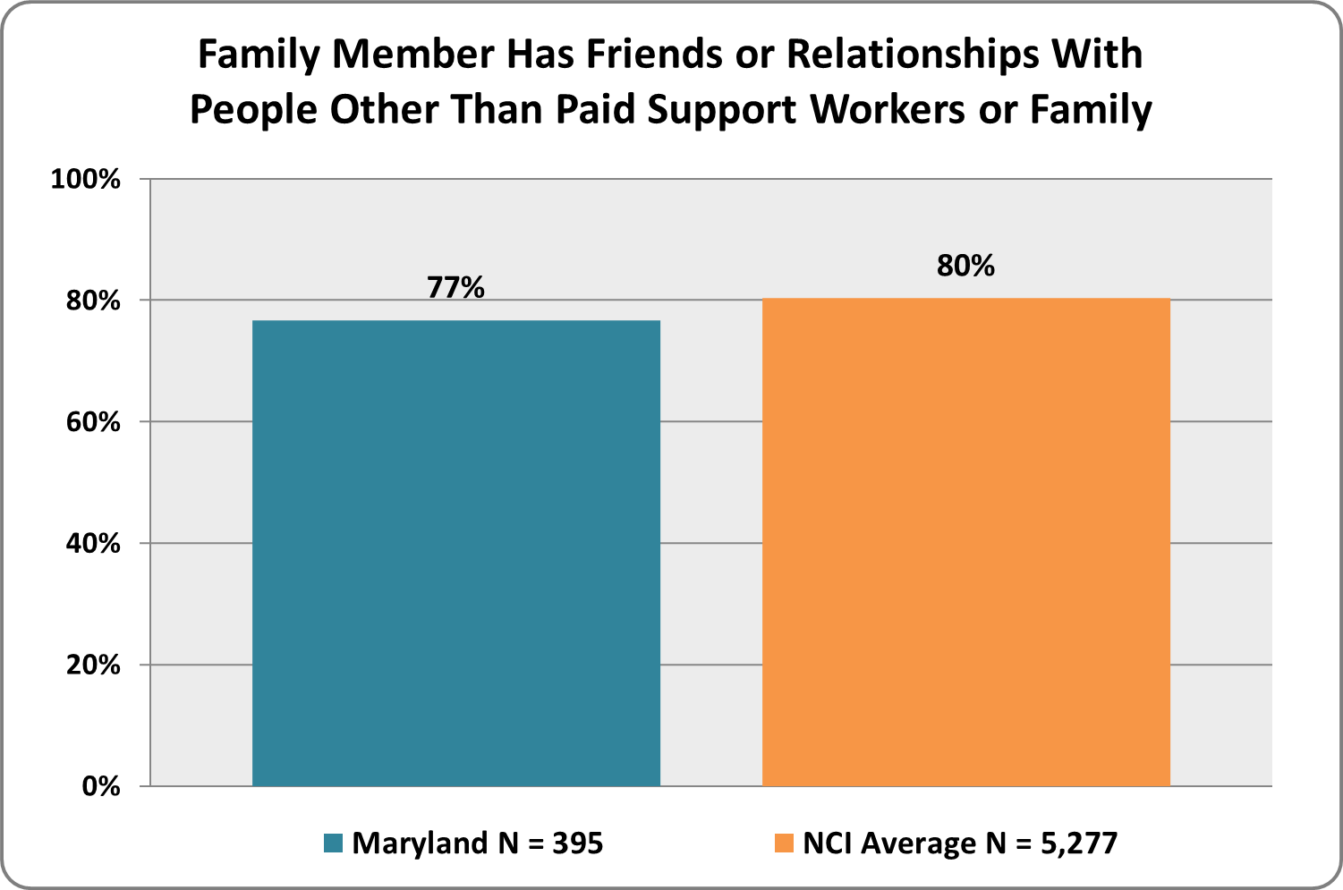 | Graph 80. Does your family member have enough supports (e.g., support workers, community resources) to work or volunteer in the community?  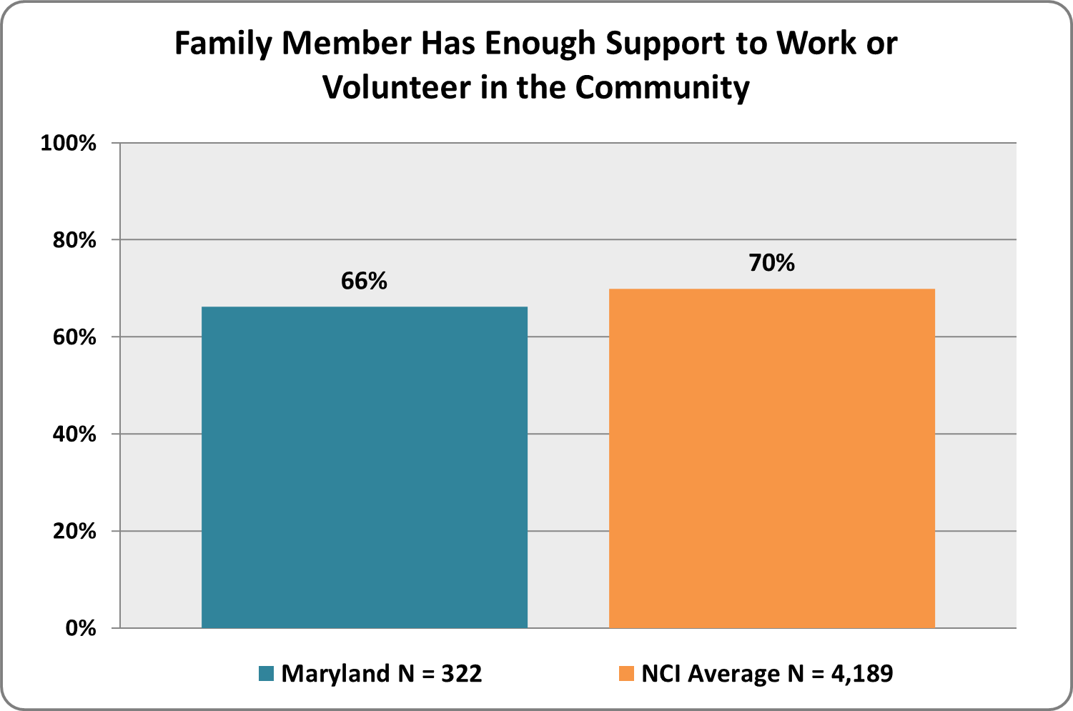

Satisfaction

families and family members with disabilities receive adequate and satisfactory supports
Graph 81. Overall, are you satisfied with the services and supports your family currently receives?  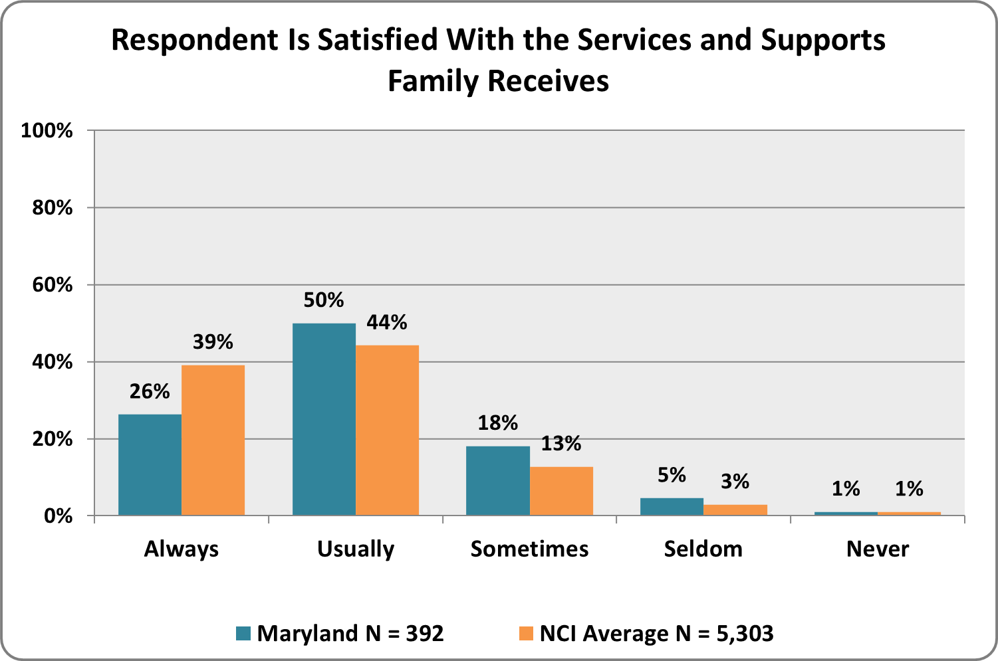 | Graph 82. Do you know the process for filing a complaint or grievance against provider agencies or staff?*  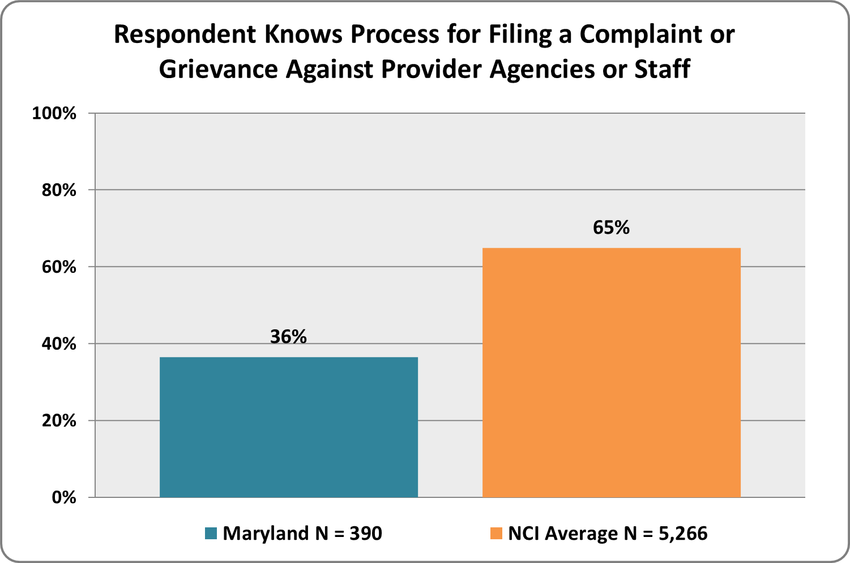
Graph 83. Are you satisfied with the way complaints or grievances against provider agencies or staff are handled and resolved?  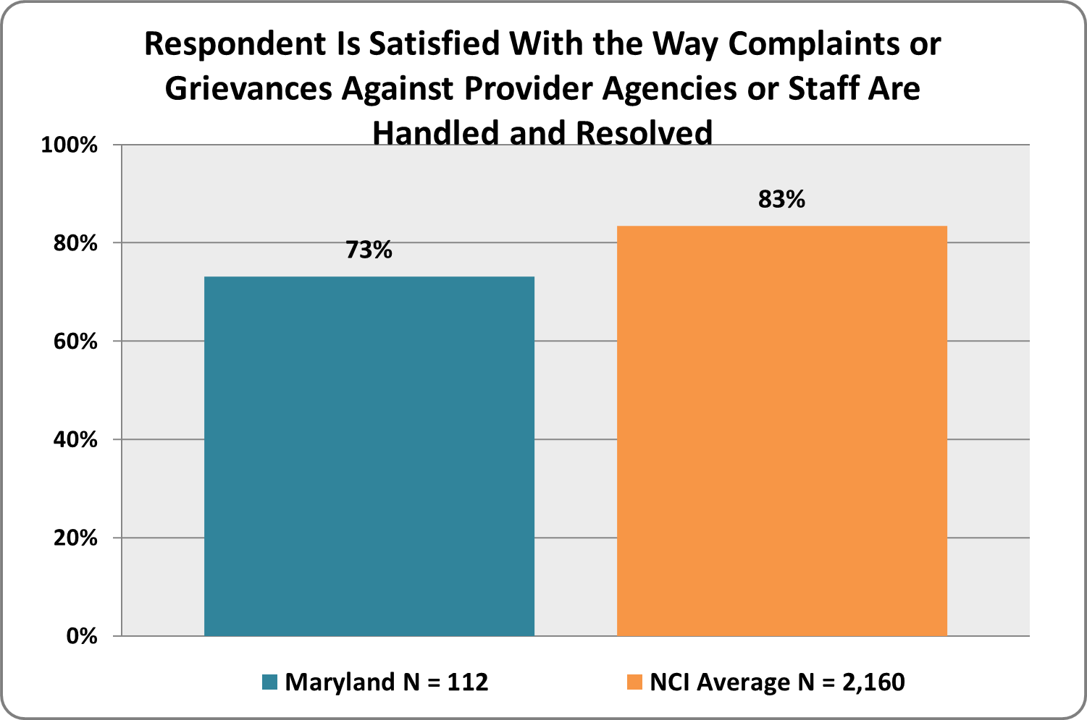 | Graph 84. Do you know how to report abuse or neglect?*  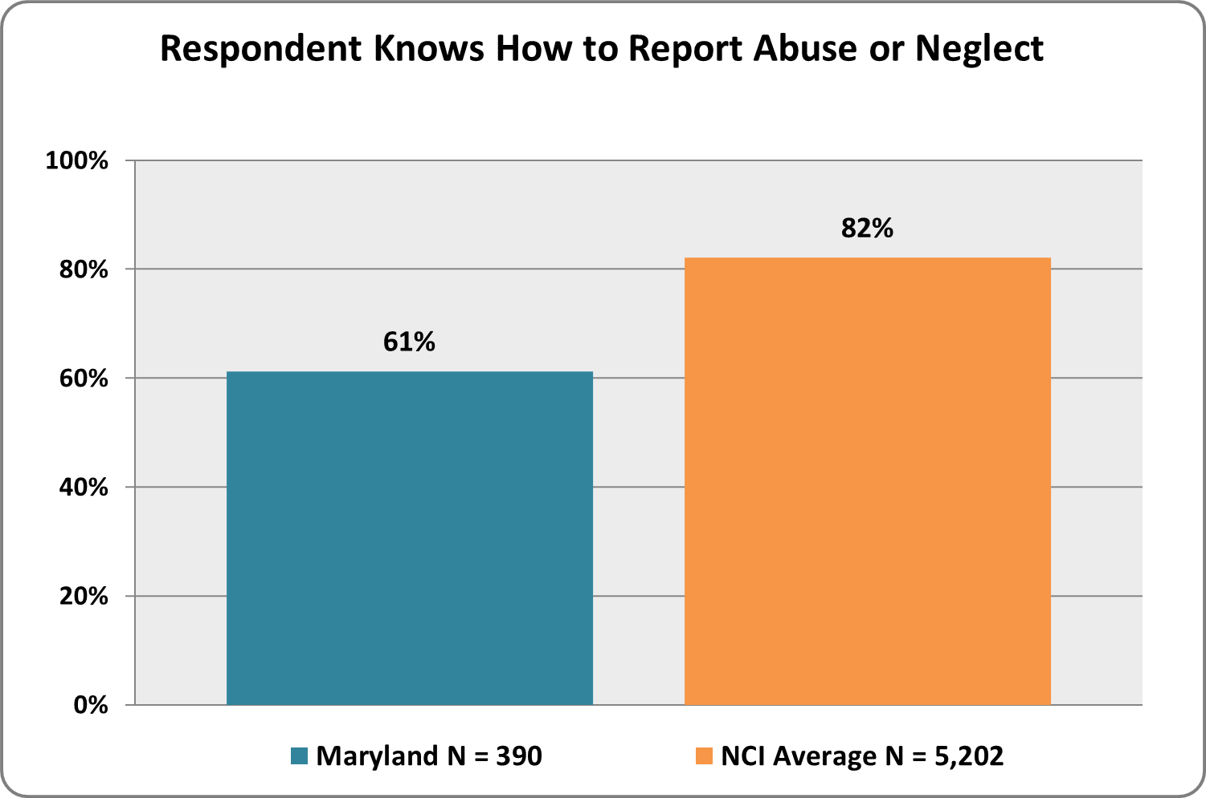
*‘Don’t Know’ responses were included in ‘No’ responses for this question

Graph 85. Within the past year, if abuse or neglect occurred, did you report it?
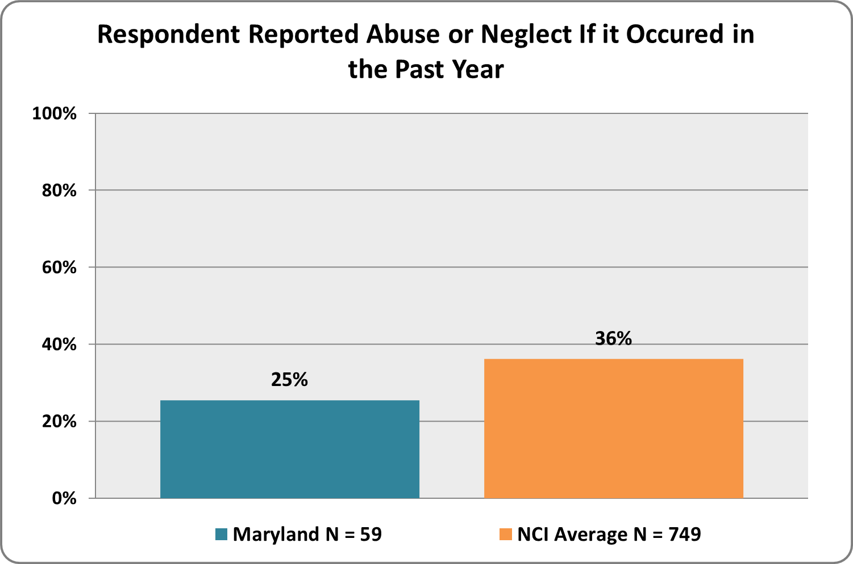

Family Outcomes

individual and family supports make a positive difference in the lives of families
Graph 86. Do you feel that services and supports have made a positive difference in the life of your family?  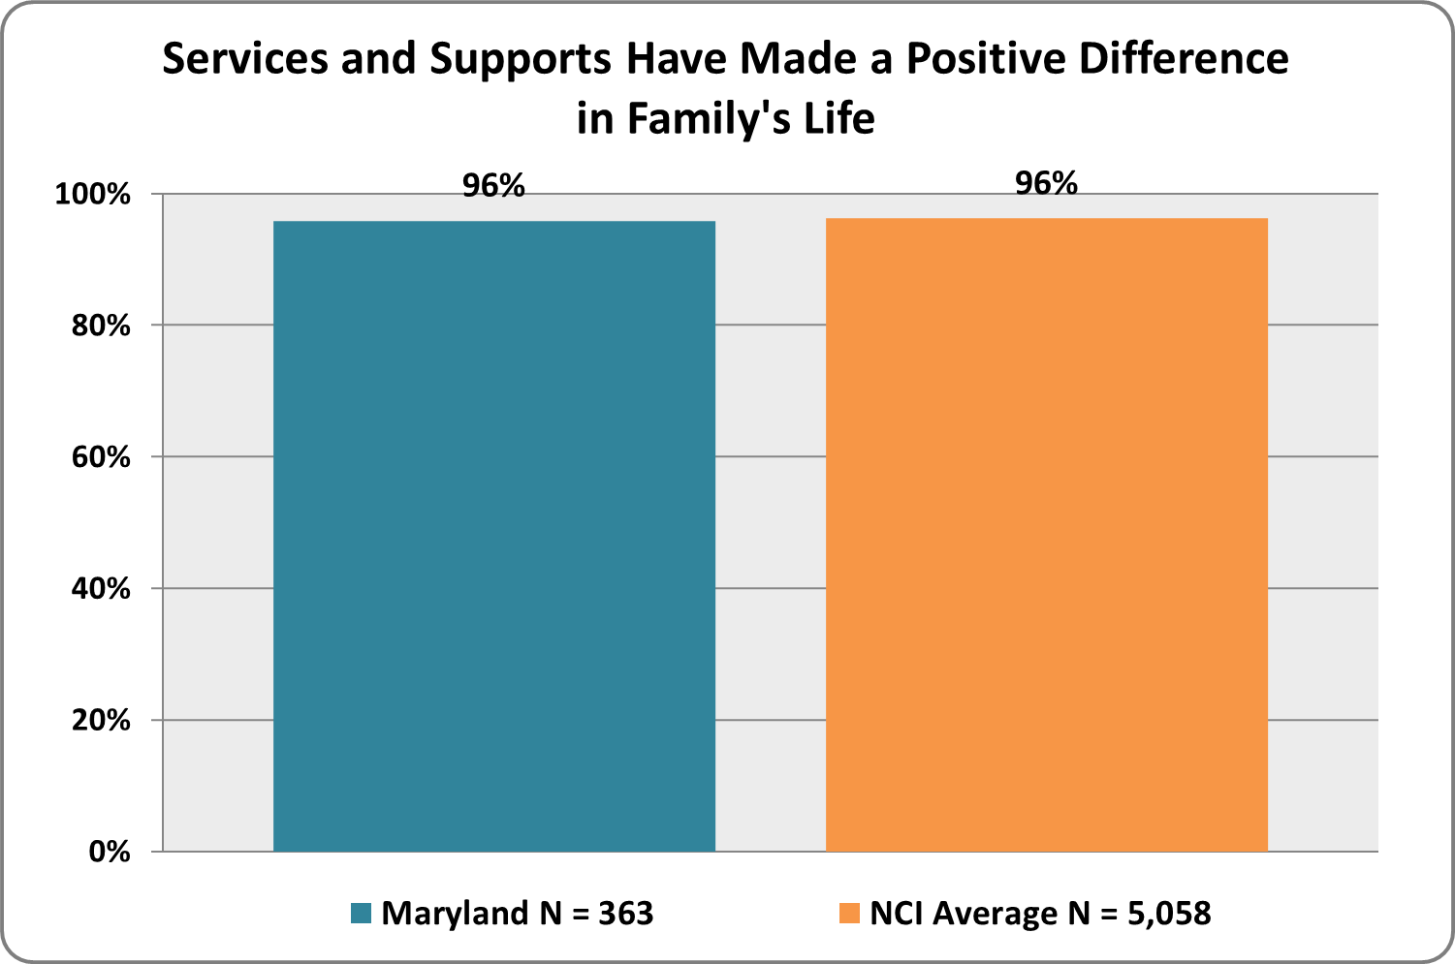 | Graph 87. Do you feel that services and supports have reduced your family’s out-of-pocket expenses for your family member’s care?  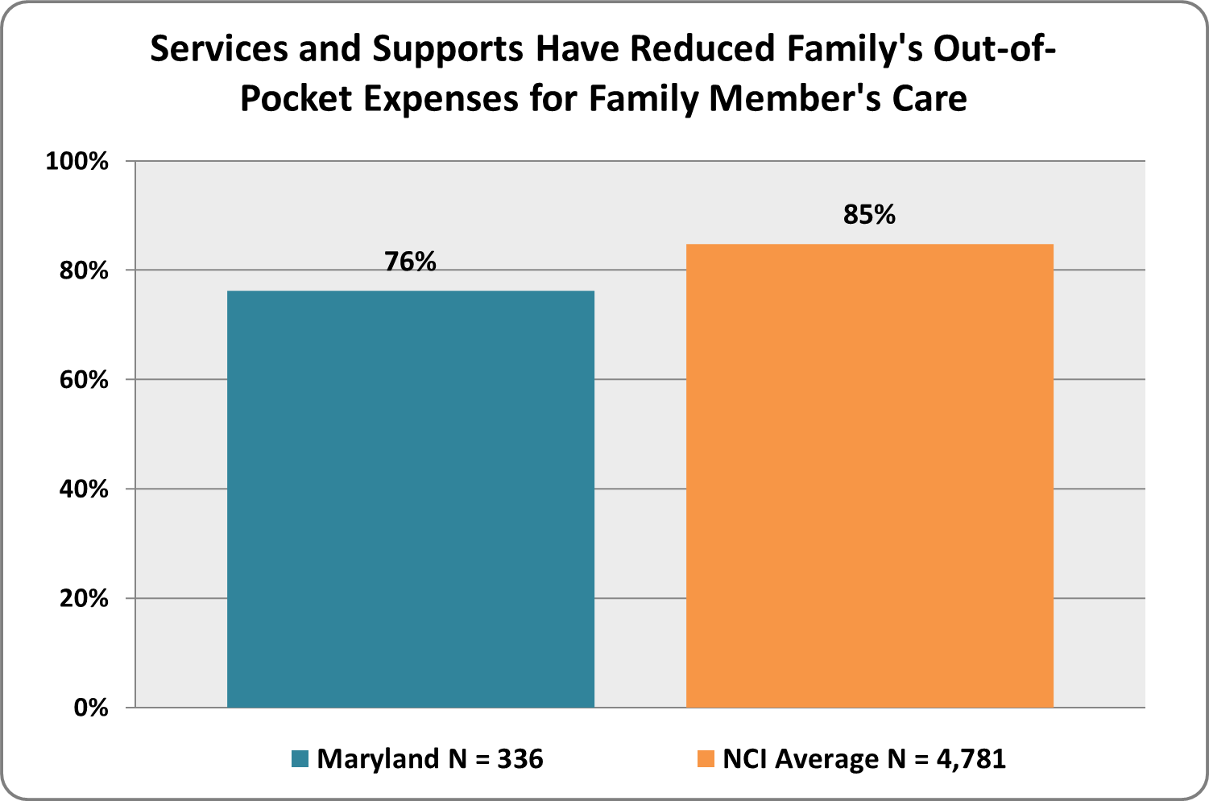
Graph 88. Have the services or supports that you or your family member received been reduced, suspended, or terminated in the past year?  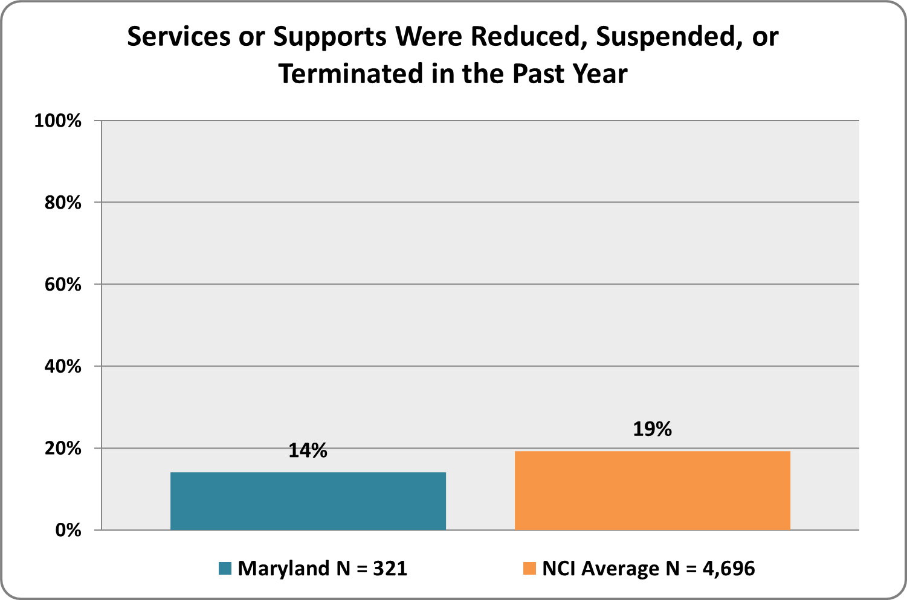 | Graph 89. If services or supports received by the family were reduced, suspended or terminated during the past year, did this change affect your family or your family member negatively?  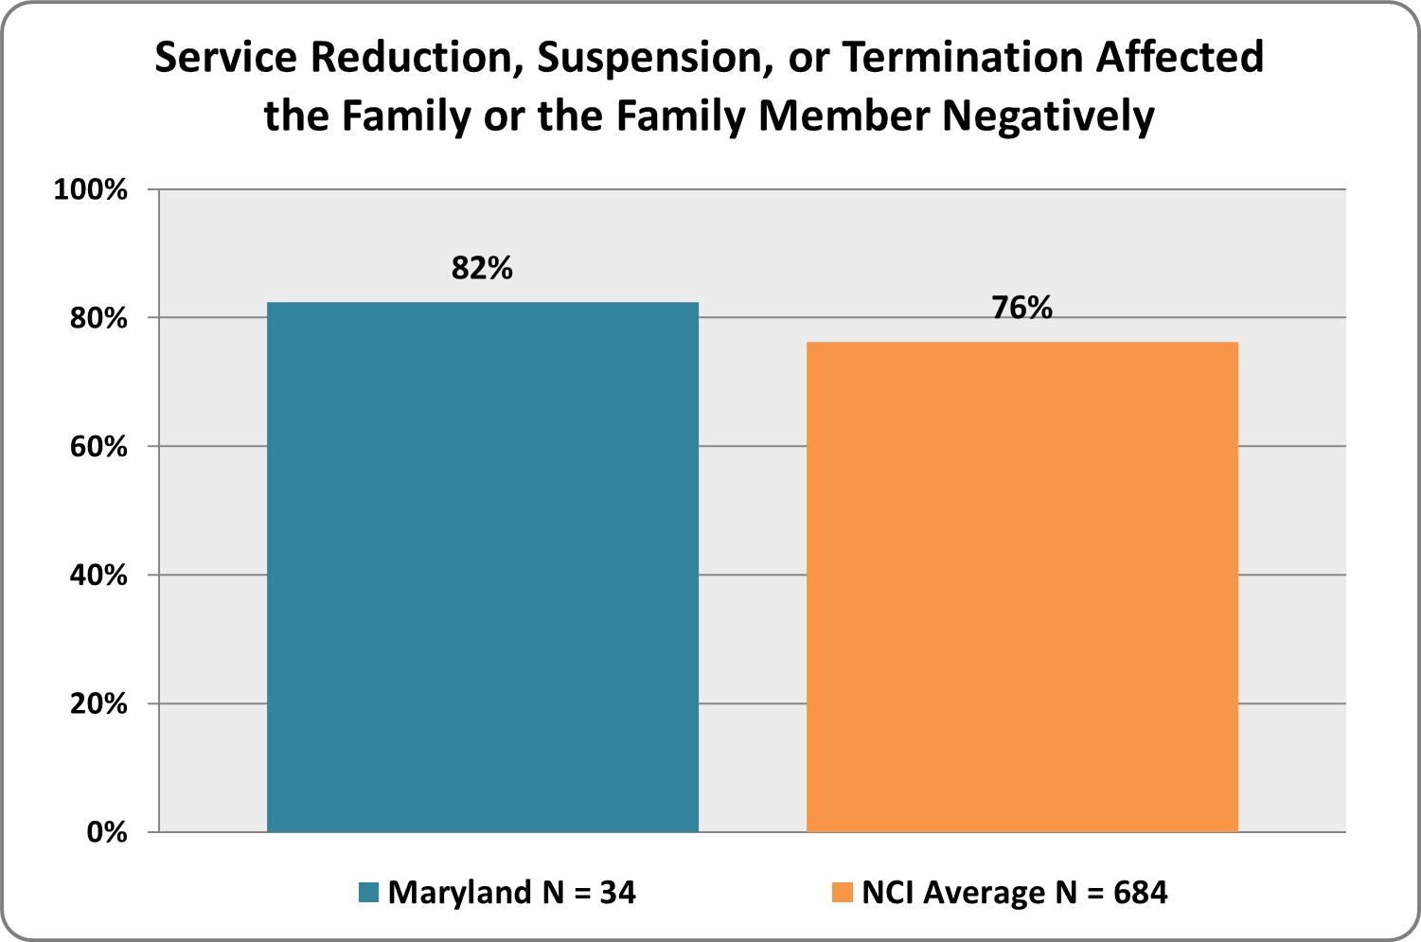

All services and supports are received from the ID/DD Agency except social security benefits.

